

Bed Project- December 2024
In a combined program with Antioch Fire Department, Penny’s Purpose, and Rotary Club of Antioch eight sets of beds were provided to families in need in Lake County in December 2024.
Frames, mattresses, box springs, and headboards were supplied by Antioch Fire Department, Blankets by The Penny’s Purpose, and linens by Rotary Club.
Volunteers from the Fire Department and Rotary were able to deliver and set up for families in Lake Villa, Waukegan, and Highwood.
The delight on the faces of the children was a wonderful experience for those involved.
Thanks to all for their support and participation in this community project, especially Antioch Fire Chief Jon Cokefair and April Andrews of The Penny’s Purpose.

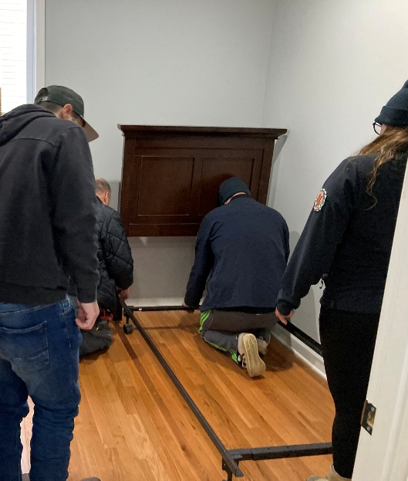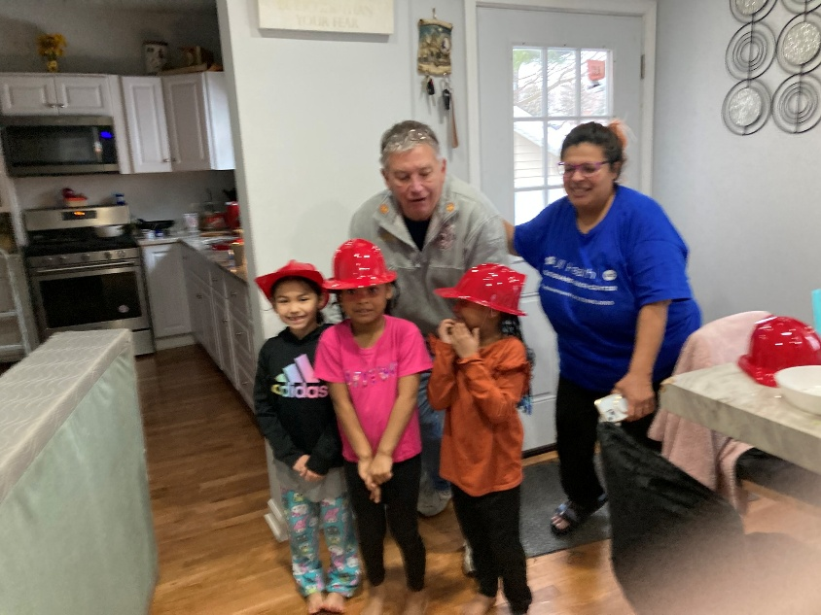

If you know of anyone who falls into this 2% in our local community, please contact us at rotaryclubantioch@gmail.com

