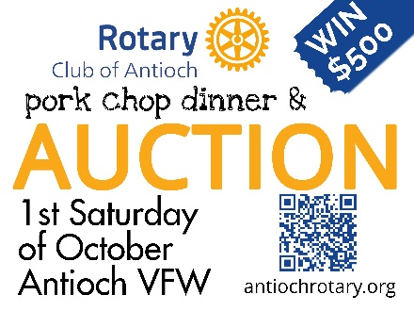
2026 Auction Advertising Agreement
Thank you for supporting the Rotary Club of Antioch. Sponsoring the October 3rd Pork Chop Dinner & Auction fundraiser will assist in providing: Community outreach locally and internationally; High School programs in expanding cultural awareness through Rotary Youth Exchange and leadership training in the 4-day Rotary Youth Leadership Award; College Scholarships for Antioch & Lakes Community High School; and Technical Grants for people entering the a trade profession; Holiday baskets equivalent to 1800 meals; and more.
Your benefits of sponsoring the event include:
- Your business logo / ad will be in the Auction booklet viewed by over 400 attendees.
- A business logo will be displayed in the Auction venue.
- An electronic version of your business logo with hyperlink to your contact information and website will also be posted on our main Club website page (www.antiochrotary.org) through the end of this year. The Rotary Club website link is on the Auction flyers posted around Antioch, Lake Villa, & Lindenhurst. Typically, between 800 and 2000 website sponsor clicks per year.
- Deadline for your ad to be included is September 14, 2026.
- Artwork in event signage will be adjusted based on the sponsorship levels:
Select | Size | Dimensions in inches (width by height) | Proportion Price | Event Poster Size
 | Small | 4.0 by 2.5 | $50 | 12 by 18 inch
 | Banner | 8.0 by 2.5 | $125 | 12 by 18 inch
 | Half Page | 8.0 by 5.0. | $250 | 18 by 24 inch
 | Full page | 8.0 by 10.0 | $500 | 18 by 24 inch
- Contact information:
Business Name _________________________________________
Address ___________________________________________________________________________
Phone ________________________________
Contact Name ____________________________________ Phone________________________________Email______________________________
Website address _____________________________________________________
- Sign agreement: ____________________________________________ Date: ______________________
- Provide the Rotarian your check payable to Rotary Club of Antioch.
- Send this form and electronic file of artwork (jpg, png, or pdf) to: Rotaryclubantioch@gmail.com
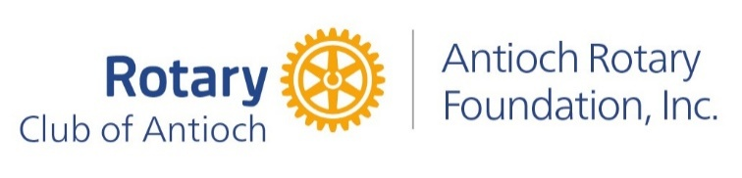
DEADLINE FOR ARTWORK AND PAYMENT IS NOON SEPTEMBER 14th.
Thank you for your partnership!

