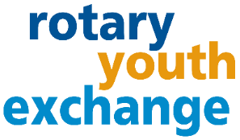
District 6440
2026 Summer Youth Exchange:

Frequently Asked Questions

WHAT IS ROTARY SHORT-TERM EXCHANGE PROGRAM?
Go beyond a vacation! The Rotary reciprocal short-term exchange is an opportunity for high school students to experience another culture. Students are matched with a “twin” overseas and live with that family typically for a month. In return, they reciprocate and host their twin student in their home for several weeks. At least three weeks in each country is required with the option for longer stays and sequence the exchange based on family plans. Take advantage of this unique and create a life-long bond with a family overseas.
WHAT APPLICATION REQUIREMENTS ARE THERE?
Age 15- 18 ½ at time of exchange and be in good standing at school – can include after graduation.

HOW MUCH DOES THE PROGRAM COST?
The program averages $2000. This cost depends greatly on the airline ticket costs and activities during travel and hosting. The estimate includes spending money, gifts for host parents and children, and $275 non-refundable FULL application fee if club approved covers administration costs and Rotary travel insurance.

WHAT COUNTRIES CAN I GO TO?
The program is a Rotary District to District exchange, which means that the connection between District 6440 can be made with willing, certified Rotary District that are participating in the short-term program. Creating matches in Europe is our main focus because they have somewhat of a similar summer school break schedule, and English is either a 1st or 2nd language. However, if you are learning a language already, we encourage you to consider utilizing this opportunity to practice your speaking skills. Taiwan is also a possibility. Countries in the southern hemisphere summer breaks do not align with the USA.

ARE THERE ANY MANDATORY MEETINGS?
The student and at least one parent must attend the mandatory training in April (usually last Sunday in April). Both parents are encouraged to attend to fully understand the program. The student is expected to attend the local Rotary Club before their exchange, while hosting their exchange student, and after the program. Students might be invited to attend the District Conference or share via video their anticipation of the program, and afterwards share photos and stories afterwards. Based on the exchange timing, a District Picnic might be coordinated during the summer, as well as some events before the exchange.

WHAT ARE MY RESPONSIBILITIES IF I AM CHOSEN?
Exchange students are ambassadors and represent country, state, city, Rotary, and much more. Therefore, behavior and attitudes are important. This includes being pleasant to those you interact with, refraining from judgement and being willing to embrace new experiences, people, and cultural differences with an open mind and abiding by all Rotary program rules (no drinking, no driving, no drugs and no dating). Be prepared to share your experiences with potential exchange students.
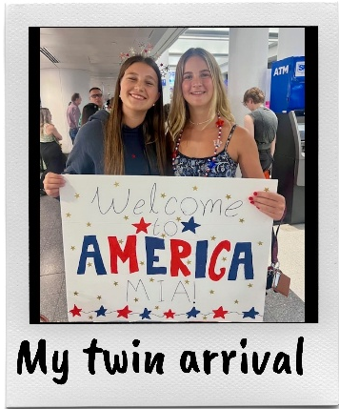
WHAT ARE MY PARENTS’ RESPONSIBILITIES IF I AM CHOSEN?

The program includes parents hosting an exchange student for a minimum of three weeks. The student must have a separate bed and be given meals. Other requirements include being open-minded and willing to share your town, city, state with the students, and involve them in your vacation plans when realistic. All adults (anyone over 18) that live at home must undergo a background check and online training.

CAN SHORT-TERM EXCHANGE STUDENTS ATTEND HIGH SCHOOL?
Attending school is not part of the program. Arrangements to shadow your student would have to be made with the schools directly. We recommend you talk to your school contact about this activity before finalizing your travel arrangements.

SO, WHAT IS ROTARY?
Rotary is a nonprofit service organization made up of over 1.2 million volunteers globally. In 1905, Paul Harris started Rotary in Chicago and rotated locations – which was the inspiration for the Rotary wheel symbol. Today Rotary International headquarters is in Evanston, IL. Rotarians are “People of Action” that have a passion for “Service Above Self” and promoting peace around the world through friendship and understanding. It is not a political or religious organization.
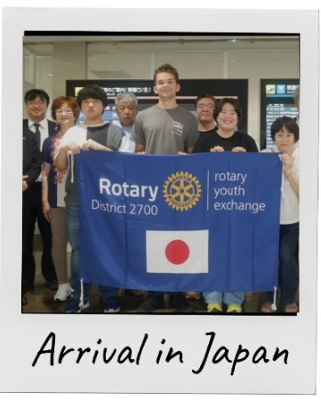
INTERESTED? APPLY! HOW?
Start the conversation by completing a preliminary application at no cost. Turn it into your local Rotary Club Youth Exchange Officer (YEO) based on their deadline, or District 6440 if a local club has not initiated recruitment. The local and/or District Rotary representatives will interview you and your family in your home to explain the next steps of the application process and to consider you for sponsorship. Deadline for Club Sponsorship is December 15, 2025.

CONTACT DISTRICT 6440 REPRESENTATIVES AT: RYE.Chair@rotary6440.org
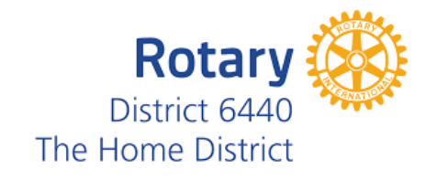
CLUB CONTACT:
Rebecca Dunleavy 847-997-3603 rotaryclubantioch@gmail.com

