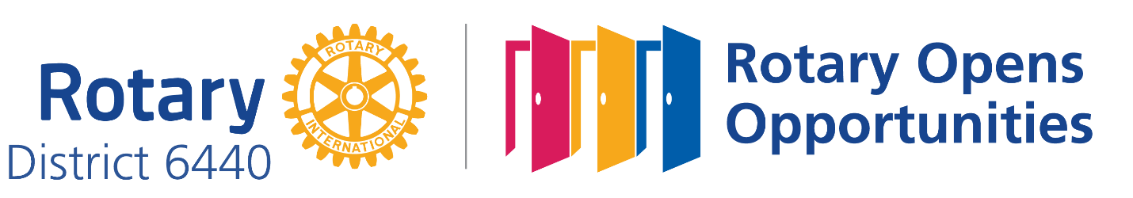

ROTARY DISTRICT 6440
2021 VOCATIONAL SCHOLARSHIP PROGRAM APPLICATION

Scholarship grants in the amount of $1,500 each will be awarded to support students entering educational programs preparing them for vocational or technical careers attainable with less than a four-year degree. Grants will be limited to programs that prepare for immediate entry into a career field (e.g. Associate of Applied Science Degree, Trade School Diploma, Certificate, License).

To be submitted:

- One completed and legible application form suitable for photo-copy reproduction and distribution to Rotary Vocational Scholarship Committee Members
- Two letters of reference (to accompany this application)
- Transcript of high school and/or community college (if applicable) grades
- Vocational Scholarship Application Rating Form signed by Sponsoring Rotary Club
- Vocational Scholarship Interview Rating Form signed by Sponsoring Rotary Club

Applications must be sent to the Rotary District 6440 Vocational Scholarship Committee by April 9, 2021.

MAIL APPLICATION AND SUPPORTING PAPERS TO:
Margaret Resnick
372A Rolling Wood Lane
Lake Barrington, IL 60010

vocscholar@rotary6440.org
mobile 847-971-1655

Applicant Name
(Last, First, Middle)
Street Address 1
Street Address 2
City, State, Zip
E-mail
Phone
Parent / Guardian
Street Address 1
Street Address 2
City, State, Zip
E-mail
Phone
Intended School or Community College
Street Address 1
Street Address 2
City, State, Zip
Financial Aid Coordinator
E-mail
Phone
Intended Technical or Vocational Program
Future Plans
Describe Completed Coursework, Volunteer Experience, Hobbies, Competitions, or Awards in this Chosen Field
SCHOOL / COMMUNITY / WORK
School Name
Street Address 1
Street Address 2
City, State, Zip
Number in Class
Rank in Class
Graduation Date
School Involvement (Clubs, Sports, Offices, Etc.)
Community Involvement
Work Experience
Counselor’s Recommendations / Comments (Optional)

Applicant’s Acknowledgment: I have completed this application and have provided the required supporting documents. I understand that I am prepared to be interviewed by the District 6440 Selection Committee.

_______________________________________ ____________________
Applicant’s Signature Date

Prefer: (circle) Morning Interview Afternoon Interview

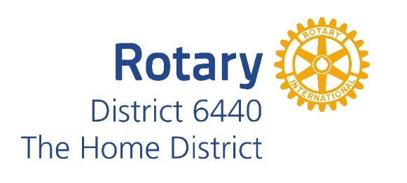

Photograph and Publicity Release Form

I, , give Rotary International District 6440 and its Rotary Clubs, permission to use my name, likeness, image, voice, and/or appearance as such may be embodied in any pictures, photos, video recordings, audiotapes, digital images, and the like, taken or made on behalf of Rotary District 6440 activities. I agree that Rotary District 6440 and its clubs have complete ownership of such pictures, etc., including the entire copyright, and may use them for any purpose consistent with Rotary International Public Image guidelines. These uses include, but are not limited to illustrations, bulletins, exhibitions, videotapes, reprints, reproductions, publications, advertisements, and any promotional or educational materials in any medium now known or later developed, including the Internet. I acknowledge that we will not receive any compensation, etc. for the use of such pictures, etc., and hereby release Rotary District 6440 and its agents and assigns from any and all claims which arise out of or are in any way connected with such use.

I have read and understood this consent and release.

I give my consent to Rotary District 6440 and its Rotary Clubs to use my name and likeness to promote Rotary International, Rotary District 6440 and its clubs, and/or their activities.

Signature Date

Parent / legal guardian (if age 17 or younger) Date

I do not give my consent to Rotary District 6440 and its Rotary Clubs to use my name and likeness to Rotary International, Rotary District 6440 and its clubs, and/or their activities.

Signature Date

Parent / legal guardian (if age 17 or younger) Date

