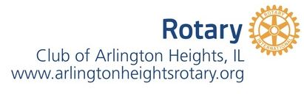

GLOBAL AWARENESS GRANT APPLICATION

School/Class/Club/Teacher Name ___________________________________
Preferred contact info: ___________________________

Problem or Need
(What language immersion, Cultural/Global Awareness goal(s) are addressed by this project/program?)
Purpose
(Briefly describe the overall purpose of this project/program)
Brief History
(What led you to see cultural/global awareness as a priority?)
Proposed Program Description of Activities
(What are the primary elements of this program? What’s the total program cost? How much financial assistance is needed? Rotary Grant can be up to $500.
Short-term goals
(What do you hope to accomplish in the first year?)
Long-term goals
(What is your ultimate goal for the program/project?)
Objectives
(What steps will be taken to achieve your goals?)
Evaluation
(How will you evaluate the success of the program?)
Personnel
(Who will be involved in the project/program? Leading, supporting, etc.)
Collaboration
(What other groups/organizations, if any, will be involved in the
project/program?)
Sustainability
(How is it expected that this program/project will be funded beyond this year?)
Rotary
(How will the Rotary Club’s support be recognized?)

Please send or email the completed application and attachments to:
John Kent -Director of Youth Services
Rotary Club of Arlington Heights, IL
1302 N Illinois Ave
Arlington Heights, IL 60004
e-mail: jkent@amfam.com
Application is also found on our club’s website: https://portal.clubrunner.ca/2354/

