2021 International Service Project Trip for
Rotarians from District 6440 & 6450

GUATEMALA
INFORMATION & SERVICE PROJECT APPLICATION
November 6 – November 15, 2021

Scope of Project

Dependent upon the number of participants, there will be up to 2 project sites. One project site will be at a school in El Rodeo, Guatemala, a small village devastated by the 2018 De Fuego Volcano disaster. This school was the site of a 2020 Rotary project. The projects at the school will consist of building a new rear wooden landing platform and stairway, working in classrooms and other areas, painting and re-laying a water line to eliminate a trip hazard for the children. Other potential projects at the school are being developed. A secondary project site will be a in Antigua, where the team members assigned there will build wooden bunk beds, which will then be transported to another site.
All participants will stay at a hotel in Antiqua, heading out with their team to their project site each weekday morning and returning late afternoon.
Team is limited. Applications will be accepted on a first-come, first-served basis.
Cost - $1,250 - The trip cost will include airfare, ground transportation, material costs, hotel, breakfast every day, lunch during the workweek. Participants will be encouraged to eat dinner as a group, but dinner is not included in the cost. There will not be an after-work excursion for this trip. (Those going will have time to relax and explore Antigua during non-working hours). Airfare includes carry-on but any need for checked luggage will be at participant’s expense. A deposit of $200 is due with your application, 2nd payment of $400 due by Aug 1st, and the remaining balance will due October 15th. The rate is based on double occupancy - if you do not have a roommate, one will be assigned. If single occupancy is desired, please contact Jim Wales for additional costs amount. Application deadline is August 1.
It is anticipated there will be a meeting in September for all registered trip participants. At that meeting, detailed trip and project information will be provided. Additionally, a section of the meeting will be set aside for an opportunity to provide suggestions to first-time travelers to Guatemala, and that travelers may find beneficial regarding health, safety, and local customs.
Project Location Information

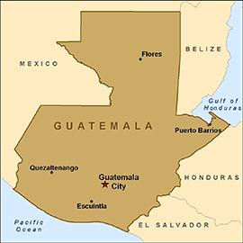

Antigua Guatemala
Antigua is a city in the central highlands of Guatemala known for its preserved Spanish Baroque-influenced architecture as well as a number of ruins of colonial churches. It served as the capital of the Kingdom of Guatemala. It has been designated a UNESCO World Heritage site. Antigua Guatemala serves as the municipal seat for the surrounding municipality of the same name. It also serves as the departmental capital of Sacatepéquez Department.

El Rodeo
El Rodeo is a town in the Escuintla Department of Guatemala, about 35 kilometers southwest of Guatemala City. It is located at an altitude of 2,483 m (8,146 ft) above sea level on the southern slopes of an active volcano called Volcán de Fuego — Spanish for Volcano of Fire.
The town, with a population estimated at 14,125 was reported to have been partially buried by volcanic material following the 2018 Volcán de Fuego eruption on 3 June 2018. The town was in the early process of evacuation when the eruption happened. One of the two schools was destroyed.
Air Transport Information

Group flight will be via United Airline.

Nov 6 – Depart Chicago O’Hare at 7:45 am. Arrive Houston at 10:33 am
Depart Houston at 11:55 am. Arrive Guatemala Coty at1:42 pm.

Nov. 15 – Depart Guatemala City at 10:30 am. Arrive Washington DC at 3:38 PM
Depart Washington DC at 5:15 pm. Arrive Chicago at 6:33 pm

Hotel Information (Tentative):
Antigua – Hotel Soleil Antigua – 99 Calle Poniente, Carretera a Ciudad Vieja, Antigua, Guatemala Tel: 502-24627777 / 78794444
http://antigua.hotelessoleilguatemala.com/gallery-en.html

Weather Information

November is a dry month with an average of 23mm (0.9in) rain. The average maximum temperature lies around 24.0°C (75.2°F). It has 212 hours of sun. Low temperatures will be approximately 58 degrees.

Health Information & Vaccinations for Travelers to Guatemala

Health Information
- COVID-19 remains a risk in Guatemala.
- Zika virus is widespread. If you're pregnant, discuss your travel plans with your doctor.
- Malaria occurs year-round in areas below 1500m. Consider taking anti-malarial medication if you're travelling to these areas. Other insect-borne diseases include dengue, Chagas disease, river blindness and leishmaniasis. Ensure your accommodation is insect-proof. Use insect repellent.
- HIV/AIDS is a significant risk. Take precautions if you're taking part in high-risk activities.
- Foodborne, waterborne and other infectious diseases include hepatitis, typhoid and tuberculosis. Drink boiled or bottled water. Avoid raw or undercooked food.
- Medical facilities in Guatemala City are adequate. They're limited elsewhere. If you're seriously ill or injured, you may need medical evacuation. Ensure your travel insurance covers this.

Vaccination Information 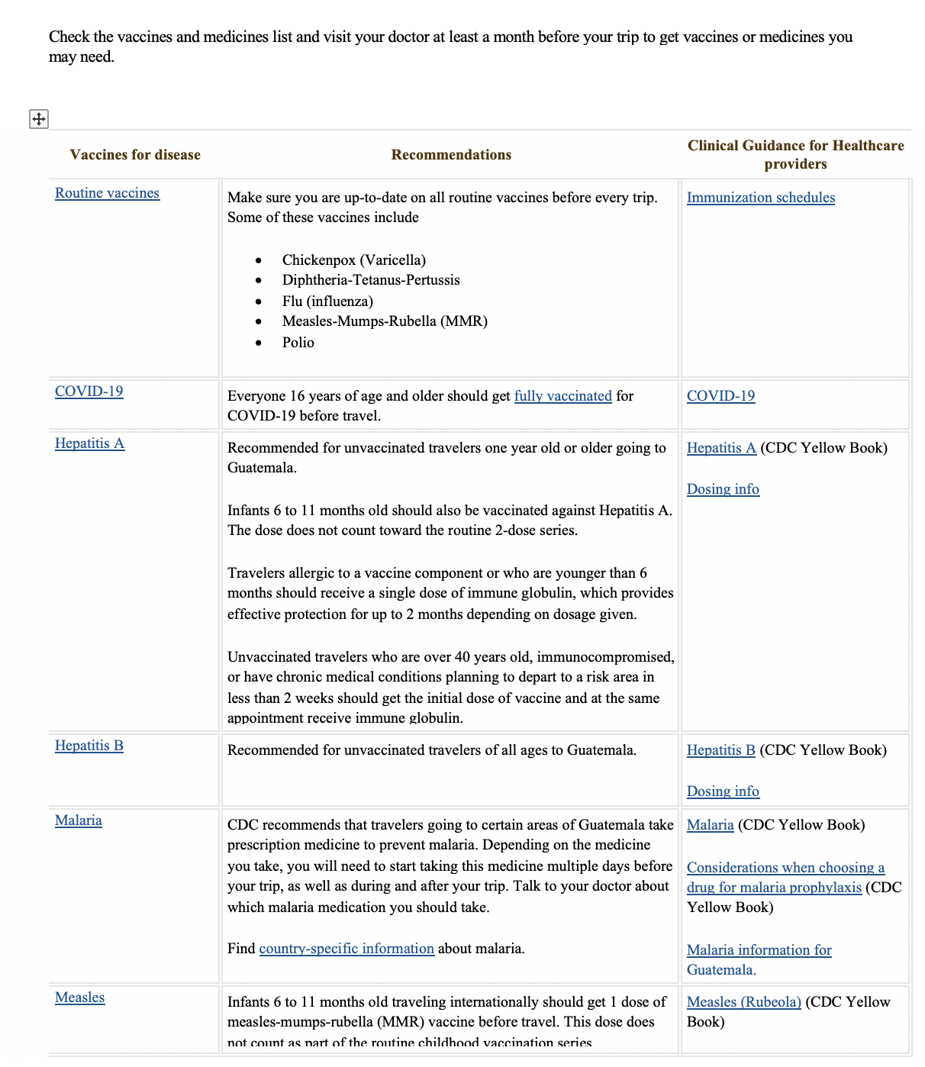
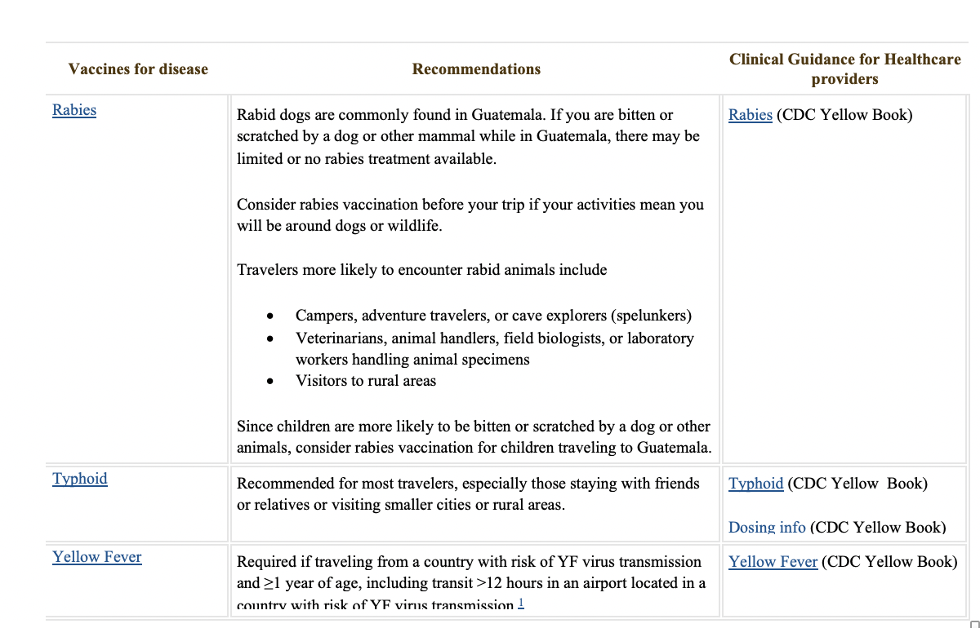

Service Project Application
Name (exactly as shown on passport): ______________________________________
Home Address: ________________________________________________________
City _____________________________________ State ______ Zip ______________
Tel: (Home) _______________________ (Cell) _______________________________
E-mail: _______________________________________________________________
Passport No: ___________________________ Country ________ Exp Date: _______ (PLEASE ATTACH COPY)
Date of Birth: _________________
Emergency contact: ___________________________ Tel: ______________________
Rotary Club Affiliation (member or guest): ____________________________________
Do you have any physical or health concerns or work limitations?
______________________________________________________________________
Do you have skills (medical, education, construction, etc.) that you would like to use?
______________________________________________________________________
Spanish fluency: ______________ Requested roommate: _______________________

Send your completed APPLICATION, WAIVER, FIRST DEPOSIT, and a copy of your PASSPORT, either in person to Jim Wales; or the application and waiver can be emailed (jim.wales1120@gmail.com) and the deposit mailed; or the application, waiver and deposit can be mailed to Jim Wales, 621 S Plymouth Ct., #504, Chicago IL 60605.
Make checks payable to “Rotary Club of Chicago Citywide Service” and write “Guatemala 2021” on the memo line.
Any questions? Feel free to contact: Jim Wales (District 6450), jim.wales1120@gmail.com - 847-815-9459 or Dr. Robert Steinberg (District 6440), doc35@comcast.net - 847-650-3668

2021 International Service Project Trip for
Rotarians from District 6440 & 6450
WAIVER OF LIABILITY, ASSUMPTION OF RISK, AND HOLD HARMLESS AGREEMENT

PLEASE READ THIS STATEMENT CAREFULLY. IT AFFECTS ANY RIGHTS YOU MAY HAVE IF YOU ARE INJURED OR OTHERWISE SUFFER DAMAGES IN CONNECTION WITH THE 2021 GUATEMALA SERVICE PROJECT.

I, (print full name) ________________________________________, am voluntarily participating in an
international service project in Guatemala (the “Program”). I acknowledge and understand that in consideration for my being permitted to participate in the Program, I do hereby, for myself, my spouse or partner, and the other members of my family while I am alive, and for my heirs, assigns, and personal representatives after my death, ASSUME THE RISK OF PARTICIPATION in the Program.

I understand that there will be extensive air, land, and water travel to get to and from the service site, that I will or may be involved in construction activities involving the use of tools, that I will or may be in mountainous, jungle or other unfamiliar environments, and that I will or may participate in physically demanding activities.

I AM AWARE THAT THESE ACTIVITIES ARE HAZARDOUS ACTIVITIES AND THAT I COULD BE SERIOUSLY INJURED OR EVEN KILLED. I AM VOLUNTARILY
PARTICIPATING IN THESE ACTIVITIES WITH KNOWLEDGE OF THE DANGER
INVOLVED AND AGREE TO ASSUME ANY AND ALL RISKS OF BODILY INJURY, DEATH OR PROPERTY DAMAGE, WHETHER THOSE RISKS ARE KNOWN OR UNKNOWN.

I hereby WAIVE, and I RELEASE AND FOREVER DISCHARGE Rotary International, The Rotary Foundation, Rotary District 6440, Rotary District 6450 and all other Rotary districts, all Rotary clubs (including but not limited to the Rotary Club of Chicago Citywide Service) and their respective officers, directors, members, employees, and agents and all Program volunteers, whether accompanying said Program or otherwise (hereinafter referred to as the “Released Parties”) of and from, any and all claims, demands, actions or causes of action on account of any injury, damage or loss to me or my property or on account of my death which may occur from any cause during or in connection with the Program; and I expressly covenant and agree to refrain from bringing any suit, claim or other proceedings at law or in equity, or otherwise as provided by law, against any of the Released Parties, on account of any and all such claims, demands, actions or causes of action.

Initial _____________
Continued on next page

I further AGREE TO INDEMNIFY AND HOLD HARMLESS all Released Parties from any loss, liability, damage or expense, including court costs and attorney’s fees, that they may incur due to my negligent or willful acts or omissions while participating in the Program. I have performed such research as I deem necessary and sufficient (including consultation with medical professionals) concerning travel to Guatemala generally and the Project specifically.

I HAVE READ THE HEALTH INFORMATION IN THIS DOCUMENT AND UNDERSTAND IT IS MY RESPONSIBILITY TO DISCUSS AND OBTAIN ANY VACCINATIONS OR HEALTH DIRECTIVES FROM MY PHYSICIAN. _______
(Initial)

I HAVE READ THE ABOVE WAIVER OF LIABILITY, ASSUMPTION OF RISK, AND HOLD HARMLESS AGREEMENT, UNDERSTAND IT FULLY, AND SIGN IT VOLUNTARILY. I am at least twenty-one (21) years of age and fully competent (and if not twenty-one, my parent(s) or guardian(s) have read and agree with the terms of this Waiver of Liability and Hold Harmless Agreement).

___________________________________________ Date ________________
Participant signature

Parent or guardian must also sign if Participant is under age 21:

____________________________________________ Date _________________
Parent/Guardian signature

