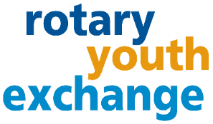
District 6440
2023 Short-Term Summer Youth Exchange:
Frequently Asked Questions

WHAT IS ROTARY SHORT-TERM EXCHANGE?
Go beyond a vacation! The Rotary reciprocal short-term exchange is an opportunity for high school students to experience another culture. Students are matched with a “twin” overseas and live with that family typically for a month. In return, they reciprocate and host their twin student in their home for several weeks. At least three weeks* in each country is required with the option for longer stays and sequence the exchange based on family plans. Take advantage of this unique and create a life-long bond with a family overseas.
WHAT APPLICATION REQUIREMENTS ARE THERE?
Age 15 ½ - 19 at time of exchange and have good grades (upper 50% of their class and/or 2.75 GPA) Gap year exchanges are allowed.

HOW MUCH DOES THE PROGRAM COST?
Typical program averages $1500. This cost depends greatly on the airline ticket costs and activities during hosting. Rotary insurance is (typically less than $100). The estimate includes spending money, gifts for host parents and children, and thank you gifts, and a $150 non-refundable application fee if club approved.

WHAT COUNTRIES CAN I GO TO?
This is Rotary District to District exchange, which means that the connection between District 6440 can be made with any other willing Rotary District. We try to match with countries who have a similar vacation schedule. Due to the short time of the exchange, the student is placed with a family/country that English is either a 1st or 2nd language. However, if you are learning a language already, we encourage you to consider utilizing this opportunity to practice your speaking skills.

ARE THERE ANY MANDATORY MEETINGS?
The student and at least one parent must attend the mandatory training in April. Both parents are encouraged to attend to fully understand the program. The student is expected to attend the local Rotary Club before their exchange, while hosting their exchange student, and after the program. Students might be invited to attending the District Conference or share via video their anticipation of the program, and afterwards share photos and stories afterwards. Based on the exchange timing, one or two District Picnics will be coordinated during the summer, and some events before the exchange.

WHAT ARE MY RESPONSIBILITIES IF I AM CHOSEN?
Students act as ambassador and represent your country, state, city and Rotary. Be pleasant, embrace new experiences, people, and cultural differences with an open mind. Abide by all Rotary program rules (no drinking, no driving, no drugs and no dating). Be prepared to share your experiences with potential exchange students.

WHAT ARE MY PARENTS RESPONSIBILITIES IF I AM CHOSEN?
Parents must host an exchange student for at minimum three weeks. The student must have a separate bed and be given meals. Requirements include being open minded and willing to share your town, city, state with the student and involve them in your vacation plans where realistic. All adults over 18 undergo a background check.

CAN SHORT-TERM EXCHANGE STUDENTS ATTEND HIGH SCHOOL?
That depends on the school. Talk to your counselor about shadowing up to one week.

WHAT IS ROTARY?
Rotary is a nonprofit service organization made up of over 1.4 million volunteers globally. In 1905, Paul Harris started Rotary in Chicago and rotated locations – which was the inspiration for the Rotary wheel symbol. Today Rotary International headquarters is in Evanston. Rotarians have a passion for “Service Above Self” and promoting peace around the world through friendship and understanding.
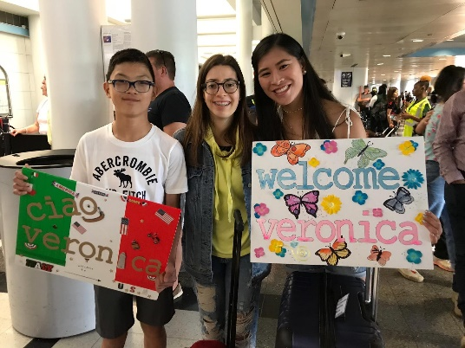
INTERESTED? APPLY! HOW?
Complete a preliminary application at no cost. Turn it into your local Rotary Club Youth Exchange Officer (YEO) based on their deadline (usually September-November). The Rotary representatives will interview you and your family in your home to provide you the next steps of the application process.

CONTACT us at: RYE.Chair@rotary6440.org

CLUB CONTACT:
COVID-19 IMPACT: The health and safety of everyone involved in the Rotary Youth Exchange program is important to us. Rotary is monitoring the Covid-19 situation globally. The exchange program timing and options might be adjusted or be canceled if we do not feel confident or comfortable with the situation.

