OPEN THE DOOR
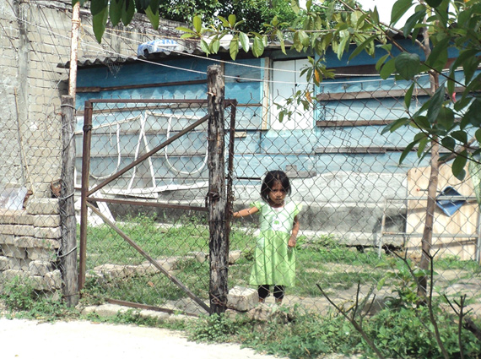
The U2 sector is the poorest of Huatulco. Here there are several schools, but most of them hardly have classrooms and none has a library. Many schools lack desks, books and basic school supplies. There are no books in people’s homes. To help the children have access to books, the Huatulco Rotary club, in conjunction with the Deerfield Rotary Club, plan to create a learning center.
Generations of families have supported themselves by long days and nights of selling hand-made goods and trinkets to tourists. Unable to communicate in English, these natives rely on bargaining to eke out their living. Most make less than $10.00 per day.
In March 2013, the City Council of Santa María Huatulco, represented by the Municipal President Lorenzo Lavariega Arista donated 1175 square meters of land located in the populous U2 Sector in Huatulco, to the Rotary Club of Bahias de Huatulco AC for the construction of the Learning Center.

Title of Project: Open the Door: Huatulco Learning & Cultural Center
Area Of Focus: Learning and literacy in local population
Total project Budget: $300,000 total $100,000 for furnishings, books, computers and equipment
Needs Assessment: Most students do not advance beyond the 6th grade, thus limiting their career choices because of a lack of fluency and literacy in English. Accessibility to higher paying jobs is dependent on their ability to communicate in English.
Main Aspects of Project: To assemble books and other materials to facilitate learning and literacy to aid students to stay in school.
Who will benefit: The population of Huatulco is approximately 40,000. Of a total student enrollment of approximately 10,000, only about 900 will attend high school. Our goal is to greatly increase the number of students who will attend high school.
Sustainability: The municipal government has donated the land for the learning center, & the Rotary Club of Huatulco holds the title officially at this time. This was done while the last president (mayor) was in office. The current president has assured the club of his government's support in providing funding that will pay for maintenance, utilities, & salaries of the employees. This contract is currently being drawn up. The Club Rotario de las Bahias de Huatulco has a bank account specified for this project. At this time only $100,000 pesos has been put aside (approximately $8000 U.S.) towards the library.

Overall outcome and impact:

GENERAL
1 -. Promote reading habits in people of all ages.
2 -. Encourage formal education for the residents of the municipality.
3 -. Enrich local culture

SPECIFIC
1. - Encourage reading and research in school-age children
2. - Provide adequate space for study and reading
3. - Offer a collection of books, CDs and movies to promote literary quality in these areas of Mexico.
4.- Develop and offer courses and writing workshops to various groups.
5.- Provide reading workshops in several languages ​​to preschoolers and school-age children.

International Club name: Rotary Club of Deerfield Club 3115 District 6440
Point of Contact name: Peter Fitzgerald Phone 224-300-3409 email: fitzcubs@gmail.com
Host Club name: Rotary Club of Bahias de Huatulco AC
Host District: 4195 Host Country: Mexico

