PEACE: WHAT YOU CAN DO
September 23, 2016
One Rotary Center
Program Speakers

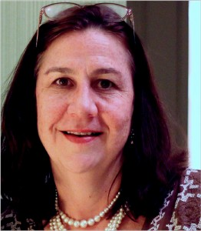
Peace Here

Susan Trieschmann
Executive Director
Curt’s Café
Restorative Justice Specialist

Susan Trieschmann has worked in Food Service since the age of 13. She was the Director of Catering at the legendary Pump Room before becoming an original owner and 25-year partner of Food For Thought Enterprise. She helped to build the company from a small catering company to a food service industry leader specializing in upscale catering and café food service management.

Susan is also an original member of Restorative Justice Evanston (RJE.) The Evanston non-profit organization works with youth and community on peaceful dialogue around harm caused, celebrations, and conflicts.

A longtime Evanston resident, Susan has been married to Tom Trieschmann for 26 years and has two children, Trevor and Anna, both graduates of Evanston Township High School (ETHS.) She is passionate about giving youth a second chance and helping them to create a positive future for themselves and their families.

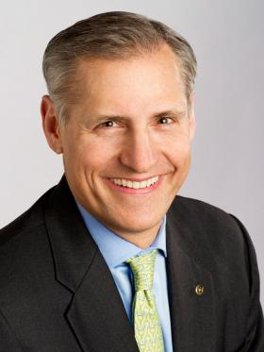
Peace There

John Hewko
General Secretary
Rotary International

John Hewko is the general secretary of Rotary International and The Rotary Foundation. Before joining Rotary in 2011, he was vice president of operations and compact development at the Millennium Challenge Corporation (MCC), a U.S. government agency established in 2004 to deliver foreign assistance in a new and innovative manner.

An attorney, John was an international partner with the law firm Baker & McKenzie (B&M), specializing in international corporate transactions in emerging markets and resident in the firm’s Moscow, Kyiv and Prague offices. While working in Ukraine in the early 1990s, Hewko assisted the working group that prepared the initial draft of the new Ukrainian post-Soviet constitution.

Hewko holds a law degree from Harvard University, a master’s in modern history from Oxford University (where he studied as a Marshall Scholar), and a bachelor’s in government and Soviet studies from Hamilton College in New York. John is a trustee of the Ukrainian Catholic University in Lviv, Ukraine. He and his wife, Margarita, live in Evanston.

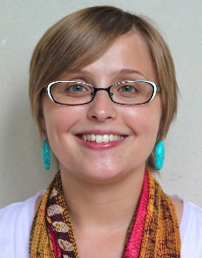
Peace Here and There

Nissa Rhee
Award-winning Journalist
Rotary Peace Fellow

Nissa Rhee is a journalist who has spent the last ten years covering peace and conflict issues in the United States and Asia. She got her start in journalism at Chicago Public Radio, where she was a producer and director for the international news magazine, Worldview. She then worked as a foreign correspondent in Seoul, South Korea and Hanoi, Vietnam. Her time in Vietnam resulted her creation of the Return to Vietnam project, which tells the stories of American veterans who have gone back to Vietnam.

Nissa now lives in Chicago and works as a freelance reporter. Her writing can be found regularly in The Christian Science Monitor, the Chicago Reader and Chicago Magazine. In 2016, she was named both a John Jay College Juvenile Justice Reporting Fellow and a City Bureau Reporting Fellow for her coverage of criminal justice issues.

Nissa was a Rotary Peace Fellowship at the University of Queensland in Brisbane, Australia between 2011 and 2013. Nissa received her BA from the University of Chicago with a focus in Human Rights, International Relations and Creative Writing. She earned her MA in International Studies (Peace and Conflict Resolution) at the University of Queensland in 2013.

