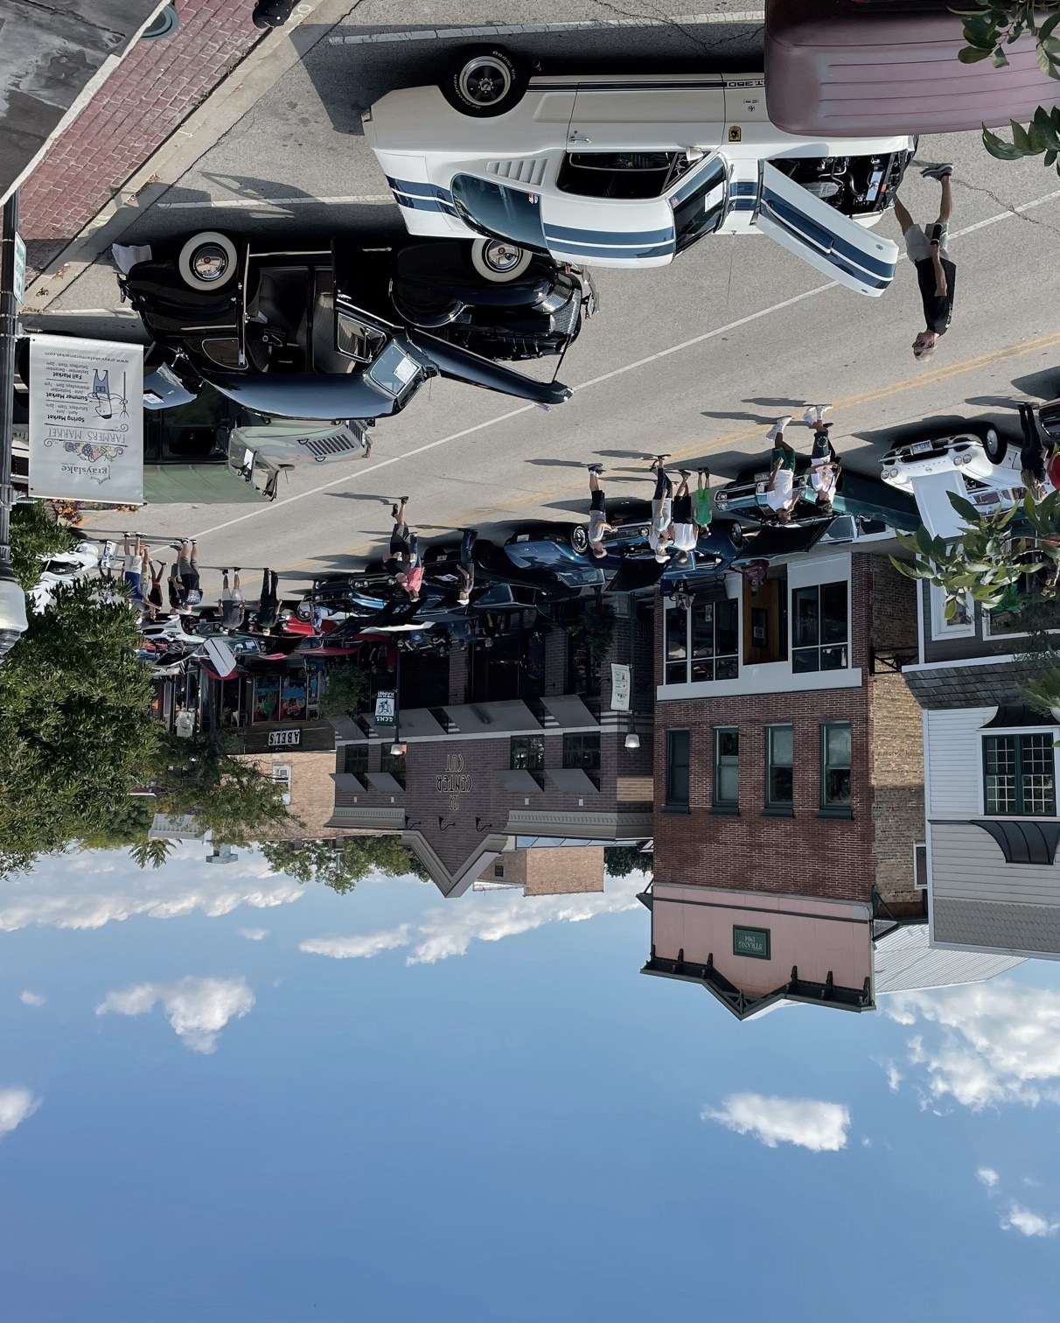
2nd Annual

Cruisin’ on Center

A: Modern Cars (2000 +)
B: 80’s & 90’s
C: 60’s & 70’s Stock
D: 60’s & 70’s Custom
E: 50’s Stock
F: 50’s Custom
G: 30’s & 40’s Stock
H: 30’s & 40’s Custom
I: 1929 & Older
J: Trucks – 1975 & Newer
K: Trucks – 1974 & Older
L: Low Riders
M: Motorcycles
N: Imports & Tuners
O: Supercars
P: Jeeps & 4x4’s

50 TROPHYS
16 CLASSES
Grayslake Car Show
Downtown Grayslake
Live Bands

Raffles

Dash Plaques
(first 100 registered)

201 Center St, Grayslake, Illinois
Saturday September 9, 2023 (9 am-2 pm)
Rain Date: September 23, 2023
Pre-registration (by 8/30) $20
Day of event registration (8 am-11 am) $25

Pre-register by mail or online at :
grayslake-rotary-club.ticketleap.com/cruisin-on-center-2023/
Proceeds Benefit High School & CLC scholarships, local food banks,
disaster relief, and Shop with a Cop
Event Hosted by: Rotary Club of Grayslake, and Grayslake Fraternal Order of Police Lodge 299
Event Sponsored By:

Please print this form, fill it out completely, and mail a check, money order, or cashier’s check
payable to: The Grayslake Rotary Foundation, for $20.00 (must be postmarked by August 30, 2023)
to The Grayslake Rotary Foundation (501C3 Charity), Attn: Car Show Committee
P.O. Box 886, Grayslake, IL 60030.
any questions call Eric at 224-588-2217

____________________________________________________________________________
Full Name
____________________________________________________________________________
Address
_____________________________________________________________________________
City, State, zip
_____________________________________________________________________________
E-Mail Address and Phone Number
_______________________________________________________________________________
Make, Model, Year

Please "XX" the Class in which you would like your vehicle registered in (one class per vehicle):
_____ A: Modern Car (2000 & up) _____ I: 1929 & Older – All Vehicles
_____ B: 80’s & 90’s (all vehicles) _____ J: Trucks – 1975 & Newer
_____ C: 60’s & 70’s – Stock _____ K: Trucks – 1974 & Older
_____ D: 60’s & 70’s – Modified/Custom _____ L: Low Riders – All Vehicles
_____ E: 50’s - Stock _____ M: Motorcycles
_____ F: 50’s – Modified/Custom _____ N: Imports & Tuners
_____ G: 30’s & 40’s - Stock _____ O: Exotics & Supercars
_____ H: 30’s & 40’s – Modified/Custom _____ P: Jeeps & 4x4’s

