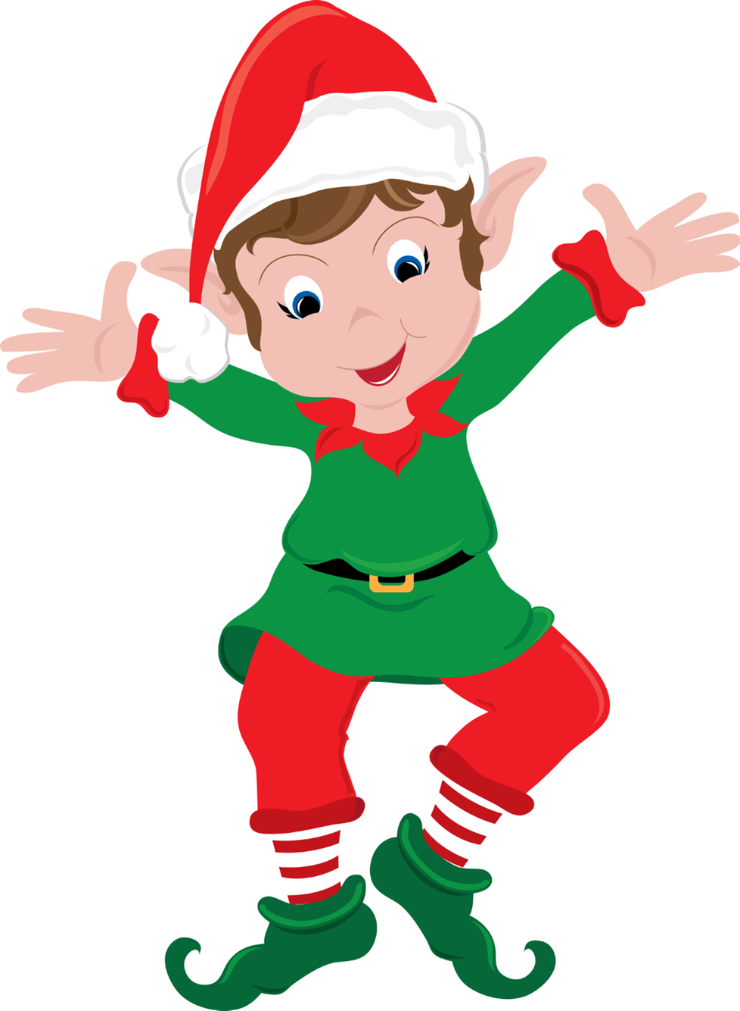
Save the Date

Running of the Elves
Huntley square
December 7, 2024
5K Run
1 mile walk
Dash for kids 5-12

