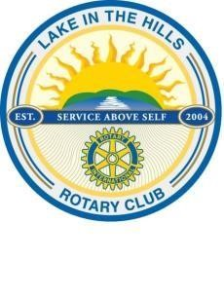
Rotary Club of Lake in the Hills, IL

District 6440

Board Meeting Minutes
July 2, 2016

- Meeting called to order at approximately 7:05 pm.

- Members present – Dot Dustin, Colleen Wales, Bill Dustin, Yvonne Cornett, Jack Bechaud & Jim Wales.

- Discussion was held regarding Ribfest items that were destroyed in the Dustin house fire. Avenues were identified to address the various areas. Areas covered were checks, information on artisans and vendors, parking passes, drink and entry tickets and food tickets,

- Colleen Wales made a motion to donate $2,000 from the disaster fund allocation under the Community Service budget to Dot and Bill Dustin due to the loss they incurred with the house fire. Motion was seconded by Jack Bechaud Motion passed unanimously. Dot and Bill Dustin were not included in the discussion and vote on this motion.

- Discussion was held on the membership application of Lindsay Herrera. Jack Bechaud made a motion to approve the membership application, seconded by Bill Dustin. Motion passed unanimously.

- General discussion on the award of the Tom Stock Memorial Scholarship. Winner has been identified and efforts would be initiated to have the Stock family on hand Friday night at Ribfest to assist in presenting the scholarship.

- With there being no further business, meeting was adjourned at 10:16 pm.

