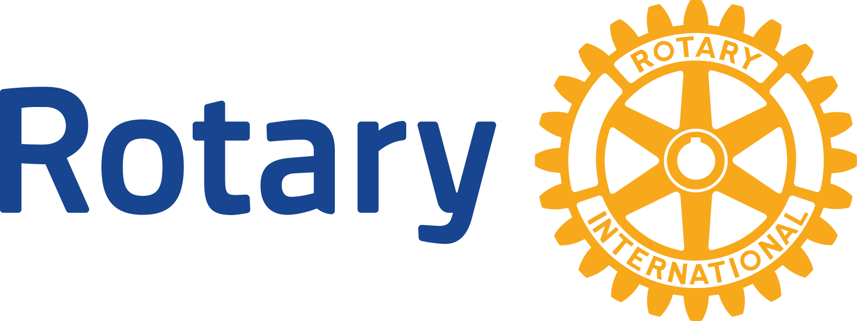
ROTARY CLUB OF LAKE IN THE HILLS

MAJOR DIFFERENCE MAKER AWARD APPLICATION

INSTRUCTIONS:
1) Use Grant Application form only.
2) Submit Grant Application by e-mail to lithrotarygrants@gmail.com
3) Submission deadline: April 28th, 2023 at 5:00 pm

Name of Organization: _________________________________________________________________________
Street: ______________________________________ City/State/Zip: ___________________________________
Phone: _______________________ Ext. __________ Web Site:_______________________________________
Contact Person/Title: __________________________ E-mail Address:_________________________________

Tell us about your mission and who is served by your organization:

Tax Status: 501(c)(3) Yes__ No__ If yes, attach copy of IRS determination letter
Has your organization received support from the Rotary Club of Lake in the Hills in the past? Yes __ No __
If yes, when? ________________

Are any Rotary Club of Lake in the Hills members affiliated with your organization or receiving payment from your organizations? Yes__ No__ If yes, please specify name(s):

Does your organization receive:
Support from a municipality/McHenry County? Yes __ No __
Funding from other foundations or service clubs? Yes __ No __

Organization Annual Budget: __________________________ Year Founded: ______________________:

Lake in the Hills Rotarians actively involved in your organization, if any: ____________________________

Please attach a list of your current board members and key staff.

PROPOSAL TO THE ROTARY CLUB OF LAKE IN THE HILLS

Project Title: _________________________________________________________________________
Grant Amount Requested: __________________ Total Project Budget: ________________________
Sources of previously secured funds: ____________________________________________________
Funds Secured from Other Sources: _____________________________________________________
Other sources of funding you are seeking, if any:

Project Goal: What do you expect your project to accomplish?

Need: How will your project address an area(s) of need in the LITH or McHenry County community?

Project Details: Who will do it, how, and timeline to complete the project?

Project Budget: List categories of expenses and amounts. If the amount requested is less than the total project budget, explain how remaining funds will be secured and whether the project can be completed without full budget.

Project Outcome/Evaluation: How will you measure the success of the project?

Publicity: Describe how you will publicize receipt of this grant in the community and on any physical items purchased as part of this grant. (The Rotary Wheel and "Gift from the Rotary Club of Lake in the Hills" signage is a required budget item for physical items purchased)

If you have any questions, please contact Becky Welter at lithrotarygrants@gmail.com
All documents are also available at www.lithrotary.org.

