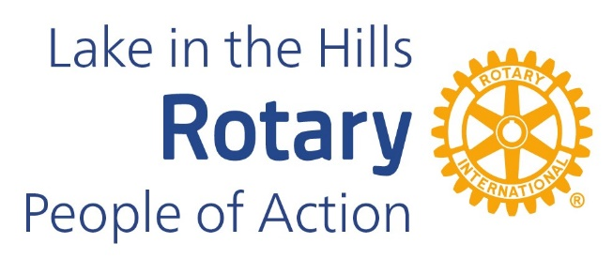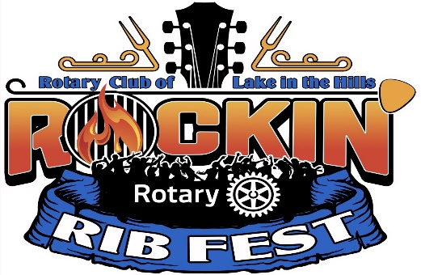
Rockin’ Rotary Ribfest 2025
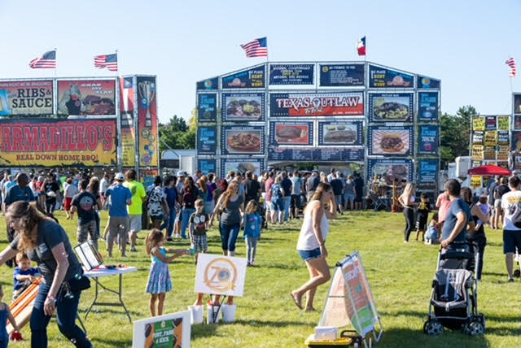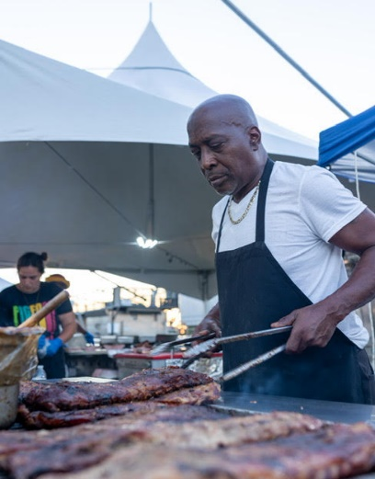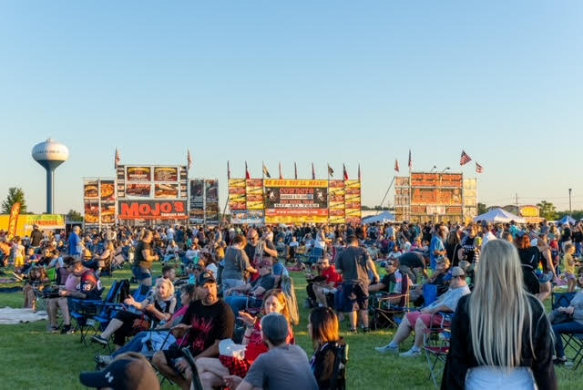

This popular food & music event features world-class BBQ vendors from across the nation offering the tastiest ribs, brisket, and more along with the best rock music entertainment of the season over 4 nights in July! This years line-up includes Bruce in the USA on Saturday night, July 12th. Rockin’ Rotary Ribfest takes place at Sunset Park in Lake in the Hills on July 10-13.
Hosted by the Rotary Club of Lake in the Hills, proceeds from this event directly benefit our community. Past donations have gone to PADS, Interact, high school scholarships, LITH Veterans Memorial as well as grants for local non-profit organizations. Your partnership with Ribfest connects you with our community and you can feel great about knowing you are helping others while doing it.
Sponsorships range from $250 - $25,000 to offer a level of support to fit any budget. Please join us!
Attached is a rate card that highlights these different sponsorship levels. If you have additional questions, please feel free to contact me. I look forward to speaking with you in more detail and look forward to your support.
Sincerely,
Wade Merritt
Rotary Club of Lake in the Hills
847-561-7179 or email wade.merritt10@gmail.com.com

