Lake Zurich Rotary meeting
June 7, 2021 - 6:30 p.m.

Attending: Petra Croneigh, John Croneigh, Nancy Shepherdson, Suzanne Martinez, Subbarao Mandavilli,
Joe Janicki, Ted Huelsman, Kera Radke, Appaji Valavala, Larry Ginsburg, Dale Perrin, AG Mark Gibson, Jorie Schaeffer

The meeting began with the initiation of Jorie Schaeffer and Joe Janicki as new members. Welcome Jorie and Joe!

George Young and Appaji Valavala want to join at our meeting on June 26. Watch for more information.

Sign up for shifts at the Farmers Market. Use the link for the signup genius sent with the last bulletin. We need to know that there will be coverage!

We will announce soon the volunteer component for our children’s activity hut to be built at Kueschmann Kove. Our grant from Rotary for this requires a hands-on component. Petra will keep us posted.

Nancy Shepherdson gave a PowerPoint presentation about the highlights of our club. It will be sent to members and good prospective members soon.

Petra gave a Moment of Inspiration at the end of the meeting.
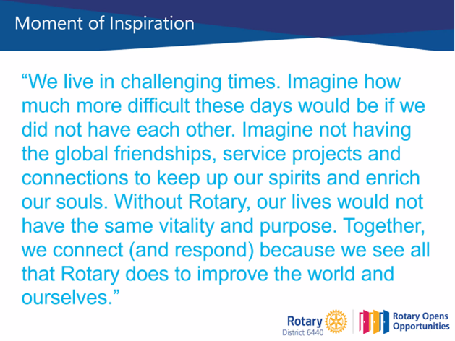

Election of Officers:
President: Suzanne “Sam” Martinez
President-elect: Subbarao Mandavilli
Treasurer: Dale Perrin
Secretary: Barbara Barker
Co-secretary: Nancy Shepherdson
Chairman Satellite Club - Petra Croneigh
Officers will be sworn in at Sam’s installation on July 24 at Mike Rein’s home in Cary, but will begin their terms officially on July 1.

Our next meeting will be June 26 at Turner Camp in Algonquin. It will be a relaxing day with family and friends. Details coming by email soon.

Respectfully submitted,

Nancy Shepherdson
Assistant Secretary

