Information for donations to be made in honor of James H. Runnfeldt, Sr.
Tax-deductible donations can be made to either The Rotary Foundation, or to the Rotary Club of Long Grove, IL Charitable Foundation. Receipts will be issued for donations over $25.

DONATIONS TO THE ROTARY FOUNDATION
Donors can either complete and submit the attached form, or donate online at www.rotary.org/give.
The Rotary Foundation Memorial or Tribute Gift Form is prepopulated to aid completion, and with designation to the Annual Fund –SHARE, per Jim’s wish.
Contributions to the Annual Fund help Rotary strengthen peace efforts, provide clean water and sanitation, support education, grow local economies, save mothers and children, and fight disease, both at home and around the world.
For online donations (which can be charged to a credit card):
- In Step 1, choose Annual Fund – SHARE
- In Step 3, select Gift Options to enter memorial/tribune information. Use this notification address:
Kelly Zima
2845 Canterbury Drive
Northbrook, IL 60062

DONATIONS TO THE ROTARY CLUB OF LONG GROVE, IL CHARITABLE FOUNDATION
Donors can complete and submit the attached form accompanied by a check. Please contact the Club at longgroverotaryinfo@gmail.com should you prefer to use a credit card.
Donations to the Club’s Charitable Foundation will be earmarked for qualified projects about which Jim was passionate, including but not limited to student exchange, vocational training, hunger, and children’s welfare.

Thank you for joining the many donating in recognition and appreciation of the example, leadership, and selflessness exhibited by Jim over many years, both inside and outside of Rotary. He exemplified “Service Above Self”, and we’re all better for knowing him.
For more information on donations in honor of Jim, contact Lyle Staab at ltstaab@kanrish.net or 845-671-1223.

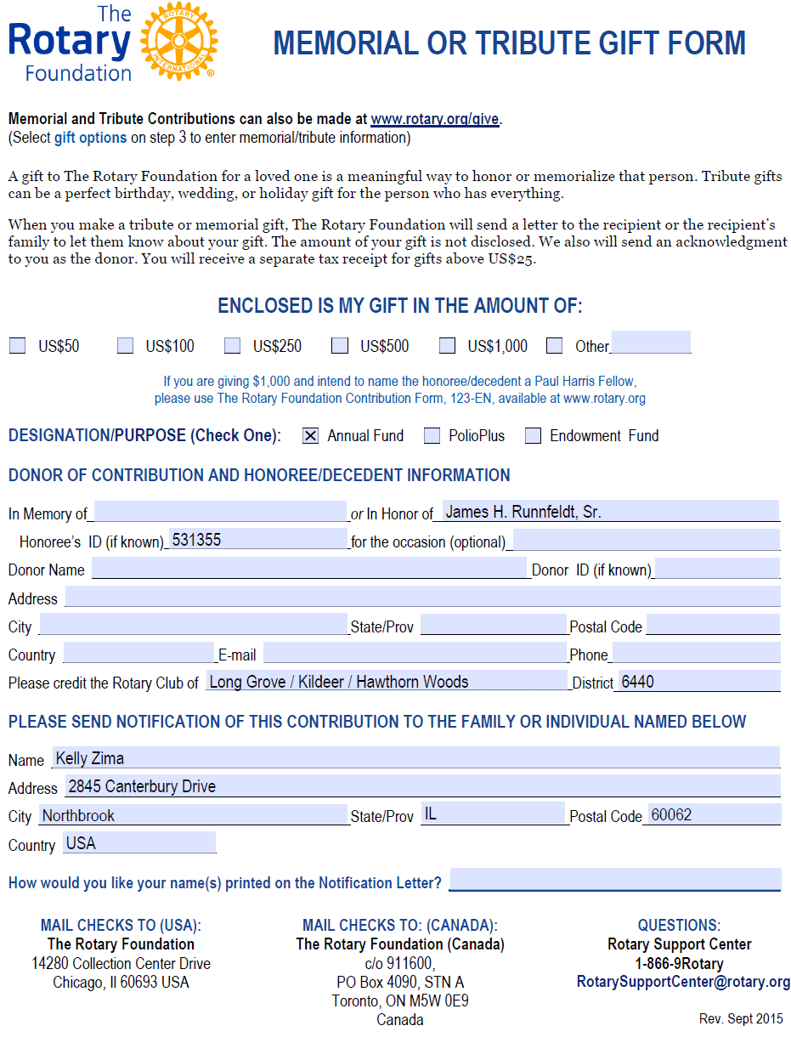

THE ROTARY CLUB OF LONG GROVE, ILLINOIS CHARITABLE FOUNDATION
CONTRIBUTION FORM
1. DONOR OF CONTRIBUTION
Type of Donor (Check one) ☐Individual ☐Rotary Club ☐Rotaract / Interact Club ☐District ☐Business
☐Charitable organization / Foundation ☐Other _______________________
Name: ____________________________ Donor ID: _____________________ ___
Club Name: ____________________________ Club No: _________________ District No: ____________ ___
Address: ___________________________ _ ______ City: ____ ____ ___ _________
State/Province: ________ _ Country: ______________________ Postal Code: _____ ________
Daytime Phone: _______________________ Email Address: _____________________________________ ____
2. (IF APPLICABLE) DONATION IN MEMORY OR IN HONOR OF
Honoree: ___Janes H. Runnfeldt, Sr. _____ Honoree ID: __531355___________
SEND NOTIFICATION OF THIS CONTRIBUTION TO Name: ____Kelly Zima____________________________
Address: __2845 Canterbury Drive_________ _ ______ City: __Northbrook_ __________
State/Province: __IL___ _ Country: ___USA________________ Postal Code: __60062 ________
HOW SHOULD YOUR NAME(S) BE PRINTED ON THE NOTIFICATION? _________________________________
3. DESIGNATION/PURPOSE (Check one):
☐General charitable programs of the Club
☐Specific charitable program of the Club (specify program) ___________________________ __
☒As Club believes Honoree would have wished
☐Rotary International Foundation General Fund ☐PolioPlus Fund ☐Other ____________________________
3. CONTRIBUTION DETAILS
Amount of contribution: ____________ ___ Check number: _________
Please make check payable to “The Rotary Club of Long Grove, Illinois Charitable Foundation.”
We can accept credit card contributions. Contact us for longgroverotaryinfo@gmail.com for details.
5. INDIVIDUAL COMPLETING THIS FORM (if other than donor)
Name: ____________________________ Daytime Phone ________________ __ _
Email Address: _____________________________________ ____ Date: _________________
Please send your completed form with contribution to:
The Rotary Club of Long Grove, Kildeer, and Hawthorn Woods
P.O. Box 111
Long Grove, IL 60047

A receipt will be issued for all donations.

