
THE ROTARY CLUB OF SCHAUMBURG/HOFFMAN ESTATES CHARITABLE FOUNDATION
P.O. Box 68774, Schaumburg, IL 60168
Dear Community Organization:
Each year the Rotary Club of Schaumburg/Hoffman Estates Charitable Foundation provides grants to strengthen our network of support, addressing basic needs, empowering those in need towards our ultimate goal: Eradicate Community Poverty. The Rotary Club of Schaumburg-Hoffman Estates has worked hard to raise funds through year-long fundraising efforts. Now we would like to award community grants to not-for-profit organizations which are either located within or serve the citizens of Schaumburg and/or Hoffman Estates, Illinois.

FUNDING GUIDELINES:
The Rotary Club Schaumburg-Hoffman Estates Charitable Foundation raises funds to further the goals of Rotary International and of our Local Club which is to Eradicate Community Poverty. This year we would like to provide funding in three specific areas:
LITERACY FOR ALL AGES (e.g. materials, classes, instruction for learning to read and comprehension) NEEDS FOR CHILDREN (e.g. food, clothing, education, social / emotional / cognitive development) ENRICHMENT FOR THOSE WITH SPECIAL NEEDS (e.g. job training, equipment providing independence)
PLEASE NOTE:
- The following do NOT qualify for funding:
  - Contributions to scholarship funds for mainstream education.
  - Staff salaries / benefits unless specifically tied to a designated project
  - General fund
- Grants will range from $1,000 to $7,500 so please develop your request accordingly.
- Any organizations that propose a creative collaboration with another organization to leverage Rotary’s contribution to the project may be given special consideration.

We look forward to receiving your application. Applications must be received via postal mail or email by March 20, 2026. Notifications of grant awards will be made by May 8, 2026. Please mail all applications to: Roger Smith 2026 Project Selection Chair, The Charitable Foundation for the Rotary Club of Schaumburg-Hoffman Estates, P.O. Box 68774, Schaumburg, IL 60168. You may also email completed applications and supporting documents or questions to Roger Smith at ProjectSelection@scherotary.org or 847-995-0696.
Sincerely, 2026 Project Selection Chair


CHARITABLE FOUNDATION
2026 Application for Project Funding
PLEASE READ & COMPLETE THE ENTIRE APPLICATION PACKET PRIOR TO SUBMITTING.
The Charitable Foundation for the Rotary Club of Schaumburg-Hoffman Estates will award grants up
to $7,500 for local nonprofit organizations. Please note in some cases partial funding of a request may be granted. ATTACH A COPY OF YOUR ORGANIZATION’S FEDERAL 501(c)(3) DESIGNATION LETTER to your Application.

A. ORGANIZATION OVERVIEW: Date: ______________
Contact Name: ________________________________________________________________ Email address: ____________________________________________________________________
Organization Name: _______________________________________________________________

Organization Mailing Address: _______________________________________________________________________________

Phone: ____________________________ Website:
Mission of the organization: You may attach brochures or existing paperwork with this information listed. Indicate which pages are attached for the committee to review.
________________________________________________________________________________
________________________________________________________________________________
Geographic reach of your services: Please complete the participant table information below with the approximate or actual number of Schaumburg/Hoffman Estates residents served and their age ranges, i.e.: child / adolescent / young adult / adult / senior
 | Most Recent Year | Prior Year | Two Years Ago
Total Participants
Schaumburg/ Hoffman Estates
Other Communities

FINANCIAL INFORMATION
Year Established: ______________________ Annual Budget: _____________________________
Annual Income: State / Federal Government Funding: _____________________________________
Annual Income: Private Contributions: _________________________________________________
Number of professional staff responsible for fundraising: ___________________________________
Has your organization received any grants or special project funding from the Rotary Club of Schaumburg/Hoffman Estates Charitable Foundation during the past 5 (five) years? If so, please list dates, amount, specific use & impact relative to the people your organization serves? (may use additional pages)
________________________________________________________________________________
________________________________________________________________________________
________________________________________________________________________________
________________________________________________________________________________

Has your organization provided hands on service involvement/ opportunities to the members of the Rotary Club of Schaumburg/ Hoffman Estates in the past 5 (five) years? If so, please list dates, type of service opportunity & impact to the people your organization serves? (may use additional pages)
________________________________________________________________________________
________________________________________________________________________________
________________________________________________________________________________
________________________________________________________________________________
________________________________________________________________________________
Does your organization have an assigned liaison* from the Rotary Club of Schaumburg/ Hoffman Estates? If so, please provide the name of the Rotarian and the name of the person / people they most closely work with in your organization.
________________________________________________________________________________
________________________________________________________________________________
*If your organization does not yet have an assigned liaison person from the Rotary Club of Schaumburg / Hoffman Estates, you may be assigned one if awarded this grant. Ongoing collaboration with an assigned liaison is preferred. Please contact us for a liaison.

PROPOSED PROJECT FOR FUNDING
E) PROJECT TITLE:
________________________________________________________________________________ ________________________________________________________________________________
Brief Description – may use additional pages
________________________________________________________________________________
________________________________________________________________________________ ________________________________________________________________________________
________________________________________________________________________________
________________________________________________________________________________
Full Project Cost and Budget (DETAIL Please detail line items you need for the Committee to review if a full project request amount is unavailable):
________________________________________________________________________________
REQUESTED GRANT AMOUNT: ($1,000 to 7,500)_______________________________________
Describe project, purpose of requested funds, and impact our funding can make. You may use additional typed pages with supporting documentation in lieu of printing information here. Indicate which pages are attached for the committee to review.
________________________________________________________________________________
________________________________________________________________________________ ________________________________________________________________________________
________________________________________________________________________________
________________________________________________________________________________
ARE YOU SEEKING OTHER FUNDING FOR THIS PROJET? YES or NO (circle one)
a) If YES, Full or Partial funding (circle one)
b) If YES, please describe sources of other possible funding
________________________________________________________________________________
________________________________________________________________________________
________________________________________________________________________________ ________________________________________________________________________________

G) If you are awarded a grant, would you be able to provide the following:
- Offer a “Hands On” Community Service Project in which 8-10 members of our club could provide 2-3 hours of their time and talent volunteering to help those you serve? Please describe briefly:
________________________________________________________________________________
________________________________________________________________________________
________________________________________________________________________________ ________________________________________________________________________________

- Publicize the Rotary Grant award within your organization’s newsletter, website or donor recognition piece& send press releases to local media outlets? Also, provide the publicity pieces to the Rotary Club of Schaumburg / Hoffman Estates for distribution to our members. Please describe briefly:
________________________________________________________________________________
________________________________________________________________________________
________________________________________________________________________________
________________________________________________________________________________
________________________________________________________________________________
- Send a representative of your organization to provide a project funding status and update presentation to our club after being awarded? Lunch meetings are held every Friday in Schaumburg at Chandler’s Schaumburg Golf Course on Roselle Road. Date T.B.D.

YES or NO
Thank you for your continued commitment to strengthening the community with your organization’s mission. A member of our committee will be in touch with you soon.
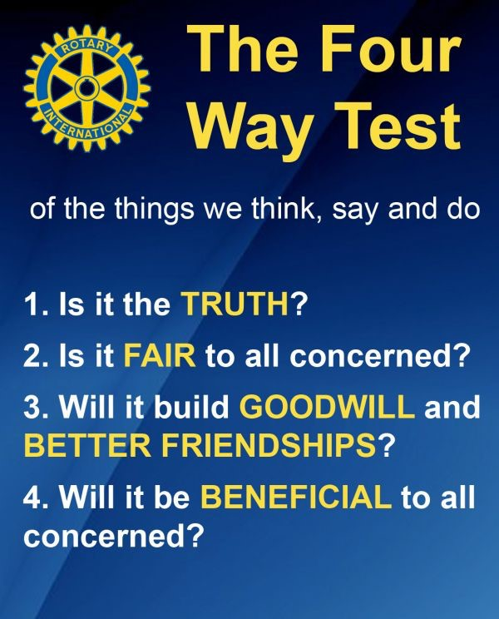
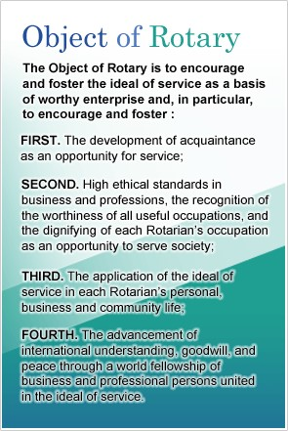
Eradicate Community Poverty

CHARITABLE FOUNDATION
2026 TIMELINE for PROJECT FUNDING
February 20, 2026 | Applications are made available to area organizations and is published on the Rotary Club website available for download.
March 20, 2026 | Deadline for Submitting Application.
April 3, 2026 | Project Selection Committee review of all applications
April 17, 2026 | Project Selection Committee will present recommendations to the Membership of The Rotary Club of Schaumburg / Hoffman Estates Charitable Foundation. Awards will be agreed upon through voting.
May 8, 2026 | Notifications of Award or Rejection will be sent to applicants.
June 5, 2026 | Awards Luncheon. A representative for an award recipient organization will be expected to attend the awards luncheon (12:00 to 1:30 pm) at Chandler’s Chophouse to receive the Project Selection Grant and briefly explain their project to our members.
It will be the responsibility of the organization to present an update to the club for the approved project prior to June 30, 2026. To schedule a date, contact the club president.
*All decisions of the Project Selection Committee & Rotary Club Members vote will be final.
To learn more about the Rotary Club of Schaumburg/Hoffman Estates visit our website www.scherotary.org

