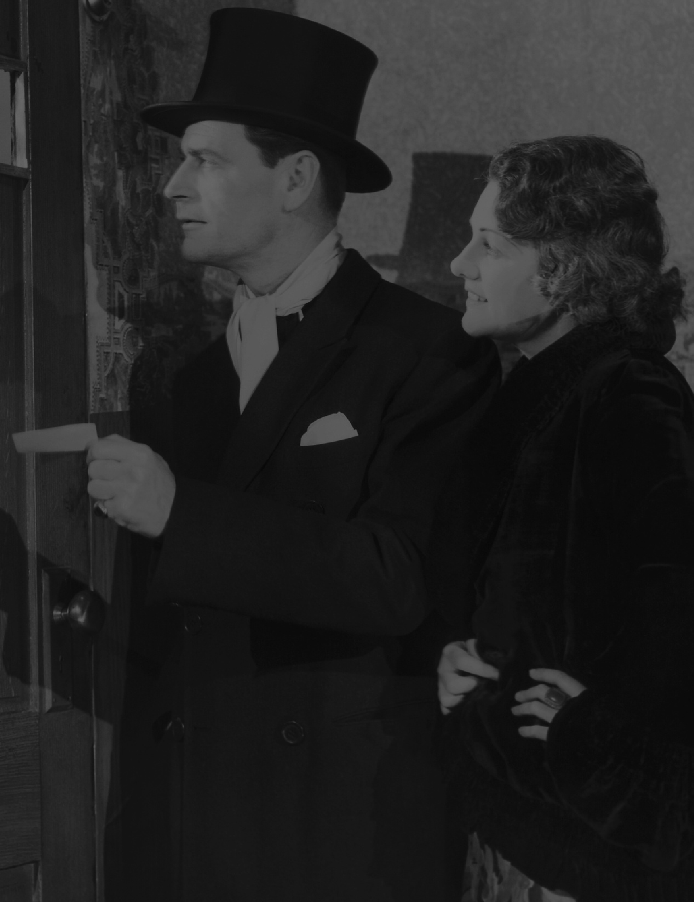

ROARING
TWEfundNraisTerIES
DETAILS
The Rotary Club of Wheeling is a 501c 3 non-profit organization. Proceeds from the event go to Rotary Club focus areas: Humanitarian efforts towards fighting disease, providing clean water, supporting education, protecting the environment and disaster response by supporting local & international charities to help those less fortunate.
- DINNER: $100 per person- includes one of four entree options: spaghetti with meatballs, chicken piccata, chicken parmesan, or an appetizing vegan salad. sides include, salad, soup, dessert, and non-alcohol drinks included (Alcohol drinks for purchase)
Jim
2023-11-16 19:16:39
--------------------------------------------

- SILENT AUCTION: Many items to choose from!
- CASH RAFFLE: $100 Ticket- 50% of Raffle Profits or $5,000 Maximum
- ENTERTAINMENT: Professional Improv Group. Guaranteeing continual "giggles" from the audience at show time.
- COSTUMES CONTEST- BEST DRESSED ROARING TWENTIES optional; business casual attire is welcome.
QUESTIONS- LEAVE A MESSAGE: 847 777-1301 for a return call.
Tickets can be purchased on Internet- Copy & Paste on Browser-link below:
Raffle Ticket: https://square.link/u/YXldX9y6
Dinner Ticket: https://square.link/u/4DoXISPU

