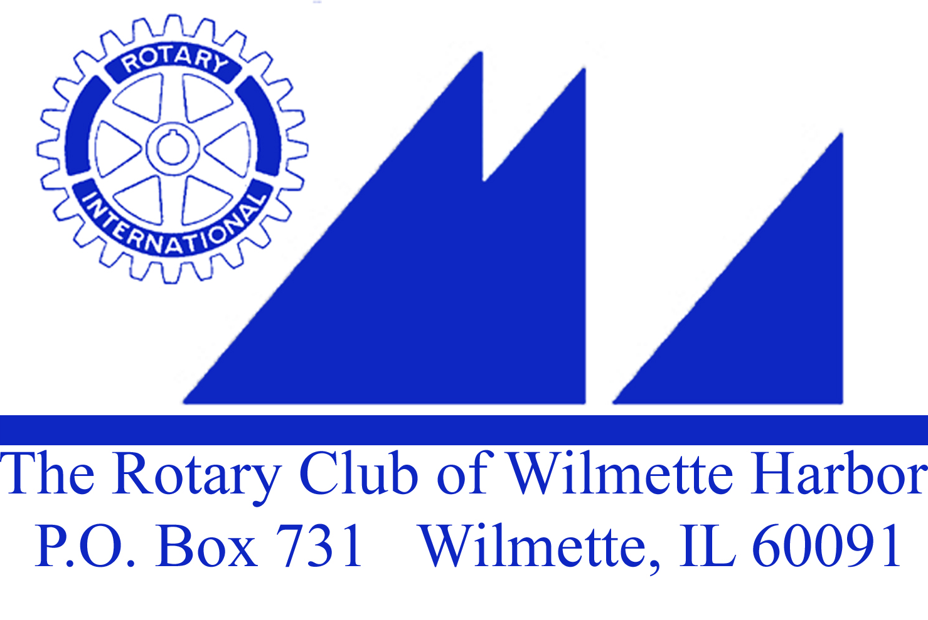

Wednesday, January 13, 2016
Call to order
Thought & Pledge

A Special Thank you:
Set Up – Gil (John Gilbert)
Treasurer – John Bowman
Attendance – Tom Ryan
Greeter – Sarah Oliver
Thought & Pledge – Sue Segal
Rotarian Bio. – Michael Donnelly
Scribe – Puran Stevens
Music – John Ray

Duty Roster next week – January 20
Greeter: Heidi Voorhees
Thought & Pledge: Margaret Wein
Attendance: Sue Watson
Scribe: John Wertymer
Bio: Ellen Falkof

Visiting Rotarians or Guests? Jean Saunders, works at Rotary International; Angela Moy our speaker today

Birthdays – Gil on 1/9
Club Anniversaries – Bob Meeder 25 yrs – 1/1/16 Linda Yonke 4 yrs – 1/10/16
Wedding Anniversary - Sarah & Wally Oliver 45 years on 1/2/16
Paul Harris Presentation – PE, Sue Watson – PH +4

Announcements:
A moment of silence for the 4 young men who tragically lost their lives early on Sunday, 1/3/16

Board Meeting will be 1/22/16 NOT 1/15/16 held at Michigan Shores. (7:15 – 8:30)

Received from Greg Michel on Monday - Invasive GI procedure this afternoon, maybe surgery in the future Beth DeWall has very generously offered to take over Greg’s duties and keep our newsletter going. Beth also has done a fantastic job this year creating our Duty Roster & Keeping our website up to date.

Update on our Holiday Fundraiser – Heidi
Upcoming Community Service Projects: Herb
2/1 – Soup Kitchen
3/12 – Kids Against Hunger Food Packing – normally the cost is $25/person to volunteer, but if we sign up before 2/14 we can save $5/person. First shift starts at 8:30AM and last shift ends at 4:00PM

RYLA : Rotary Youth Leadership Awards –
Applications are due by this Friday, 1/15/15 so I have the opportunity to bring 3 candidates before our board on Friday, 1/22/16 and get our selection to Sean Nelson who Is the RYLA Chairperson for District 6440. We have budgeted for 3 students. Session I is March 10-13th and Session II is April 7-10th 2016.

WINTER TRAINING Registration Now On Line! – Saturday, February 6 is the date! Harper College is the location. There will be “3” sessions that members need to register for.

GRANTS MANAGEMENT – Looking for 2 members from our club to attend this year’s mandatory GMS. This one will be taped for review in the future. The GMS mandatory rule is being looked at for change, should this year’s taping be successful.

MEMBERSHIP – Looking for 2 members from our club to attend. This session brings together our successes and attempts to assist you in building a membership you can continue to grow with.

2016-17 AG/LEADERSHIP TRAINING – Mandatory for all 2016-17 District Officers, Assistant Governors, Committee Chairs and those thinking about stepping up to a District Position next Rotary year. Want in? Contact DGE Rick atmailto:Gov.Rick@Rotary6440.orgGov.Rick@Rotary6440.org.
register at. www.Rotary6440.org. There is no charge for this event!

Our District Conference, District Assembly and District Youth Conference will be April 28 – May 1. So please mark your calendars.

Wilmette Public Library’s One Book Program Features Richard Russo’s Pair of “Fools” (Barbara Goodman – Adult Services Librarian)

The Wilmette Public Library invites community members to double their reading pleasure this year as its annual One Book, Everybody Reads program features two novels published 23 years apart by Pulitzer Prize-winning author Richard Russo.

Readers are encouraged to first meet the characters in Mr. Russo's 1993 novel Nobody’s Fool and then revisit them in Everybody’s Fool, the author's new novel that will be published just 11 days before he visits Wilmette. The best-selling author will discuss both books on May 14 at 2 p.m. at the Wilmette Jr. High School, 620 Locust Road, Wilmette.

One Book, Everybody Reads is the Library’s annual community-wide reading and book discussion program, funded by the Friends of the Wilmette Public Library. Each year, local residents are encouraged to read the selected title and participate in various events that explore the book and its themes.
Details about these spring events will be available at a later date.

Club Bio: Mike Donnelly
Mike's grandparents came from Ireland. Father was a paratrooper and mother a musician.
--born in Southside Chicago , youngest of five
--went to school in Howard, and New Trier High
--moved to Colorado for first two years of college, studying history and music
--he finished college at Kendall College in History
-- in 1984 got a job in Harris bank as a teller for 16 years
--in 1984, met his wife Lisa , married and moved to Glenview, Il. Lisa works for Dr. Dupa in plaza del Largo
-- in 2008 Mike moved from Branch manager to small Business, then from commercial line of credit for working capital to commercial mortgages
-- in 2001, he joined the Rotary club, first in the evenings, then to morning club.
--Mike loves music playing Guitar and Piano. You can find his songs in You-tube
-- his hobbies are Golf and Music
-- 2016 excited to be back for the 3rd term as president of Chamber of Commerce

Speaker(s): Angela Moy – Renaissance of Chinese Culture
Angela Moy, Cultural Event Coordinator at Mid-USA Falun Dafa Association (NFP). Angela grew up in Guangzhou, China and worked for Procter & Gamble in China for several years before immigrating to the U.S. in the mid-1990s. She later earned a bachelor's degree in Business from the University of Illinois at Chicago.

Although living in the U.S. for the last 20 years, Angela's interests for traditional Chinese culture grew stronger and she has been passionate about educating Americans on authentic Chinese culture. As a Cultural Event Coordinator, she has given presentations on traditional Chinese dance and music throughout the Chicagoland area to various organizations including public libraries, rotary clubs, senior centers and schools since 2012.

Angela’s lecture transports her audience to ancient China thru the re-telling of Chinese legends, new year's traditions, and an introduction of Shen Yun Performing Arts, a premier Chinese dance and music performance coming to Chicago in Feb. 2016. The introduction educates the audience about the origin and features of the classical Chinese dance, Chinese costumes, cultural context and how Shen Yun production brings to life 5,000 years of Chinese civilization on stage.

Meeting adjourned at 8:30AM

