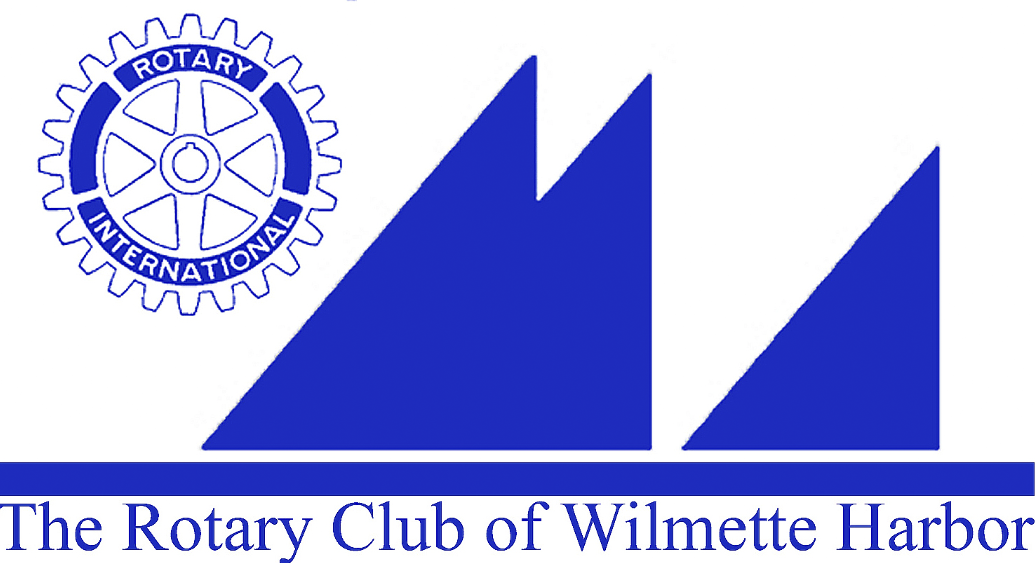
Harbor Light Newsletter

MEETING DATE: Wednesday, November 25, 2015
GREETERS: Frank Hussey
THOUGHT FOR THE DAY: Jim Griffith
ATTENDANCE: Ellen Greenberger
SCRIBE: Joyce Knauff

GUESTS: Beverly Voorhees, Heidi Voorhees mother; Sarah Plummer, Heidi’s neice; Janet Glasgow (Johns wife) and her “Mum” from England

VISITING ROTARIANS:

BIRTHDAYS: Jeff Martin – 11/29

ROTARY ANNIVERSARIES: Tim Frenzer -11/25 (6 Years)

ANNOUNCEMENTS: Holiday Fundraiser – Heidi Voorhees got up to announce we really need to push for sales in the next week as the deadline for orders is Thursday 12/3. You can drop orders off at Heidi’s or John Bowman, leaving in their mailbox.

Holiday Party, Sunday 12/6/15 instead of meeting on December 2…No meeting Wednesday, 12/2
Holiday Party, John & Sue Bowman’s home, 312 Washington Ave, Wilmette, starts 6PM. Appetizers, side dishes and dessert will be potluck. Following what you should bring based on first letter last name:
A-K Dessert
L-R Side dish, e.g. veggie or starch
S-Z Appetizers
John & Sue will have a hot entrée and salad starting around 6:30 PM
White Elephant exchange around 8 PM
Festive Holiday dress.

Polio Plus– End Polio Now – Campaign in high gear. The Bill & Melina Gates Foundation has raised their match “3 to 1”. Club voted to give Shenanigan monies through the end of December to Polio Plus.

Foundation – Annual giving Tuesday – by RI. Give to The Rotary Foundation on December 1 at www.rotary.org/give. Have you heard about Giving Tuesday??? It’s a global movement for charities and individuals to come together for one common purpose: to celebrate and encourage giving…Join us on December 1st as Rotary participates in Giving Tuesday and celebrates the good work our members do around the world.
Top three reasons to support Rotary on Giving Tuesday, December 1st.
- Fund unique projects. Our Foundation’s unique grant model creates locally led community development projects throughout the world. These life-changing projects are only possible because of the generous support from our members and friends of Rotary.
- Raise awareness. While Rotarians give in their communities and our Foundation throughout the year, Giving Tuesday is a great chance to reach new supporters by leveraging social media and the momentum of Rotary Foundation Month in November.
- Continue the tradition. Last year we raised over $100,000 in a single day to fund sustainable, life changing projects. With your support this year we can do even more……
Register today for the RI Convention – May 29 – June 1, 2016
The date is set, John Kim in Seoul doing a tour of hotels. In the meantime, you need to register. Rotarian Stan Sherman will be stepping up to get us all ready for Seoul.
A reminder regarding the Seoul Convention:
- Convention fees for Rotarians increase after December 15th from $310 to $375.
- Registration on line is simple: http://www.riconvention.org/
- Please personally invite others to join you in Seoul
- Star Alliance offers reduced air fare rates from this site: http://conventionsplusbookings.startaliance.com/trips/starHome.aspx?me
etingcode+0Z01S16

Paul Harris Award – Match for District 6440:
If you are interested in getting a Paul Harris with $500 donation here is what you need to do.
- Download and fill out the form – The Rotary Foundation Contribution Form
This is a 2-page form which you need to fill in both pages with our club #27231 and your individual ID number
Checks only…No Credit Cards. Make your check out to “The Rotary Foundation”. A $500 donation will be matched with 500 points from the district for the donor to receive a Paul Harris Fellow.
Send the 2 page form filled out and $500 check to: Laura Kline, 1628 Old Barn Circle, Libertyville, IL 60048

RYLA – Rotary Youth Leadership Awards. Carol Wells has the application and will start working with Anna Helfman at New Trier looking for candidates. If you have someone in mind you can contact Carol Wells.. We have budgeted to send 3 applicants. Session 1 is March 10-13 and Session 2 is April 7—10. High School students that are 15,16 and 17years old are candidates.

Linda Frothingham book signing - Saturday 11/28 from Noon – 2PM at Persimmon, 1167 Wilmette Ave, Wilmette. Her newly published book Simply Inspired…by Sea Glass & Nature’s gift. Linda will in addition to signing her book, she will be doing a Holiday Baby Book Drive with Linda Howard for Literature for All of Us on Tuesday, 12/8 from 5-7PM at Market by The Noodle, 708 12 St, Wilmette. Bring a baby book (ages 0-2) or purchase a Simply Inspired Journal to be given to Literature for All of Us. Linda Fronthingham and Linda Howard are former members of our Rotary Club…

GOOD NEWS/BAD NEWS: Walter Reed donated some historical information relative to our Wilmette Harbor Rotary Club… Looking for someone to be the Club Historian!
Herb McDowell announced that WHRC members showed up to help with the Holiday Parade last Saturday in Wilmette.
Walter Reed announced that his son Brian competed in the Special Olympics District Bowling tournament and won, got a gold medal and is competing in Rockford.
Michael Bailey announced that his daughter received her Ph.D in “Substrate structure-activity relationships guide, cultural engineering of modular ploy of synthase Ketoreductases…. Whatever all this is??

MEMBER BIO MOMENT: Norine Chip – Grew up in Rogers Park in the same house she is living in today. Her parents live on one floor and she and her three children on the other. She has 2 older brothers, went to Catholic schools, St Mary in Minnesota, Her mother is from Ireland. She received the Rotary Scholarship and got her Masters in Business. She loves the outdoors, lived in Australia and Seattle now back here. Likes to help and is now looking for a new opportunity that will utilize that skill.

PROGRAM: John Glasgow – loves history and shared the re-build of Chicago from the fire and then reviewed Frank Lloyd Wright’s architecture in the area and his history. He had a power point presentation with Frank Lloyd Wrights houses.

NEXT WEEK’S PROGRAM: No Meeting on Wednesday, 12/2

NEXT MEETING CLUB DUTIES Wednesday, December 9th
Greeters: Chris Kondos
Thought for the Day: Ray Lechner
Bio: Jack Close
Scribe: Herb McDowell
Attendance: Sue Kozak

