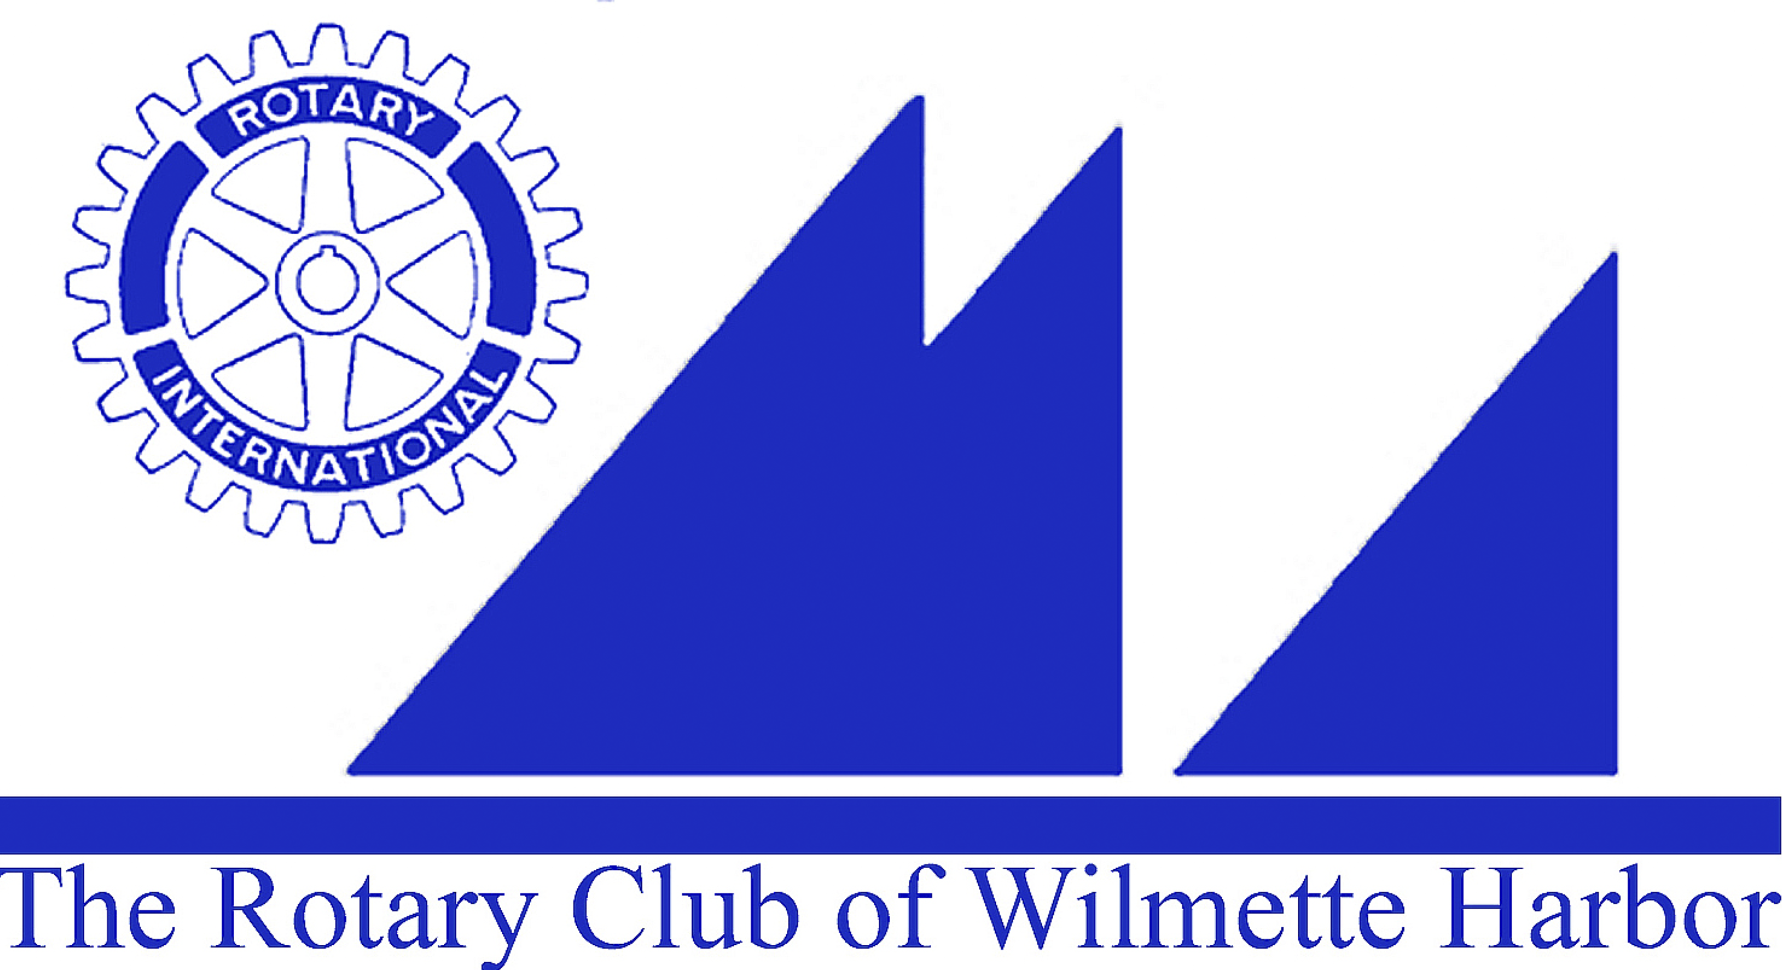
Harbor Light Newsletter

MEETING DATE: Wednesday, December 30, 2015
GREETERS: Walter Reed
THOUGHT FOR THE DAY: George Pearce
ATTENDANCE: Beth DeWall
SCRIBE: John Ray

GUESTS:
VISITING ROTARIANS:
BIRTHDAYS:
ROTARY ANNIVERSARIES:

ANNOUNCEMENTS:
- No morning meeting on Wednesday, 1/6/16 – instead we will meet at Carol Wells’ home 822 Chestnut, Wilmette (6 – 7:30PM) Carol will provide beverages. If you’d like to contribute some snack food it would be appreciated. This meeting is called “Thinking Outside the Box” so bring any ideas for Fundraising and Membership.
- Our Newly Elected Officers and Board Members for 2016-2017
President – Sue Watson
President Elect - George Pearce
Secretary - Joan O’Neill
Treasurer – John Bowman
Directors serving 2 year terms – (2016-2018)
Ellen Greenberger
Jack Close
Jim Griffith
Continuing Board Members – (2016-2017)
Michael Bailey
Ellen Falkof
Herb McDowell

- RYLA – Rotary Youth Leadership Awards: Applications are due to Carol Wells by Friday, 1/15/16. We have budgeted for 3 students. Session 1 is March 10-13: Session 2 is April 7-10
- Winter Training – Registration is now Online at www.Rotary6440.org Saturday, 2/6/16 is the date at Harper College. No charge for this event.
- Grants Management – We are looking for 2 members from our club to attend this year’s mandatory GMS. This will be taped for review in the future.
-Membership – We are looking for 2 members from our club to attend. This session brings together our successes and attempt to assist in building membership

-2016-2017 AG/Leadership Training – Mandatory for all 2016-17 District Officers, Assistant Governors, Committee Chairs and those thinking of stepping up to a District Position next Rotary year. Want in? Contact DGE Rick Rivkin at Gov.Rick@Rotary6440.org

- Our District Conference, District Assembly and District Youth Conference will be April 28 – May 1, 2016. They are looking for your creative assistance to finish planning the weekend celebration. Contact Very Mayer with your thoughts v_mayer@msn.com

UPCOMING EVENTS:
Soup Kitchen – Monday, 2/1/16
Kids Against Hunger Food Packing – Saturday, 3/12/16

GOOD NEWS/BAD NEWS:

MEMBER BIO MOMENT: Susan Fisher

PROGRAM: Dick & Emily Axelrod authors of Let’s Stop Meeting Like This: Tools to Save Time and Get More Done
Dick and Emily’s book invites us to think again by introducing a new way to meet that brings people together for productive cross-functional and cross-generational collaboration. They have field-tested this approach for thirty years and offer a flexible, repeatable process that’s helped get real work done in thousands of meetings across all sorts of organizations
www.AxelrodGroup.com

NEXT WEEK’S PROGRAM: Angela Moy – Renaissance of Chinese Culture

NEXT MEETING CLUB DUTIES - Wednesday, 1/13/16
Greeter: Sarah Oliver
Thought for the Day: Sue Segal
Member Bio: Michael Donnelly
Set-Up: John Gilber
Attendance: Tom Ryan
Scribe: Puran Stevens

