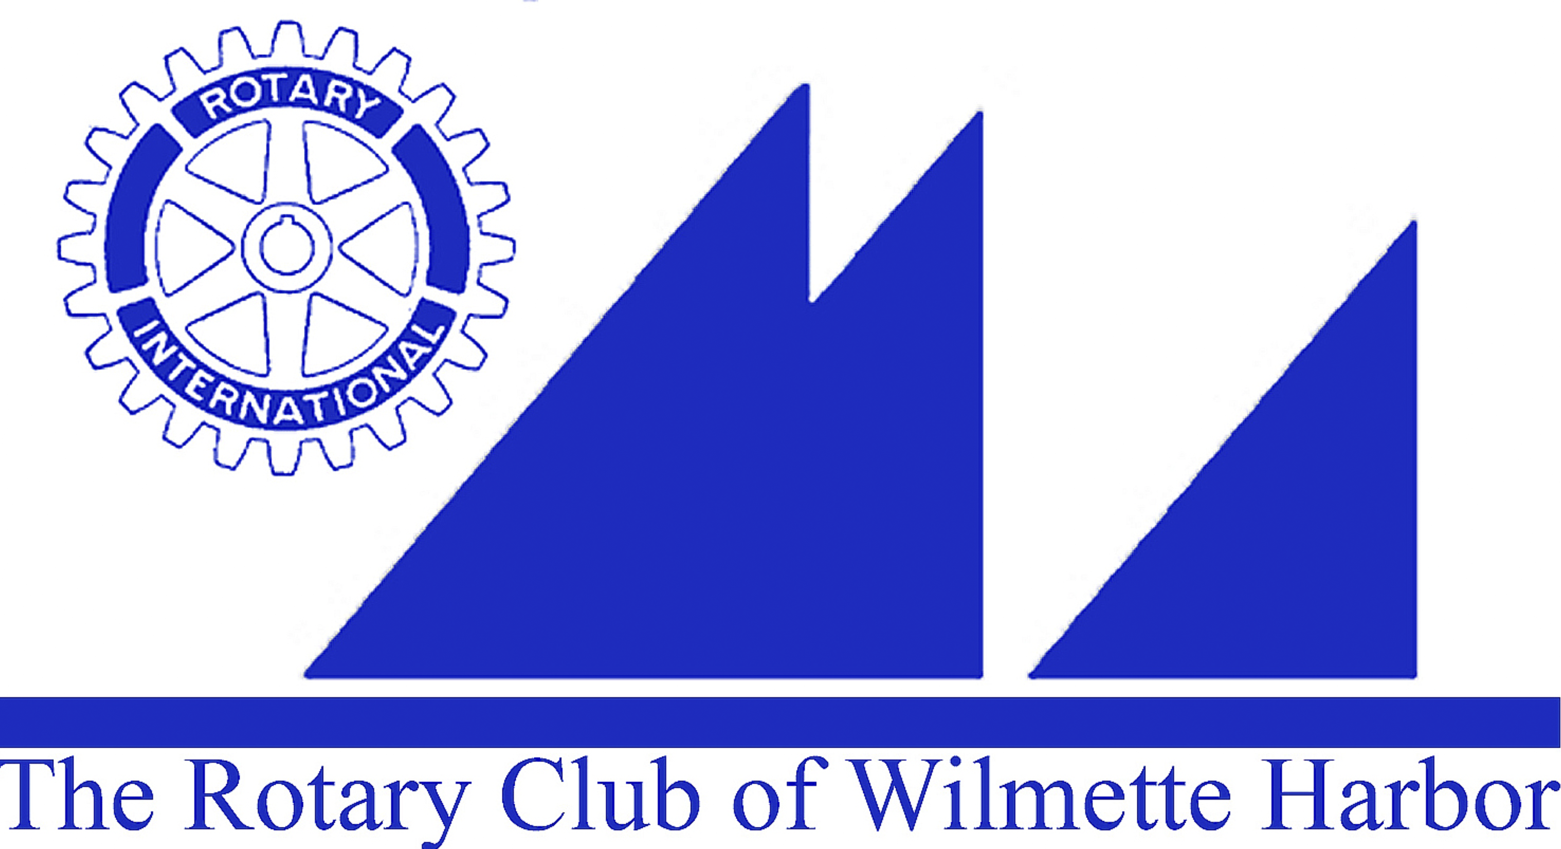
Harbor Light Newsletter

MEETING DATE: 2-17-16
GREETERS: Linda Yonke
THOUGHT FOR THE DAY: Karen Yonke
ATTENDANCE: Jack Close
SCRIBE: Mike Donnelly

GUESTS: Henry Apfelbach , Brian Mills , Jim Pearson Chris

VISITING ROTARIANS: n/a
BIRTHDAYS: n/a
ROTARY ANNIVERSARIES: Jack Close 2 years

ANNOUNCEMENTS:
- Wilmette Chamber Recognition Dinner is 2-25-16 at the Wilmette Golf Course. Michael Donnelly, incoming Chamber President , contact Mike for details
- Next board Meeting 2-19- at 7:15am Michigan Shores Club

UPCOMING EVENTS:
- Soup Kitchen 3-7 to 3-21
- 3-12 Kids against hunger 11-1PM
Ellen Falkof has signup sheet

GOOD NEWS/BAD NEWS: n/a

MEMBER BIO MOMENT: Gil Gilbert
PROGRAM: CJE Senior life
Gerri Persin and Barbara Milsk spoke

NEXT WEEK’S PROGRAM:

NEXT MEETING CLUB DUTIES
Greeters: Keith Dronen
Thought for the Day: Ellen Greenberger
Set-Up: Gil Gilbert
Attendance: Ellen Falkof
Scribe: looking for a scribe?????
Rotary Bio: John Glasgow

