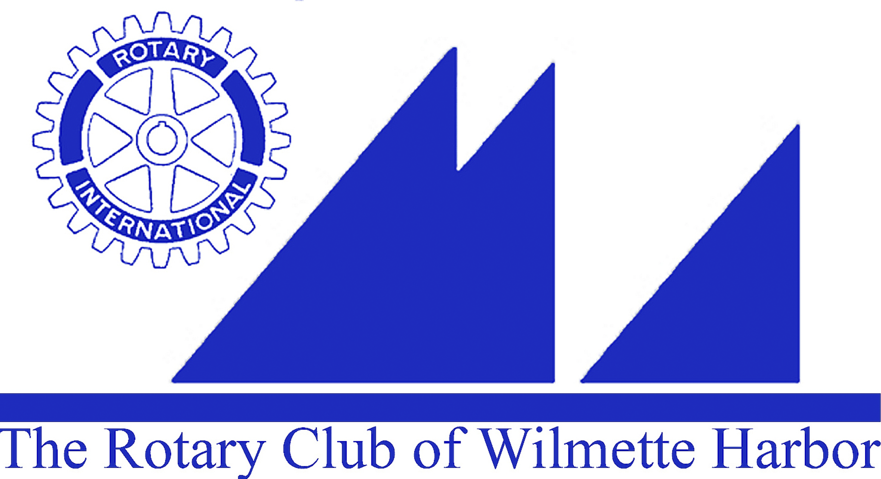
Harbor Light Newsletter

MEETING DATE: February 24, 2016
GREETERS: John Glasgow
THOUGHT FOR THE DAY: Ellen Greenberger
ATTENDANCE: Ellen Falkof
SCRIBE: Jack Close/Carol Wells

GUESTS: speaker, Lali Watt

VISITING ROTARIANS:

BIRTHDAYS: Chris Simcox – February 26th
Rotary’s 111 Birthday - February 23rd

ROTARY ANNIVERSARIES:

ANNOUNCEMENTS:

Next Wednesday, 3/2/16, First Wednesday of the month – No morning meeting. The first Wednesday in March we are taking a tour of William Harris Lee & Co., 1138 Central Ave., Wilmette – 6PM. The tour will be led by Lisa Zimmerman the General Manager.

Chris Cole has been approved by the Board as a new member of the Rotary Club of Wilmette Harbor: Chris was born and raised in Michigan and comes from an active Rotary Family. His business is Yellowstone Language Institute – www.yellowstoneenglishcamp.com where he is the director and the company provides corporate training often to international companies and visitors. Chris has recently moved to Wilmette and enjoys the outdoors and giving back to the community.

As per the Rotary Club of Wilmette Harbor Bylaws: Section 1 – Regular Membership – Club members have 7 days after this announcement to voice any objections. These must be in writing to any of the current board members.

Items for Illinois AMVETS: Sue Watson will be taking items to her President Elect Training 3/4 - 3/6. They are looking for:
- Gently used Adult and Children’s clothing
- Backpacks and Purses
- Old Cell Phones
- Laptops
Please drop your donations in the box on Sue Watson’s front porch, 116 Park Ave., Wilmette before she leaves for training on Friday, March 4th.

Weekly Speaker Suggestions: Help Susan Fisher continue the fantastic job she has been doing with our weekly program and suggest interesting/informative speakers for our morning meetings. Please email Susan at sefisher@ameritech.net with your ideas/suggestions.

District Conference: 4/28 – 5/1 at the Marriott Lincolnshire Resort.
Registration is open on the District Website and you can book your stay in the reserved block of rooms. New Members are strongly urged to attend.
Great speakers have again been booked for the Plenary Sessions.

Donations in Honor/Memory of Walter Reed: Please don’t forget to remember Walter with a donation to the Rotary International Foundation. Handouts will continue to be placed at the tables for the next few weeks, but you can also easily go into your Rotary International webpage to donate or call RI (847-866-3000) and they will be happy to assist you.

Jeanne Reed to speak at the Wilmette Historical Museum: Jeanne continues Walter’s work and will be speaking about his book “THE CHILDREN OF LA HILLE” this Sunday, February 28, 2016; 2:00 – 3:00PM. The program is free.

Looking for healthy adults 50 – 70 yr. for MRI Brain Scan: You’ve been wanting to check and see what is up there? Now is your chance. Meriel Owen, PhD student in Neuro Imaging at Northwestern University is looking for healthy adults, 50-70 years of age, right handed, no metal implants and not claustrophobic interested in helping with her study. It takes about 2 hours and you will be paid $20 for your time. You would be helping with Meriel’s important research on motor recovery after stroke. Anyone interested may email Meriel at meriela.owen@gmail.com (Service Above Self)

UPCOMING EVENTS:

Kids Against Hunger Food Packing: 3/12, 11AM-1PM: If you are interested in joining us please email Ellen Falkof at efalkof@gmail.com

Soup Kitchen: 3/21: If you are interested in joining us please email Tom Ryan at TomRyan709@gmail.com

GOOD NEWS/BAD NEWS: Great News!! Gil found our long lost Club Vests hidden in a downstairs locker at Sheridan Shores. Now we will be able to wear them with pride and indentify ourselves when we volunteer.

MEMBER BIO MOMENT: John Glasgow regaled us on the serendipitous meeting of his lovely wife Janet at Oxford University.

PROGRAM: Lali Watt, Vice President of the Board of The Talking Farm
The Talking Farm consists of 3 acres of land that is leased from the Skokie Park District for use as a sustainable, urban garden. As of today only 3-4% of the food we eat is grown in the state of Illinois – an agricultural state. Lali informed us that 40% of the food grown is wasted. Much of the cause for this waste is our misunderstanding of Sell by dates – still perfectly good to eat they are only recommending it be sold by that date AND Use by dates – which are just a “guide”. As of today the Talking Farm is only growing and selling to restaurants such vegetables as Kale, lettuce, eggplant, garlic, and onions. The Talking Farm embodies the long term commitment to sustainable green development and preservation of open spaces in an urban environment. For more information go to www.thetalkingfarm.org

PROGRAM IN TWO WEEKS (March 9, 2016): Breaking the Cycle of Poverty and Slavery – Brad Jeffery, President of Causegear

IN TWO WEEKS MEETING CLUB DUTIES
Greeters: Pam Kerr
Thought for the Day: Tim Frenzer
Set-Up: Gil – John Gilbert
Attendance: John Glasgow
Scribe: Jim Griffith
Rotary Bio: Tim Frenzer

