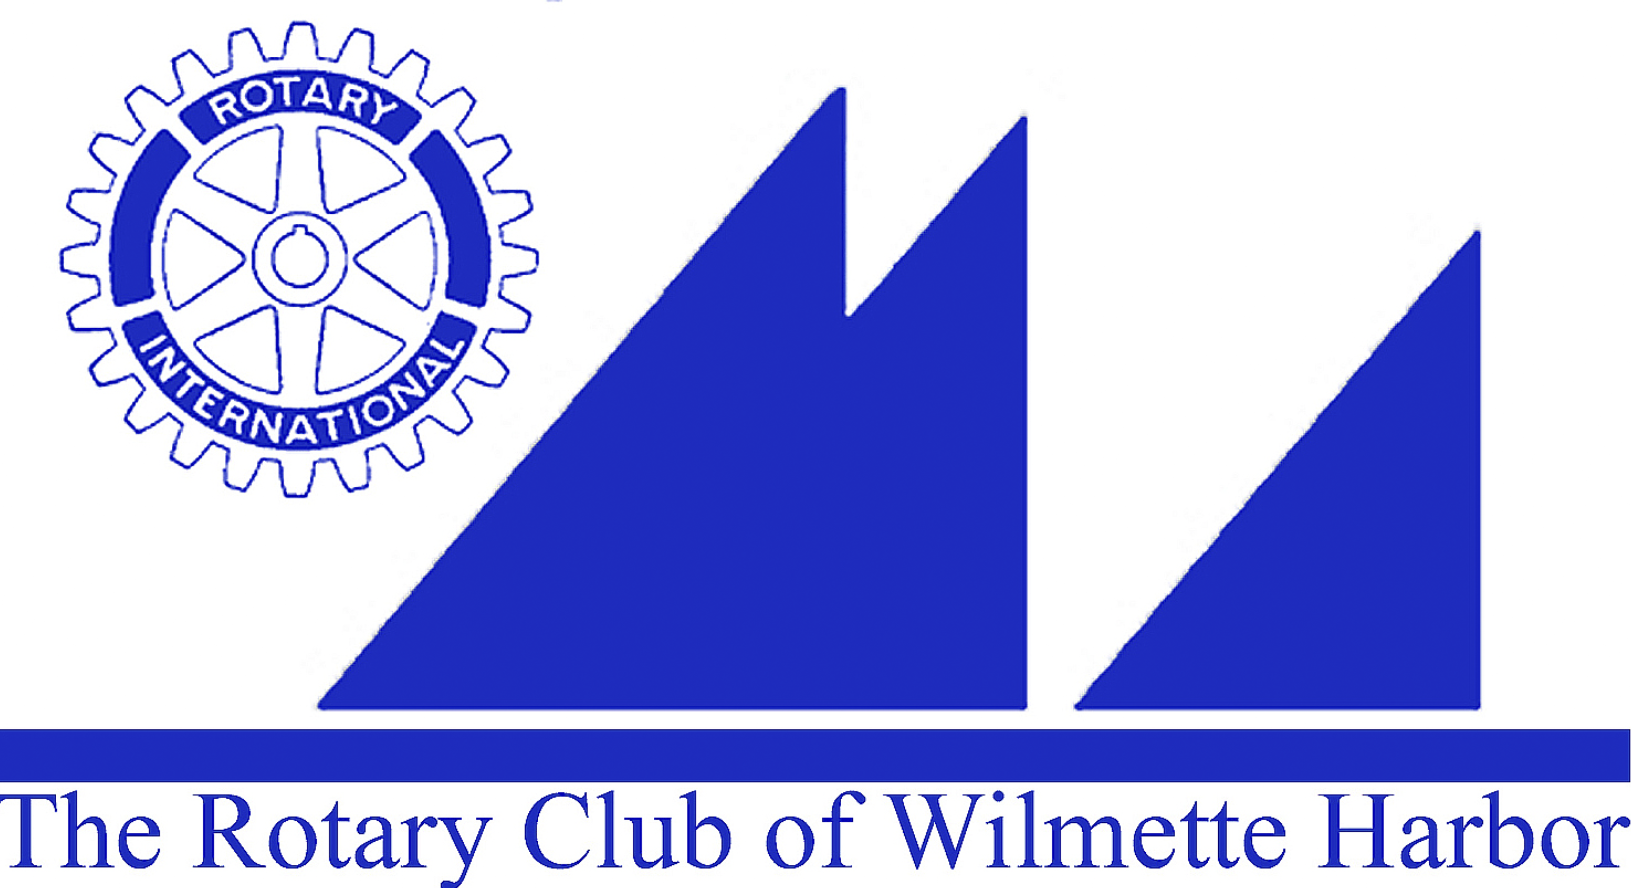
Harbor Light Newsletter

MEETING DATE: May 11, 2016
GREETERS: John Kessler
THOUGHT FOR THE DAY: Mike Bailey
ATTENDANCE: Linda Yonke
SCRIBE: Ellen Falkof

GUESTS: Omowale Casselle, Co-Founder of Digital Adventures
Jim Waite, Rose Peterson, Kirk Stewart & Spencer Olson

VISITING ROTARIANS: Chris Vodden, Sean Nelson,

BIRTHDAYS:

ROTARY ANNIVERSARIES: Beth DeWall – 11 years

WEDDING ANNIVERSARIES: Jim & Mary Bowman, 30 years

ANNOUNCEMENTS: Fundraising non event has raised $7000 so far. Everyone is encouraged to send in their contributions as soon as possible.

Five Vocational Scholarship applications have been received and will be carefully considered beginning this week.

Applications for Community Grants have been slow to come in. Deadline is approaching on May 15, 2016.

Elmwood Dunes clean up is this Sunday at 1 p.m.. Help needed. Contact Sue Watson. Bring gloves and help clear the site of weeds and garlic ustard.

Nominations for Rotarian of the Year are due to Carol Wells. No Club Officers or Board Members are eligible.

District Conference: Carol thanked all who attended: Sue Watson, Beth DeWall, Susan Fisher, Joan O’Neill, Sarah Oliver, Pam kerr, Puran Stevens, George Pearce. Special Thanks to John Kessler and Barry Miller who sold golf balls before the start of the conference and raised $140 for EPN.

UPCOMING EVENTS:
Soup Kitchen is Monday, June 6th. Contact Tom Ryan if you want to help.

2016 Rotary Road Trip to Miller Park – Cubs vs. Brewers: Saturday, July 23rd, Tailgate party at 3:10: Contact: 6:10 Contact Joan O’Neill for details.

GOOD NEWS/BAD NEWS:

MEMBER BIO MOMENT:

PROGRAM: Sean Nelson – Ryla Chairman, District 6440
Our RYLA recipients: Rose Peterson, Spencer Olson, Kirk Stewart

NEXT MEETING CLUB DUTIES
Greeters: Maureen Barry
Attendance: Jim Bowman
Scribe:
Bio: Joyce Knauff

