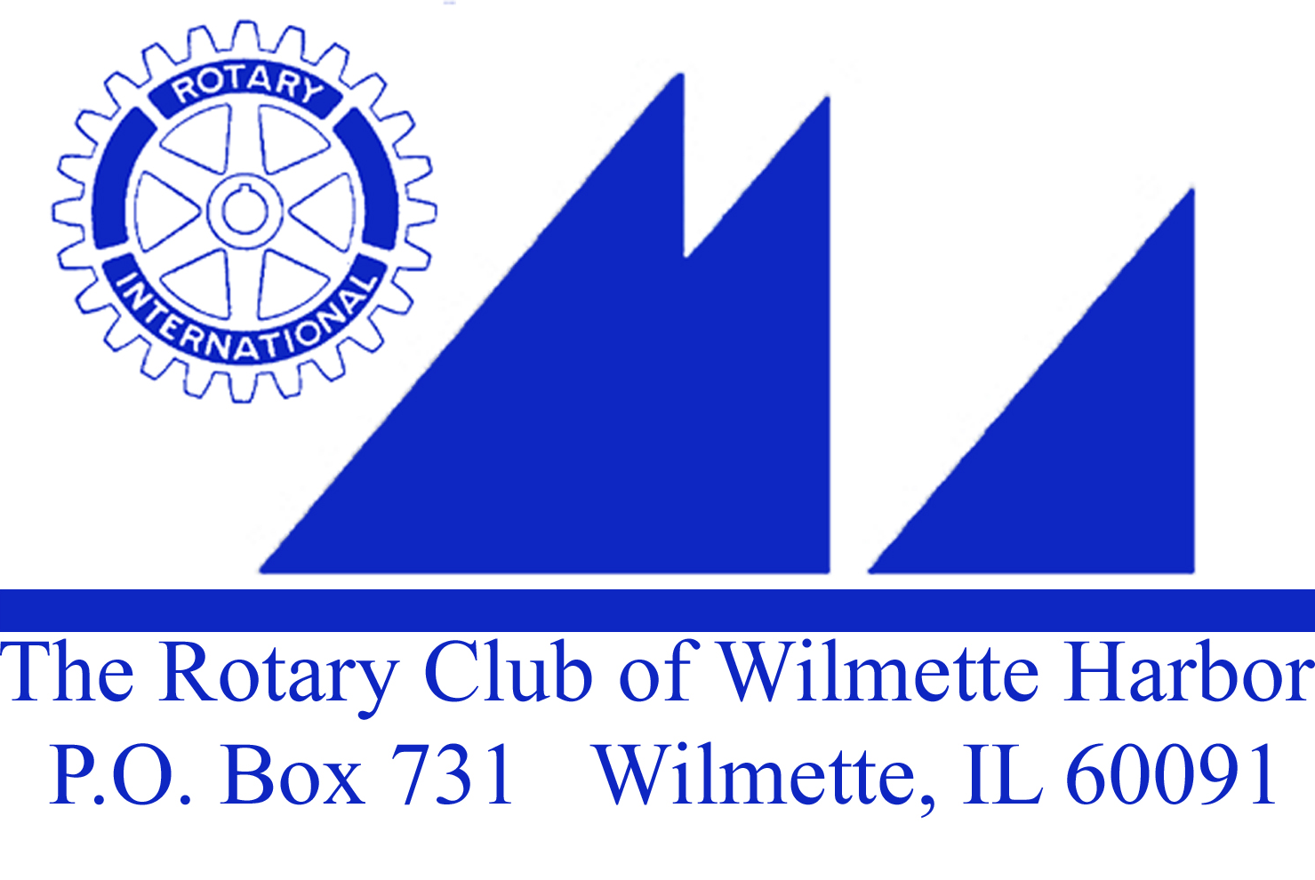

Wednesday, May 18, 2016

- Call to order

- Thought & Pledge – Sue Watson

- Four Way Test – In all the things you think, say, or do:
1st – Is it the truth?
2nd – Is it fair to all concerned?
3rd – Will it build goodwill and better friendships?
4th – Will it be beneficial to all concerned?

A Special Thank you:
Set Up – Gil (John Gilbert)
Treasurer – John Bowman
Attendance – Jim Bowman
Greeter – Maureen Barry
Thought & Pledge – Sue Watson
Rotarian Bio. – Joyce Knauff
Scribe – Carol Wells with help from Sue Watson
Music – John Ray

Duty Roster next week, May 25, 2016
Greeter: Norene Chip
Thought & Pledge: Jack Close
Attendance: ?
Scribe: Karen Donnan
Bio: Ellen Greenberger

- Visiting Rotarians or Guests –
James Waite – prospective member
Jack Bliamptis, New Trier Class of 2011, U of C Class of 2015. Jack Has just returned to the US after having spent the past year in Nantes, France teaching at a French boarding school
Jamie Revord

- Birthdays – John Ray – May 14
Hank Hufnagel – May 17

- Club Anniversaries – 26 years and Founding Members of our Club on May 22, 1990
- Gil Gilbert
- John Glasgow
- John Kessler
- Joyce Knauff
- Herb McDowell
- Barry Miller
- Heidi Voorhees
- John Wertymer

- Wedding Anniversary –

- Paul Harris Presentation – Joan O’Neill – PH +1
Frank Hussey – PH +8

Announcements:

Board Meeting?

10) Fundraising – Non-Event Spring Fundraiser – Update; Heidi Voorhees – A special thanks to Jim Griffith who offered a beautiful sailing outing – Susan Fisher was the winning bid.

11) Upcoming Community Service Projects:
Next Soup Kitchen is scheduled for Monday, June 6th – Tom Ryan
Vocational Scholarship: Chris Simcox $1500 goes to:
- ^{Piotr Pacholarz}
- ^{Mona Niyagan Safi}
- ^{Isabelle Walker}
Grant Applications available online – due on May 15, 2016 – Herb McDowell, Chair

Elmwood Dunes: Update – Sue Watson

12) Rotarian of the Year – Please email me any of your nominations. The board will vote at our June board meeting. No Club Officers or Board Members are eligible.

13) Dear Rotarian,

We have some very exciting news for you!

As you know, the 2017 Rotary International Convention will take place in Atlanta from June 10-14. While every Rotary Convention is an exciting event, 2017 will be extra special because we will be celebrating the 100th Anniversary of The Rotary Foundation. As a matter of fact, it was in Atlanta at the 1917 Rotary Convention, that Rotary President Arch Klumph announced the formation of OUR foundation with the first contribution of $26.50.

In honor of Arch's birthday on June 6th, and in memory of the first donation, Rotary is offering a special registration fee of $265 - but only from May 28th to June 6th. After June 6th, the registration fee will increase to $340.

If you are going to the Seoul Convention, you will be able to register and pay with your credit card in the House of Friendship. For those of us who aren't going to Seoul, registration will be available online at http://www.riconvention.org/en/atlanta.

14) 2016 Rotary Road Trip to Miller Park – Cubs vs Brewers: Saturday, July 23rd 3:10PM Tailgate Party: 6:10 Game Time has sold out. You can still buy tickets on your own if you are interested.

Any More Announcements?

Beth DeWall asked for volunteers to help weed the Pasek Garden this Saturday.

Good News/Bad News –
Had a wonderful lunch with Margaret Wein yesterday, she hopes to attend a meeting very soon. From Norene Chip: I apologize for not attending Rotary, as much as I would like to as I have been my mother's main caregiver. My mom went into hospice last week and the hospital. We brought her home Friday and she is comfortable and very happy I am here to take care of her.
Please let the crew know I am well and about my mom.

Club Bio: Joyce Knauff

Speaker(s):
Jamie Revord
Jamie manages the Annual Giving and Alumni Relations team. A Certified Fund Raising Executive (CFRE), she has been with Rotary since 2002, and worked with the Ambassadorial Scholarship and Rotary World Peace Fellowship programs, as well as major gifts and endowment administration, before assuming her current role. She earned her BA in English from the University of Notre Dame, and holds masters’ degrees in Curriculum and Instruction from Loyola University Chicago and in the Teaching of English to Speakers of Other Languages (TESOL) from the University of Stirling in Scotland. She was a Rotary Foundation Ambassadorial Scholar sponsored by D-6440 for study in Scotland.

Meeting adjourned at 8:30AM

