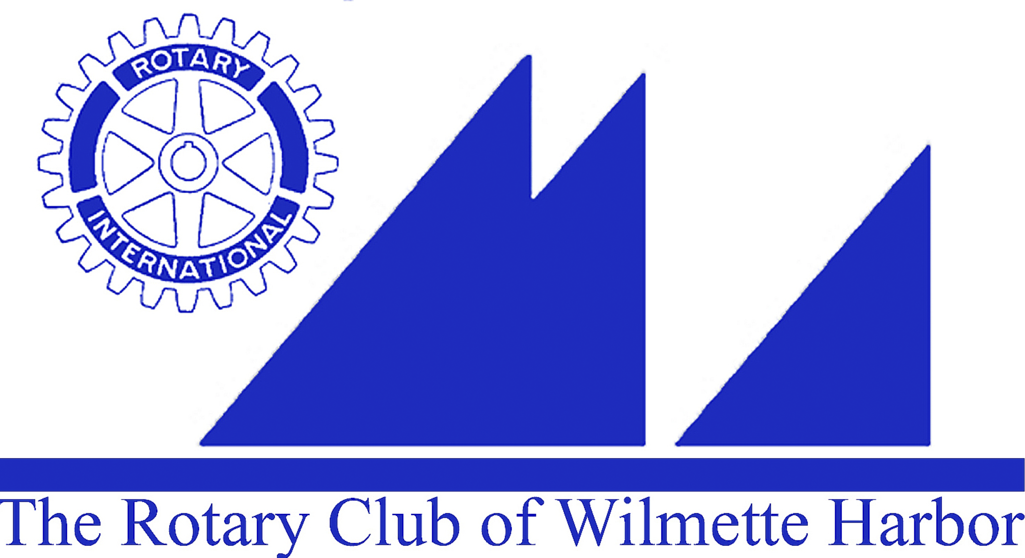
Harbor Light Newsletter

MEETING DATE: June 15, 2016
GREETER: George Pearce
THOUGHT FOR THE DAY: John Glasgow
ATTENDANCE: Greg Michel
SCRIBE: Carol Wells with assistance from Norene Chip
ROTARIAN BIO. – Pam Kerr

GUESTS: Jim Pockross, Austin & Kitty Walker

BIRTHDAYS: Bob Meeder – June 15
Tim Frenzer – June 16

ROTARY ANNIVERSARIES: Ray Lechner – 9 years on 6/19
Mike Donnelly – 10 years on 6/13

ANNOUNCEMENTS:
- Sammy Simcox, son of our member Chris Simcox, is filming our meeting today to add footage to the 3 shorts he is creating as promotional films for our club to use online or at events. Sammy is a graduate with a degree in film. He most recently filmed at the Soup Kitchen on 6/6 and also at the Elmwood Dunes where WHRC was a major donor in it’s preservation.
- Special thanks to Joyce Knauff for presiding over last week’s meeting while Carol Wells was in Atlanta at the CDC
- Board Meeting Reminder: This Friday, June 17th in the Michigan Room at Michigan Shores (7:15-8:30AM) PE, Sue Watson will be presiding over her first meeting.
- Fundraising: Non-Event Spring Fundraiser has raised more than $11,500 with 90% member participation. These funds will be used to fund our projects in 2016-2017.
- Community Service Grants: 16 recipients have been chosen by the Community Service Grants Committee. Their recommendations will be voted on by our Board this Friday and then passed to the Foundation Board before the Grant recipients are announced on 8/10. The committee worked to find organizations who have an impact on our community.
- Last chance to nominate a worthy member for Rotarian of the Year. Please email Carol – cwellssee@aol.com - with any nomination before Friday, 6/17.
- Rotary International Conference in Atlanta 2017 – Registration is now open and the conference will be held from 6/10-6/17. Many members from our club have already registered. This is a great opportunity to attend an International conference, don’t miss out.

UPCOMING EVENTS: Installation Dinner and 9 Hole Golf Scramble, Wednesday, June 29th. We are having a 9 Hole (FUN) Golf Scramble at the Wilmette Golf Club; first tee time is 3:00PM, Dinner is at 6:00PM Go to the link below and you can sign up online. This will be a fun evening as we install the new President, Sue Watson and members of her board. Don’t miss it!
http://www.wilmetteharborrotary.org

GOOD NEWS/BAD NEWS: Sue Kozak is doing better and getting out. She recently was able to attend a concert at Ravinia. We are so happy to hear this news and hope to see you soon.
Joan O’Neill just returned from a hands on service trip with her church to Jamaica and strongly encourages members to step outside their comfort zone and think about an international service trip. Joan says it will change your life in ways you can’t imagine.
Tim Frenzer brought some flyers for the first fundraiser for Housing Our Own. Tim will bring tickets to future meetings. A Jeep Cherokee is the Grand prize and they are only selling 1000 tickets so don’t miss out. Go to: http://www.housingwilmette.org/

MEMBER BIO MOMENT: PDG Pam Kerr - Pam talked about how she had volunteered her whole life. As an adult she was on the board of the Junior League. At Junior League is where an Assistant Governor came to speak and said he’d like someone from their organization to join Rotary – She did. She quickly became President of WHRC and then became the 2nd woman from our club to become District Governor (We’ve had 3 so far: Karen Kline, Pam Kerr & Sarah Oliver). Pam has always been impressed by Rotary’s “Global Reach” and continues her amazing work with the Global X-ray Project. Her passion and commitment encourages each of us to do all that we can – Service Above Self.

PROGRAM: Carol Wells – Sharing her experience at STOP (Stop Transmission of Polio) training at the CDC in Atlanta
Carol attended the first week (6/6 – 6/10) of 3 weeks of training for “STOPPERS” at the CDC in Atlanta. These 75 individuals were chosen from over 1200 applicants. The majority are doctors, healthcare workers, communication specialists and data specialist from Africa and the Middle East. They have been chosen for a 2 Year stint in some of the most dangerous areas of the world. Their job will be as advisors in each host country and will be placed where they are needed; working on Polio control and eradication. During the week they learned about the many different variations of the OPV (Oral Polio Vaccine), surveillance, AFP (Acute Flaccid Paralysis) the major indicator of Polio’s presence. They learned about logistics for the vaccine – expiration, storage, transport (cold chain) and fecal sampling. On Friday, in small groups, they worked on a complicated “Case Study” to sharpen their skills for their arrival in country. Carol said the week was truly amazing, especially being surrounded by so many real life heroes. She brought lots of “Rotary Swag” – End Polio Buttons, Stickers and bracelets that were distributed to all the Stoppers and they were wearing them with pride. Rotary is ALWAYS mentioned with Centers for Disease Control and Prevention (CDC), World Health Organization (WHO) and UNICEF (United Nations International Children’s Emergency Fund) as being there at the beginning (1988) when Polio Eradication started.

NEXT WEEK’S PROGRAM: Terrance Hake - Operation Greylord

NEXT MEETING CLUB DUTIES
Greeter: Jim Griffith
Thought for the Day: Frank Hussey
Rotarian Bio: John Kessler
Set-Up: John (Gil) Gilbert
Attendance: Hank Hufnagel
Scribe: Pam Kerr

