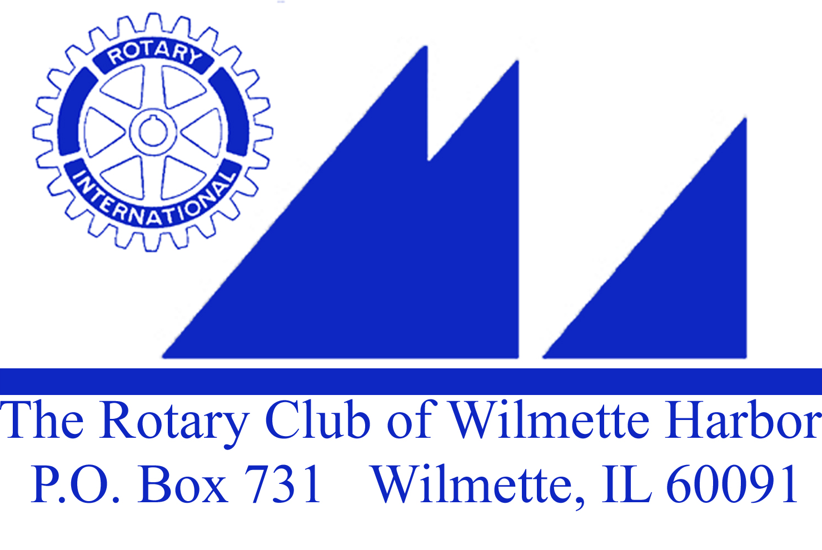

Wednesday, June 22,, 2016

- Call to order

- Thought & Pledge – Carol Wells

- Four Way Test – In all the things you think, say, or do:
1st – Is it the truth?
2nd – Is it fair to all concerned?
3rd – Will it build goodwill and better friendships?
4th – Will it be beneficial to all concerned?

A Special Thank you:
Set Up – Gil (John Gilbert)
Treasurer – John Bowman
Attendance – Hank Hufnagel
Greeter – Puran Stevens
Thought & Pledge – Carol Wells
Scribe – Pam Kerr

Duty Roster next meeting, July 13, 2016 (July 6th First Wednesday event?)
Greeter: Mike Bailey
Thought & Pledge: Maureen Barry
Attendance: Chris Cole
Bio/Current Events: Jackie McGuire

- Visiting Rotarians or Guests? Katherine Rush – Ambassadorial Scholar, Ed Lockwood and Bob Janes – grade school friends of Jim Griffith

- Birthdays – Ray Lechner – June 26 (not present)

- Club Anniversaries –

- Wedding Anniversary –

- Paul Harris Presentation –

- New Member Induction -

Announcements:

10) Upcoming Community Service Projects:
Community Service Grants: The 16 Community Service Grants that were proposed by the Committee were passed by the Board last Friday, 6/17 and were passed by the Foundation Board last evening. We will honor those recipients on Wednesday, August 10, 2016.
French Market (Dates?) – John Kessler

11) Installation Dinner – Wilmette Golf Club, Wednesday, June 29, 2016. 9 hole Golf Outing starting at 3PM and drinks at 6:00PM and dinner/events at 7PM. On our website and sign up sheet?

12) Rotary International Conference in Atlanta 2017! - Registration is open now. The conference is from 6/10 – 6/14/17.

Any More Announcements? Katherine Rush asked if club members knew anyone interested in joining the board of the Joel Hall Dancers. Carol Wells will have the contact information. The Wilmette Village raffle for a Jeep was announced a second time ($100/per ticket). Our HealthRays Project (digital x-rays)is installing 3 clinics this summer with an installation ceremony planned near Guatemala City on August 25th. Planned installation of another clinic in Gualan, Guatemala made front page news.

Good News/Bad News – Karen Donnan was in South Africa on a tour bus and the common thread of the participants was ROTARY! Herb McDowell’s grandson was a “badger boy” in his high school and his granddaughter had a solo at Carnegie Hall

Club Bio: John Kessler (skipped to give speaker more time)

Speaker(s): About the Author
Terry Hake graduated from Loyola University of Chicago School of Law in 1977. He served for three years as a prosecutor in the Cook County State's Attorney's Office in Chicago, Illinois, and later as an FBI agent in Chicago. In April of 1980, he agreed to assist the FBI and the United States Attorney's Office in an investigation of the Cook County Court system. While working undercover, he was made an FBI Special Agent in 1983.
Mr. Hake testified at the trials of 23 defendants charged during Operation Greylord. After serving in federal law enforcement for 23 years, he retired from the United States Department of Justice Office of Inspector General and eventually returned to the practice of law as an Assistant State's Attorney in Cook County. In 1989, Mr. Hake received the Louis E. Peters Award from the FBI and the Society of Former Special Agents of the FBI for his undercover work as a prosecutor in Greylord.
Mr. Hake is a member of the Society of Former Special Agents of the FBI and of the faculty at the Inspector General Criminal Investigator Academy at the Federal Law Enforcement Training Center. He retired from the State's Attorney's Office in 2016 after his book was published. He now lives in Winnetka, Illinois.

Operation Graylord ran from 1976-1994. It was the largest public corruption task force in Illinois. A Bill Kurtis video was shown. In 1983 Terry was revealed as an undercover agent. He testified for 10 years against corrupt judges and attorneys.

Meeting adjourned at 8:30AM

