Old Pueblo Rotary Club
Tuesday, September 8, 2020 (ZOOM)
Club Meeting Notes
#2020-008

Agenda:

- Call Meeting to Order (12:10 pm)
- Welcome
- Pledge of Allegiance
- Inspirational Moment
- Announcements
- Service Projects Update
- Club Member Check-ins (Pat picks 3)
- Sergeant at Arms (Beto)
- Gold Cup
- Happy Bucks
- 50 / 50 Tickets now available (monthly drawing)
- https://saguaro-tucson-rotary-club-foundation.square.site/
- TODAY’S SPEAKER: Brittany Taft, Community Food Bank of Southern AZ
- Around-the-Horn --- any final comments
- Four Way Test (Sam)
- Close Meeting

Inspiration Moments “Teacher Quotes”:

“A teacher is one who makes himself progressively unnecessary.” –Thomas Carruthers
“Proper teaching is recognized with ease. You can know it without fail because it awakens within you that sensation which tells you this is something you have always known.” –Frank Herbet
“Teachers have three loves: love of learning, love of learners, and the love of bringing the first two loves together.” –Scott Hayden
Club Announcements:

- KUDOs Shannan Marty: Did you see Sunday’s Paper? Our very own Shannan Marty was highlighted for her 11 years of dedicated sales performance with Tierra Antigua Realty. Shannan was recognized for her superior service to her clients in the Tucson community. Keep up the great work Shannan.

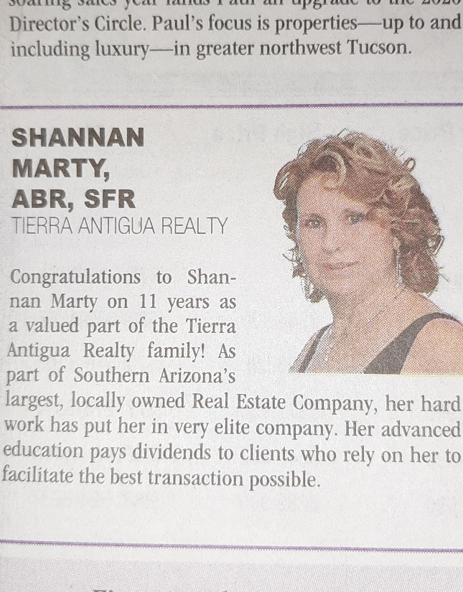

- Tucson Rotary Club – Tucson Classics Car Show Raffle. Don’t forget to purchase your raffle tickets – OPR Club is partnering with Tucson Rotary Club in their annual fundraising effort. With the cancellation of the 2020 Car Show, they are transitioning to a raffle fundraiser with an online auction. Tickets are only $5 for your chance to win one of our great prizes. https://tucsonclassicscarshow.com/
  - Prizes include:
  - Grand Raffle Prize: 2007 C-6 Chevrolet Convertible or $15,000 cash!
  - $3,000 Shopping Spree Sam Levitz Furniture
  - $2,500 Cash from Wellspring Financial Partners
  - $2,000 in Appliances or Furniture from Tucson Appliance & Furniture Company
  - $750 Massage Package from Tucson Family Wellness
  - $500 Car Care Gift Certificate from Jack Furrier Tire & Auto Care toward a set of new Cooper tires
  - Raffle Winners will be announced on Saturday, October 17, 2020 at 3:30 p.m.

- OPR plays On-line BINGO. Sarah and I will attempt to run on-line BINGO game or three on Tuesday, September 29. It will be offered during our normal Club Meeting time. It will be a laugh. BINGO winners will receive gift cards. Hope to see you over Zoom on the 29th.

- OPR Club Recognition Event. Many of our Club Members will be recognized for their superior service to Rotary in the coming weeks. We’re looking at dates in late October with Brother John's Beer Bourbon & BBQ serving as the host site. 1801 N Stone Ave, Tucson, AZ. More to come.

- District 5500 Notes:

The District Governor Selection Meeting is set for September 25, 2020. I want to thank past Old Pueblo Rotary Club President Tori Meyer for being our Club’s representative on this most important District Committee.

- OPR Club 5-year Bylaws Review. Sam has hosted two virtual committee meetings. Expect to see the Committee’s recommended updates in the coming weeks. A big thanks goes out to Sam (Committee Chair) and his committee.

- In-person Hybrid Meeting Solution (going virtual). OPR Club Board is investigating IT capabilities to provide club members with a way to participate virtually upon return to our in-person lunch time meetings. Beto and his team will have a solution in place once we return to in-person meetings.

- Reminder – weekly OPR Club Meetings and monthly Club Board Meetings will be held virtually (via Zoom) through the Month of September.

- Service Above Self. When you hear the phrase, “Service Above Self”, what does it mean to you? Maybe helping others, selflessness, doing your part for your community? If you or someone close to you is a Rotarian then it is a motto you are very familiar with. Service Above Self was a motto that came out of a conversation between two Rotarians during the 1911 National Rotary Convention in Portland, Oregon. With a slight modification it was officially adopted by Rotary in 1950 at the Rotary International Convention in Detroit, MI and it has brought together people from all ends of the earth in creating a better world each day, ever since.

Club Service Projects:
- July 2020 Service Project - COMPLETE. Old Pueblo Club partnered with Rincon Club on their Rotary Assist Project to benefit the Youth On Their Own's Emergency COVID-19 Fund. Our OPR Club raised $1,050 of the $4K total.

- August 2020 Service Project - COMPLETE. Helped Community Food Bank of Southern Arizona to load food at Kino Stadium. 12 club and family members helped serve 141,158.24 pounds of food to 1285 households in the Tucson community. Furthermore, OPR Club Members & Foundation raised and provided a $500 donation to the Community Food Bank of Southern Arizona .

- September 2020 Service Project: September on-going. Delivery of Hots Spots to Flowing Wells School students and families.

Contact David Baker - David.Baker@fwusd.org
We have received all the internet "hot spots" and have begun to identify families for distribution. We have created an instruction sheet to help families set up the device.

As part of the 5500 Matching Grant, our participation was to ask members to deliver the devices. I am writing to see who would be interested in delivering devices to student homes.

This would be the process:
- Let me know when you are available (FW is ready to begin today).
- Stop by 1556 W. Prince Road to pick up the device and address. We have a few families in Three Points, so that would be a road trip of about 1 hour each way.
- Call the family to announce who you are and when you will deliver the device. Explain who you are, how the device is funded, and you will be wearing a mask.
- Deliver the device/instructions and let the family know it was provided by Old Pueblo Rotary. Also, let the family know the device is prepaid for 12 months and can be moved to any location T-Mobile has cellular service.
- Return home safely.

- October 2020 Service Project: OPR Club is partnering with the City of Tucson to Adopt-a-School (“Road”) Project. Participate in a Fall 2020 Clean Up Day. Saturday, October 10th. Trash bags and grippers will be provided by the City. Clean the perimeter of Flowing Wells High School. Need volunteers and a project leader. Contact Pat Kerr at patkerr2016@gmail.com.

- November 2020 Service Project: Salvation Army: Thanksgiving Meals Program.

    - Assist and raise cash contributions for the Salvation Army's Thanksgiving Meals Program. The Salvation Army and St. Demetrios Greek Church have partnered together for 31 years to provide a full hot Thanksgiving meal to those without family and friends to share with. Don't miss your opportunity to be a part of this wonderful Tucson tradition.

- December 2020 Service Project: Interfaith Community Services Gifts of Love Program

    - Directly support and raise cash contributions for the Interfaith Community Services Gifts of Love Program. The ICS Gifts of Love program helps families who do not have enough at particularly demanding times of year: the holidays and back to school. We match pre-screened families in need with generous individuals, organizations and faith partners to provide gifts during the holiday season.

Today’s Speaker:
Brittany Taft
Community Food Bank of Southern Arizona
The Community Food Bank of Southern Arizona responds to the root causes of hunger and seeks to restore dignity, health, opportunity and hope to people living in poverty.
Our mission is to change lives in the communities we serve by feeding the hungry today, and building a healthy, hunger-free tomorrow. The Issues We Face:

Equal access to healthy food
1.6 million Arizonans do not have reliable access to adequate food for an active, healthy life. These families often have to choose between food and housing, medical care or education. Over 80% have reported they water down their food, or purchase inexpensive, unhealthy food as a coping strategy.

Serious diet-related disease
Poverty is linked to obesity, diabetes and other serious illnesses. More than 50% of the people who visited the CFB in the last 3 years reported a member of their family having either high blood pressure or type-2 diabetes.

Social Isolation
People living in poverty are twice as likely to experience depression and feel isolated from society. This can make social service resources seem inaccessible, and lead to missed economic opportunity and feelings of hopelessness.

Lack of Economic Opportunity
The U.S. ranks high for income and wealth inequality among high wealth countries. In southern Arizona, there are just not enough high paying jobs to provide opportunity for working poor families to lift themselves out of poverty. 60% of people who visit the CFB report they are employed. Many of those who are not employed are seniors or have a disability.

