Old Pueblo Rotary Club
Tuesday, December 1, 2020 (ZOOM)
Club Meeting Notes
#2020-016

Agenda:

- Call Meeting to Order (12:10 pm)
- Welcome
- Pledge of Allegiance
- Inspirational Moment
- Announcements – Club and District 5500
- Service Projects Update
- Club Member Check-ins (Pat picks 3)
  - Lynn Kastella
- Sergeant at Arms (Beto)
- Gold Cup
- Happy Bucks
- 50 / 50 Tickets now available (monthly drawing)
- https://saguaro-tucson-rotary-club-foundation.square.site/
- TODAY’S SPEAKER: Dr. Woody Self, published author
- The Four Way Test (Sam)
- Close Meeting (1:10 pm)

Inspirational Moments:

December 1st, 1913, Ford’s assembly line starts rolling. Henry Ford installs the first moving assembly line for the mass production of an entire automobile. His innovation reduced the time it took to build a car from more than 12 hours to one hour and 33 minutes.

Today, in 1955, in Montgomery, Alabama, Rosa Parks is jailed for refusing to give up her seat on a public bus to a white man, a violation of the city’s racial segregation laws. The successful Montgomery Bus Boycott, organized by a young Baptist minister named Martin Luther King, Jr., followed Park’s historic act of civil disobedience.

On December 1st, 1959, Antarctica is made a military-free continent. Twelve nations, including the United States and the Soviet Union, sign the Antarctica Treaty, which bans military activity and weapons testing on that continent. It was the first arms control agreement signed in the Cold War period.
Club Announcements:
- December 2020 Service Project: On-going. Gifts of Love Program, Interfaith Community Services.
  - Asking OPR members to sponsor a child during the Christmas Holiday Season. 12 Children have been identified.
  - The ICS Gifts of Love program is a way to match families in need with donors and groups who are willing to help meet seasonal needs. The holidays are an especially challenging time for the Pima County families who turn to ICS for help to meet their basic needs. As you prepare for your holiday celebration, please consider adopting a child(ren) from a family who does not have the resources to buy clothes or gifts.
  - Click into the link: https://www.roonga.com/oldpueblorotary

- Third Space Cookies and Cakes Auction – December 15, 2020. Beto do you an update for us?

- Old Pueblo Rotary Club Zoom Bingo Fundraiser is here again. We will host Zoom Bingo on Tuesday, December 22, 2020. Come for the fun and fellowship with Sarah LoRang and other OPR Members. Sign-up and game details are coming soon.

- Weekly OPR Club Meetings and monthly Club Board Meetings Announcement will continue over Zoom through the month of December.
  - For the safety of our club members and with the approval of the Old Pueblo Rotary Club Board, we will continue to host our weekly club and monthly board meetings over Zoom through December 2020.
  - The OPR Club Board will reevaluate when to return to in-person meetings in mid-December.

- District 5500 Notes:
ROTARY LEADERSHIP ACADEMY. The Arizona Rotary Leadership Academy (RLA) is an exciting and innovative distance learning approach to leadership development. This year, we will be holding the courses via ZOOM on consecutive Saturdays. For the first time, the courses will be held sequentially. Starting on Saturday, January 23, 2021.
Sign-up at https://rotaryd5500.org/

- OPR Club 5-year Bylaws Review. Final reviews. Next step - Committee Chair will present the updated Bylaws to the OPR Club Board for approval.

- Service Above Self. Rotary’s motto, “Service Above Self,” traces back to the early days of the organization. It was adapted from a speech Ben Collins made in 1911 when he declared that the proper way to organize a Rotary club is to live by the principle “Service, Not Self.” Today the motto plays out in a variety of service projects that Rotary Clubs around the world undertake. Thousands of hours of volunteer time are committed by Rotarians for the benefit of others.

Club Service Projects:
- July 2020 Service Project - COMPLETE. Supported Youth On Their Own - YOTO. Old Pueblo Club partnered with Rincon Club on their Rotary Assist Project to benefit the Youth On Their Own's Emergency COVID-19 Fund. Our OPR Club raised $1,050 of the $4K total. Project Leader Jesse Andre.

- August 2020 Service Project - COMPLETE. Southern Arizona Food Bank Food Distro. Helped Community Food Bank of Southern Arizona to load food at Kino Stadium. 12 club and family members helped serve 141,158.24 pounds of food to 1285 households in the Tucson community. Furthermore, OPR Club Members & Foundation raised and provided a $500 donation to the Community Food Bank of Southern Arizona. Project Leader Pat Kerr

- September 2020 Service Project: COMPLETE. District Matching Grant Project. Delivery of Hots Spots to Flowing Wells School students and families. Big Thanks to Justhy, Tori, Jim, Paul Hawkins, and David Baker for all their delivery activities. Supported 50+ FW School System Students / Families. $12,000 project. D5500 Matching Grant Close-out Paperwork submitted. Project Leader David Becker.

- October 2020 Service Project: COMPLETE. Fall Clean-up / Trash Removal. Fall Clean-up in and around Flowing Wells High School. OPR Club is partnering with Tucson Clean & Beautiful Inc.. 19 OPR Club Members and U.S. Army Soldiers from the Tucson Recruiting Company participated. Project Leader Pat Kerr.

- November 2020 Service Project: COMPLETE. Handbags of Hope. Old Pueblo Rotary Club (Tucson), with support from the local United States Army Tucson Recruiting Company, purchased and filled 40 “Handbags of Hope.” The handbags were donated to Primavera and Casa de los Niños to distribute to women escaping domestic violence or leaving other dangerous, unhealthy situations. Project Leader Rene Ground.

- December 2020 Service Project: ON-GOING. Gifts of Love Program, Interfaith Community Services. Gifts of Love Holiday Program
The ICS Gifts of Love program is a way to match families in need with donors and groups who are willing to help meet seasonal needs. The holidays are an especially challenging time for the Pima County families who turn to ICS for help to meet their basic needs. As you prepare for your holiday celebration, please consider adopting a child(ren) from a family who does not have the resources to buy clothes or gifts.

The ICS holiday Gifts of Love is a wonderful way to bring together friends, neighbors, co-workers, or service organizations to celebrate the true spirit of the season. Each year many Tucson families have a happier holiday thanks to your personal generosity.

Click into the link:
https://www.roonga.com/oldpueblorotary
- Then scroll down to browse and select profiles (children sponsorship opportunities) - You can also click on the "Select Now" button. If you would like to see all the profiles click on the "See All" button on the bottom.
- Once you have an individual you would like to sponsor Click "View Details" attached to the individual profile
- When ready to confirm sponsorship, press "Select profile"
- When you select the individual, the donor who selects that person will be brought to a page where they will have to create a login for themselves. All they have to do is put in a name and email address and create a password.
- Once they register, they will automatically be brought back to the person that they wanted to select and they will press the button "Select this profile" on the bottom.
Notes:
- All items need to be purchased and Christmas wrapped by Friday, December 11
- Please place all items in a box or trash bag for ease of transportation.
- Please contact me as soon as you have shopped and wrapped for your adopted child(ren) and I’ll schedule a pick time and place with you.
- January 2021 Service Project: Sock Drive for Flowing Wells School System. Project Leader Dana Rothstein.

- February 2021 Service Project: Tucson Million Trees. Project Leader Karen Riddle.

- March 2021 Service Project:

- April 2021 Service Project: Rotary Peace Pole – Joe Daniszewski is leading this activity. If you would like more information, contact him at joed57@hotmail.com.

- May 2021 Service Project:

- June 2021 Service Project:
Today’s Speaker:
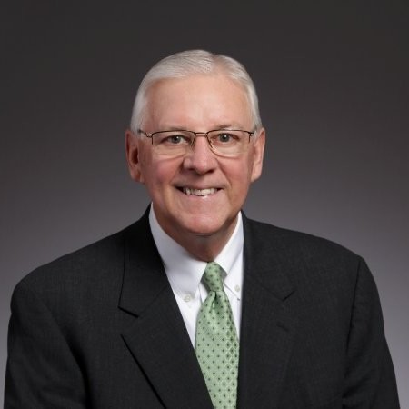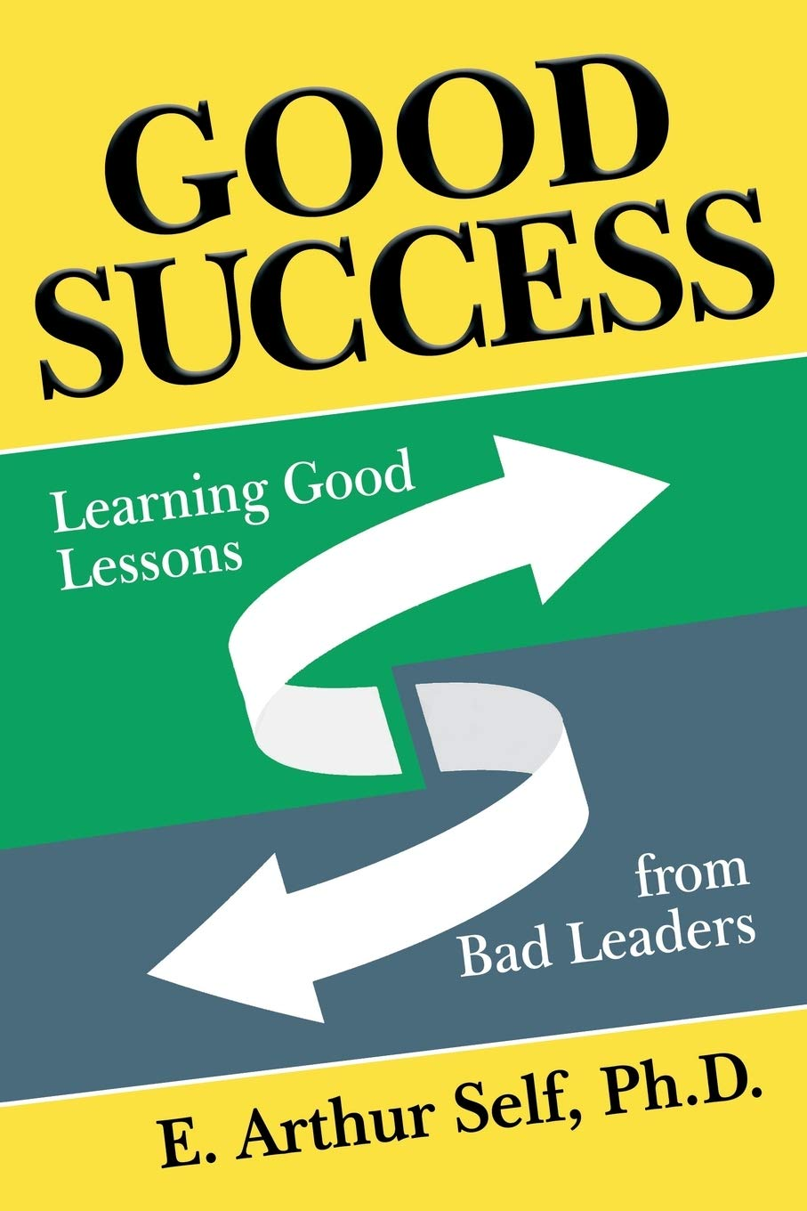

Dr. E. Arthur “Woody” Self

E. Arthur “Woody” Self, Ph.D., has over forty years successfully blending a leadership career in higher education with business theory and organizational practice. The combination of the theoretical and the pragmatic has led to transformative and lasting solutions to difficult problems for his clients, the institutions he has served and the businesses he has owned/sold.

He has held positions in community colleges, as well as doctoral degree granting institutions, and has been the president of two institutions of higher learning: Malone University of Canton, Ohio, and Seattle Pacific University. He also served as the founding Dean of the School of Business at Northwest University.

