Selection Criteria:
Selected students are positive representatives of their school. In addition to academic achievement, selected students also display characteristics of good citizenship, leadership, school/community involvement, and service to others. Students are selected as Kenai Rotary Students of the Month by Nikiski teachers and administration.

The Rotary Club of Kenai values community and service-minded individuals and wants to recognize efforts that put “Service Above Self”.
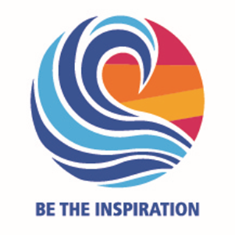

Congratulations!

You, _________________________, have been awarded Kenai Rotary’s Student of the Month for the Month of _________________, in the 2018-19 School Year.
You’re Invited…

You are invited to attend the Annual Student of the Month Luncheon on May 7th, 2019. All of the Kenai Rotary Student of the Month awardees will be invited to speak briefly about their community and school activities, their interests, and their ambitions for the future.

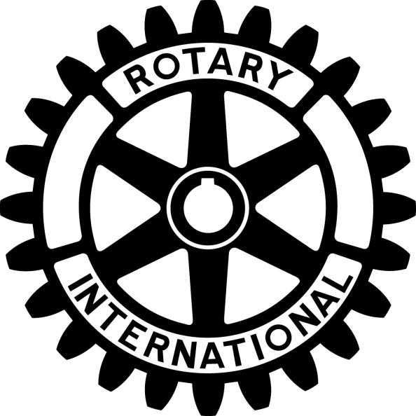

Kenai Rotary

Student

of the

Month

What is Rotary?
The object of Rotary is to develop friendships as an opportunity for service – and vice versa.

Rotary History
Our 1.2 million-member organization started with the vision of one man—Paul P. Harris. The Chicago attorney formed one of the world’s first service organizations, the Rotary Club of Chicago, on 23 February 1905 as a place where professionals with diverse backgrounds could exchange ideas and form meaningful, lifelong friendships. Rotary’s name came from the group’s early practice of rotating meetings among the offices of each member.

Rotary Activity
Locally, Kenai Rotary is involved in Kenai park improvements, hosts the annual Soapbox Derby, provides scholarships, and fulfills other important service roles.
Globally, Rotary has been working to eliminate polio. You may be aware of the devastating effects of polio on families in developing countries. Rotary International has been vaccinating children for polio since 1979, now close to eradication.
Rotary International provides Peace Fellowships, adult and youth cultural exchanges, and adult and youth leadership development opportunities (have you heard of RYLA?!). Rotary is involved in peace projects, medical relief to the under-served, and improving water and educational systems in areas that need this attention.
We are neighbors, community leaders, and global citizens uniting for the common good. With you making Kenai a better place, we can accomplish even more. Thank you for using your time and talents to serve others!

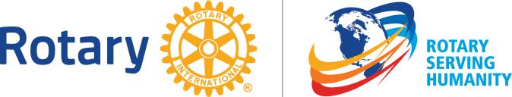

You are APPRECIATED!

The Four-Way Test is an ethical guide for Rotarians to use for their personal and professional relationships.
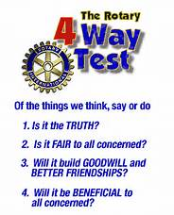

Find more information about Rotary here:
Rotary International: www.rotary.org
Kenai Rotary: http://portal.clubrunner.ca/2430
RYLA (Youth): http://rotarydistrict5010.org/

