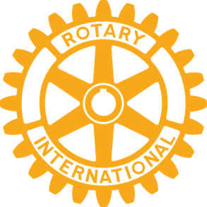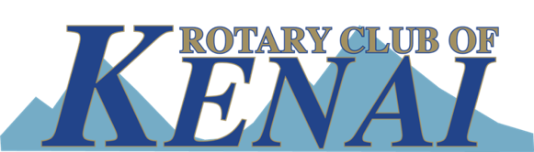

Welcome Letter Kenai Rotary

Welcome to our Kenai Rotary Club. Our club consists of 25 men and women that are business and professional leaders in the Kenai community. These individuals believe in the “Rotary” motto of service above self!

Kenai Rotary has been a strong community leader, since 1982, in supporting our youth, community, international programs and the club. Annually we raise over $30,000 for the various programs and activities. The following are the Kenai Clubs goals for 2017-18 Rotary year:

- Support of community Parks and Recreation, 2017 baseball programs
- Clean up of the Kenai spur highway.
- A scholarship for the Kenai and Nikiski High School’s graduating seniors.
- Recognizing the student of the month, awarded by their peers, at Kenai and Nikiski High School.
- Annual Soap Box Derby for young adults.
- Spring youth leadership programs in our district (RYLA).
- Eradication of Polio in the World.
- Support of Alaska’s foster children.

Our club meets each Tuesday at noon at Kenai Caterings Iditarod Café. At each meeting we have an opportunity to network with our membership and become informed by a program of interest each week, if you would like to join our meeting, please give me a call at 907.741.2131.

With warm regards- President Dick Peck

