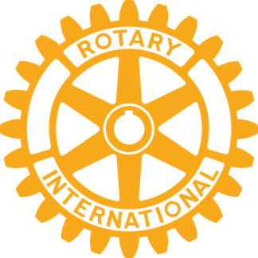

The Rotary Club of Marana
Presents

The 2015
‘Service Above Self’
Awards Dinner

Featuring…

The Rotary Club of Marana’s
Man of the Year
Woman of the Year
MUSD Employee of the Year
Student of the Year

The Town of Marana’s
Ora Mae Harn, Crystal Legacy Award
Branding Iron Awards

Master of Ceremonies, Ed Stolmaker

Friday, October 9th, 2015
5:30 pm to 8:00 pm
No-Host Cocktails, Silent Auction,
Dinner, Awards Ceremony

Heritage Highlands
Dove Mountain
4949 W. Heritage Club Blvd
Marana, Arizona 85658

Click here for pricing

