Rotary Clubs of Tucson Analysis and Solutions
BNAD 597C
University of Arizona
Kray Althaus | Anita Berberi | Stephanie Bilardi | Chris Bozorth | Amanda Shaw | Seth Wadley

Table of Contents
Executive Summary 3
Membership and Demographics of Rotary 3
Vocational Career Paths 3
Target Trade and Technical Demographic 4
Vocational Training in Tucson 5
Impact to Businesses 5
Funding 6
Accreditation 6
Government Grants and Funding 6
The Rotary Vocation Fund of Arizona 6
Recommendations 8
Appendix 10

Executive Summary
This executive summary aims to inform the reader of the research conducted by Eller Graduate Members on behalf of Rotary Clubs of the Tucson Area. Our focus on conducting research was to help develop a program that offers Tucson Area youth ages 16-24 the direction, opportunities for vocational training, and life skills needed to become qualified candidates for local businesses in need. To assess the feasibility of a vocational program being successful in the Tucson area, the Team commits to extensively researching six key areas where factual data will be required to elicit funding and/or support from the community:
- Opportunities and obstacles for small business owners in the Tucson Area
- Understand interest and key drivers for ages 16-24 in the Tucson Area
- Identify complementary/ overlapping vocation services available to Tucson Area youth
- Identify competing vocation services in the Tucson Area
- Determine funding options available for vocation services
- Demographics of the Tucson Area clubs

Membership and Demographics of Rotary
There are three distinct types of memberships incorporated under the umbrella of Rotary: Clubs; Rotary, Rotaract, and Interact. Rotary International and Rotary Foundations. Each one of these multi-level networks has membership requirements, which have unique ties to the community they serve, and their code of conduct as no two clubs are run the same, and all have ties to some type of humanitarian aid. Joining Rotary club is a lengthy process. You fill out an interest application, and administrators then review and place you into a club that aligns most with your interest. After this process, members are asked to join their social events and meetings to see if they are a good fit with this club; if they are, they are invited to join the club, followed by an induction ceremony. (Rotary, 2022)
We conducted a district 5500 demographic survey to gain insights into the demographics of the greater Tucson area clubs and to see if any club members could be integral to building a vocational program with Rotarian members. Of the 183 participants of the survey, only 56 of these members own their own businesses. Of the 56 participants, 37 participants own businesses in the Greater Tucson area; the services they provide range from healthcare, law, and real estate, to retail, non-profits, architecture, and food. The Tucson area participants' Rotarian membership ranges from 47 years to one month in service; 81 % of these members have four-year degrees, 32% are female, and 68% are male. (Shaw, 2022)

Vocational Career Paths
In Arizona, the most in-demand careers consist of manufacturing, construction, healthcare/social assistance, and Administrative and Waste Services, with an average growth of 2.8% across 136,000 jobs (Arizona Commerce Authority, 2022). Most of these jobs consist of non-union businesses and industries supporting employees with on-the-job training or financial support to gain accreditation such as an associate degree or a two-year certification from an accredited school/training institute. Unions such as the Ironworkers Local 75 (Ironworkers Local 75, n.d.), AFSCME Local 449 (AFSCME, 2020), and IBEW Local 570 (IBEW Local Union 570, 2022) all offer some on-the-job training. Many also offer apprenticeship programs and encourage those interested in vocational work to become certified professionals while starting their careers. However, only 7.1% of all vocational workers in Arizona will be represented by a union in 2021, with only 5.3% employed by a union (U.S. Bureau of Labor Statistics, 2022).
Adolescents (age 16 – 24) primarily seek careers that offer good wages, provide career growth opportunities, and can see their careers working said trade. Unions typically have a more structured apprenticeship and on-the-job training program because they have a vast network of connections through other labor unions across the country that would help facilitate the skills gap. However, due to high union dues, low career availability, and limited career growth inside the unionized organization, we do not recommend initially partnering with unions to develop a vocational program. Instead, we recommend prioritizing connections with local non-union businesses and contracting groups to establish a vocational program.

Target Trade and Technical Demographic
To gauge the target demographic interest in technical and trade vocations, our Team distributed a survey to our personal networks. We received 55 respondents; however, we have focused our analysis on the 43 who reside in Tucson; this will be 78% of the respondents (Berberi, 2022). Of those in Tucson, only 35% of respondents have been told about trade and technical, and 49% stated they are not interested in trade or technical careers (Berberi, 2022). Of those who were not interested, 0% were told about a trade or technical career. Of respondents interested in trade and technical careers: Salary and benefits were the most selected as important job attributes, matching the information on a national survey through Statista Research Department survey on Leading Factors in choosing a career in Appendix 2. Making up 36% of choices (Berberi, 2022). Of respondents interested or may be interested in trade and technical careers: Health Support, Utilities, and Cosmetology were the most selected. Construction and Transportation were the tier 2 most selected (Berberi, 2022).
Based on this information, we believe 16–24-year-olds lack awareness of trade and technical careers. The Arizona Department of Education has a Career and Technical Education (CTE) program that is working to indirectly affect this issue by addressing the connection between education and the workforce (Welcome to AZ Career and Technical Education, 2022). CTE is building a career preparation ecosystem reinforced through K-12, postsecondary, adult education, workforce development, and industry. They are working on advertising better career opportunities to ensure we, as a state, value skills over time-in-seat. In an interview with Jeff, we learned that presenting trade and technical career paths to high schoolers is possible, and audiences have been engaged when hearing the material (Jeff Hamstra, 2022). Rotary's involvement in this effort should assist school career counselors in increasing awareness of trade and technical career paths. Members should work to expand the number of schools that offer these awareness sessions. Career counselors are already required to advertise post-high school career path opportunities, not just college paths. Rotary can help fill the gap by connecting career counselors with business owners.

Vocational Training in Tucson
Many companies requiring vocational workforces in the Tucson area have turned to offer their own training programs. Some of these companies have even formed coalitions to better facilitate the training and recruitment process. One example of this would be the Independent Electrical Contractors (IEC). They have combined to create a program that focuses on recruiting talent to the trade, then filling roles within the member organizations as needed (Southern Arizona Independent Electrical Contractors, 2022). Although this program primarily targets those who have already completed high school, there are training programs specifically designed to help younger students gain exposure to the vocational trades.
One example of this would be JTED Pima, which partners with many schools in the Tucson area to provide both on-campus opportunities for education and after-school programs. While the program requirements vary between the vocations, there are opportunities for all students currently enrolled in high school courses (Pima JTED, 2022). Once students have completed high school or received their GED, they can shift to pursue further certifications or training through community-based or nationally recognized programs offered by Pima Community College and Pima Medical Institute. In most (if not all) cases, the organizations providing the training offer local businesses the opportunity to partner and recruit directly from their talent pool.
While only a subset of the total vocational programs is given as examples, the opportunities for vocational training in Tucson span all industries the Team investigated and covered the different ages in the target market. More information on some of the training programs investigated can be found in the attached file titled “Vocational_Training_Opportunities.xlsx”. These training programs vary in cost from free (to the student/apprentice) to college tuition ($15,000+). Given this, the Team recommends that instead of creating a new vocational training program, the Rotary club pursues partnering with established organizations.

Impact to Businesses
The trade (skilled worker) industry has been an industry that has been hurting for several years now. Several research factors are causing this issue, but one significant factor was the publication of "A Nation at Risk:" This publication in 1983 was when there was a shift in focus on what was taught in our K-12 grade schools. With this shift in principle by the schools to focus on pushing 4-year college degrees, the focus on skilled laborers took a back seat. The skilled laborer industry has taken a big hit in the last decade, and several factors are causing this. The biggest reason for the shortage in the industry is the retirement of many baby boomers, who make up over 25% of the workforce. With the retirement of the baby boomers, there are not enough skilled laborers filling those positions.
Through our research, we have seen that this is not an issue unique only to Southern Arizona but a nationwide issue. One person we interviewed, Andrea, who runs a vocational program in Minnesota, says parents and teachers represent that going into trades is seen as settling for a less worthy occupation. However, there is hope. Andrea says programs like hers in Minnesota are popping up throughout the United States. They are trying to turn the pendulum and show people that trades are worthy, desirable occupations with good benefits.

Funding

Accreditation
The primary competitors identified as part of the Eller Business Consulting project were local educators, such as JTED and Pima Community College. The funding options associated with these institutions are tied to national accreditation. The Rotary Clubs of the Tucson Area confirmed during scope conversations that any vocational program provided would not seek accreditation. Therefore, all national funding that requires accreditation was not researched, and the requirements for local educators are not contained within this deliverable.

Government Grants and Funding
In the last three years, Arizona benefited from over $27 million in grants from the U.S. Department of Labor Employment and Training Administration to support vocational and apprenticeship training opportunities. A total of 6 programs were created; 2 in 2019, 2020, and 2021. The USDOL grants awarded and the associated programs aim to "increase the level of apprenticeship activity among employers within information technology (IT) and IT-related industries, advanced manufacturing, and health care industry sectors. These sectors have not traditionally implemented apprenticeship programs, tiny- and medium-sized businesses." (Labor, Employment and Training Administration, 2022)
Each of the six programs involved collaboration between accredited educators and large businesses to provide training in the targeted areas. Accredited educators include Pima Community College, Arizona State University, University of Arizona College of Applied Science and Technology, Cochise Collect, and no less than nine other higher education institutions located outside of AZ. Business partnerships include many large businesses, including Raytheon, Boeing, Accenture, JP Morgan Chase, Nationwide, Petsmart, and Honeywell. Contact information for each program is listed in the Stakeholder document contained within this final deliverable.
Additionally, $80 million in funding will become available through the U.S. Department of Labor Employment and Training Administration for Nursing Expansion programs in 2022.

The Rotary Vocation Fund of Arizona
The Rotary International model and, subsequently, the Rotary Clubs model directly support the desire to provide vocational training through the Rotary Foundation.
District 5500 began its own 501c3 Foundation, the Rotary Vocational Fund of Arizona (TRVFA), in 2007. (Silvers, p. 4) TRVFA is a non-profit organization whose purpose is to "assist those people who qualify under Arizona law to obtain financial assistance to further their vocation studies." (5500, 2022, p. 38) The TRVFA's mission is to "ensure a revenue stream which will continuously fund vocational education grants requested by struggling Arizona residents who demonstrate the desire and will to enable themselves to thrive…" (The Rotary Vocational Fund of Arizona, Inc, 2022)
The Rotary Vocational Fund of Arizona Board is represented by 33 current Rotarians representing Districts 5495 and 5500. Twelve of the TRVFA representatives are current or former District Governors. (Arizona, 2022) Two members of the board, Jeanie Morgan and Diane Ventura-Goodyear, and one previous member, Joe Hentges, were interviewed as part of the Eller Business Consulting Project. All three are former District Governors for Arizona.
Candidates who meet the eligibility requirements are identified and recommended to TRVFA by financial aid counselors in vocational education institutions and/or Rotarians and their clubs (The Rotary Vocational Fund of Arizona, Inc, 2022) (The Rotary Vocational Fund of Arizona, Inc, 2022). The TRVFA Board receives candidate applications for grant application processing, and if approved, the applicant must then be interviewed and approved for sponsorship by a local Rotary Club. ("Club sponsorship provides the ability to identify and build relationships with worth applicants")(The Rotary Vocational Fund of Arizona, 2022)
Directors of the TRVFA are charged with responsibilities including, but not limited to, "ensuring TRVFA has an informative presence at educational and social events." (5500, 2022, p. 39) Additionally, The District 5500 Strategic Priorities Plan for 2022-2023 charges each Rotarian in southern Arizona to "support the Rotary Foundation through contributions, grant development and educational programs" (5500, 2022, p. 74)
The Rotary Vocational Fund of Arizona is an organization that meetings Arizona's Credit For Contributions to A Qualifying Charitable Organization (QCO) requirements (The Rotary Vocational Fund of Arizona, Inc, 22). "This individual income tax credit is available for contributions to QCOs that provide immediate basic needs to residents of Arizona who receive temporary assistance for needy families (TANF) benefits, are low-income residents of Arizona, or are individuals who have a chronic illness or physical disability. The maximum credit allowed is $800 for married filing joint filers and $400 for single, heads of household, and married filing separate filers." (Revenue, 2022)
Statewide in 2021-2022, only 9.60% of Rotarians donated to The Rotary Vocational Fund of Arizona. In District 5500, the total donated was just over $54,000, which fell far short of covering the $140,000 grants approved and funded for the District. (Morgan, 2022) The $140,000 supported 72 individuals in District 5500, of which 44% were within the targeted 16-24 age range, 33% were 25-33, 20% were 34-42, and 3% were over 43. An overwhelming majority (over 65%) received assistance in some form of healthcare/medical vocational training. These figures support the Team's recommendation to focus on the healthcare/social sector.
The institutions that received the funding for the 72 District 5500 TRVFA recipients were not identified as part of the Team's initiatives. However, in interviews with the Rotary TRVFA Board members, PMI and Pima Community College were identified as existing local partnerships. Jeanie Morgan, current TRVFA President, indicated that forming similar alliances with other, smaller niche institutions would be beneficial to Rotary and its grant recipients due to the price and longevity of the programs currently funded. (Morgan, 2022) In particular, short, low-cost CNA and phlebotomy certifications are available to awardees in Phoenix; District 5500 would benefit from identifying institutions that provide a similar service and developing a partnership.

Recommendations
The research and findings of the Eller Business Consulting Group lead to the conclusion that the Rotary Clubs of the Tucson Area should not pursue creating a new vocational training program in Tucson. Tucson already has substantial offerings in this space, with additional programs funded by the U.S. Department of Labor to be released to the public in the near future.
The Team recommends, instead, partnering with established organizations that already offer vocational services to the Tucson area. Partnerships will allow for RCTA to educate the younger population on available vocational career opportunities, form alliances with well-funded, accredited programs that are already in place, increase the public awareness of RCTA, and assist the Arizona residents who "demonstrate the desire and will to enable themselves to thrive." (The Rotary Vocational Fund of Arizona, 2022). In addition, to the benefits mentioned above, this solution aligns with current RCTA strategic goals, programs, and committees and best suits the organizational structure of Rotary.
The Pima JTED program offers various business partnerships the RCTA could utilize existing Rotarian skill sets for now. Opportunities within JTED include a guest speaker and lecturer roles, job shadowing events, and internships. These options will immediately increase awareness of vocational career opportunities for the target demographic and open direct lines of communication between Rotary Clubs of the Tucson Area and high school counselors.
In addition to the JTED partnership, the Team recommends that the RCTA clubs, members, and committees begin to form alliances with accredited vocational programs for high school graduates and above. RCTA can accomplish this by reaching out to the programs and stakeholders provided in the final deliverables package and educating financial aid counselors on the services the Rotary Vocational Fund of Arizona offers. Marketing materials already exist for such an initiative. This recommendation aligns with the current funding available to the RCTA, will provide an opportunity for Rotary to make a meaningful impact in the community, and will also introduce new potential members and mentees to the individual Clubs.
The most in-demand careers in Arizona are manufacturing, construction, healthcare/social assistance, and Administrative and Waste Services, with an average growth of 2.8% across 136,000 jobs (Arizona Commerce Authority, 2022). A focus group conducted in the Tucson area indicates an interest in vocational careers such as Health Support, Utilities, and Cosmetology (Berberi, 2022). And 66.48% of TRVFA disbursements for District 5500 in 2021 were to healthcare programs. The Teams recommendation would therefore be to focus on building key relationships with healthcare/social assistance vocational providers to start.
In conclusion of Phase I, the Teams recommendation is to partner with established vocational training programs such as JTED, focusing on vocational healthcare/social assistance programs. The key stakeholder list, provided in addition to this document, lists many local contacts who are willing and interested in establishing a path forward for vocational education within Tucson for Phase II.

Appendix

1| See the excel document titled Rotary Demographic Responses for more information on the survey information that Wendy H. sent out to District 5500.
2 | Statista Research Department, 2021
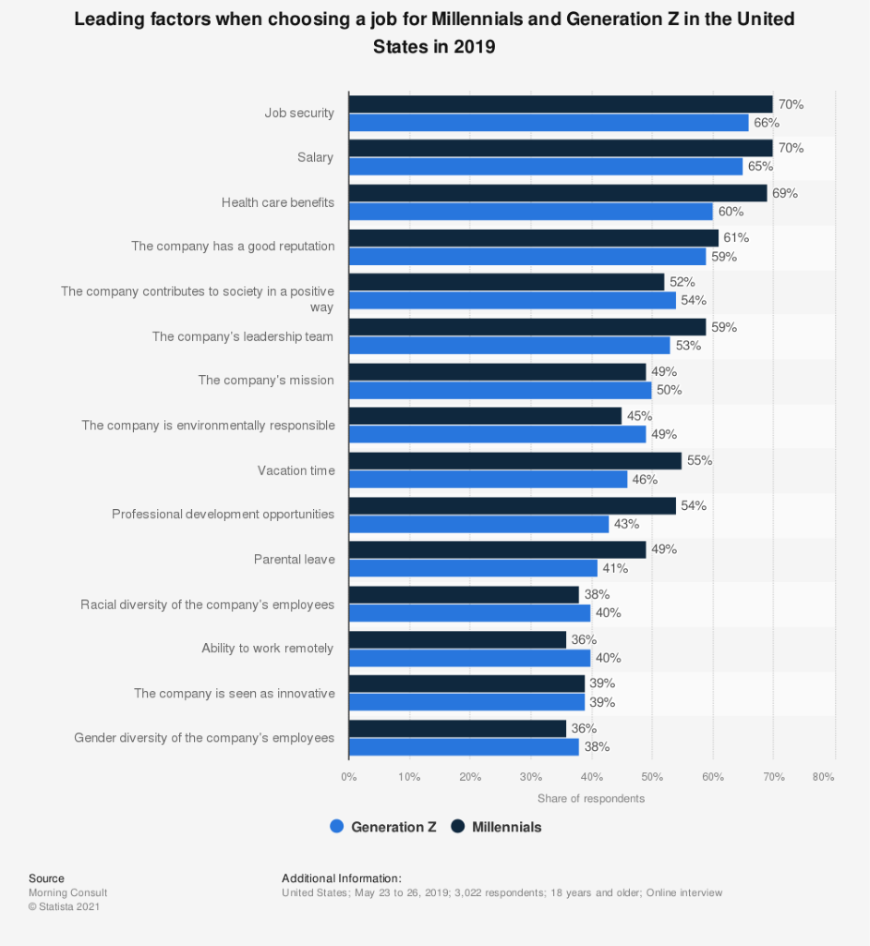

3 |Important Job Attributes from Survey Respondents of Ages 16 – 24 in Tucson
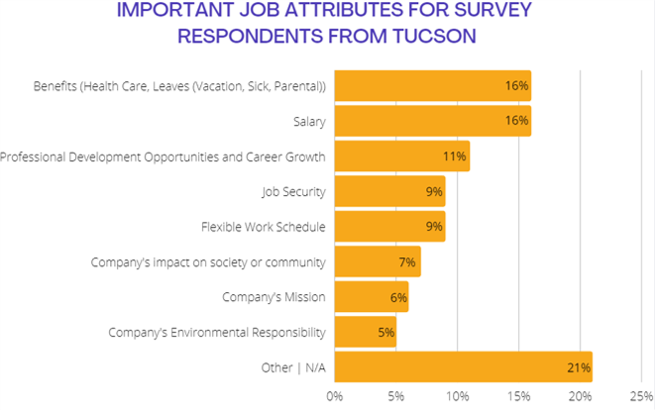
4 | Location and Age Demographics from Survey Respondents in Tucson
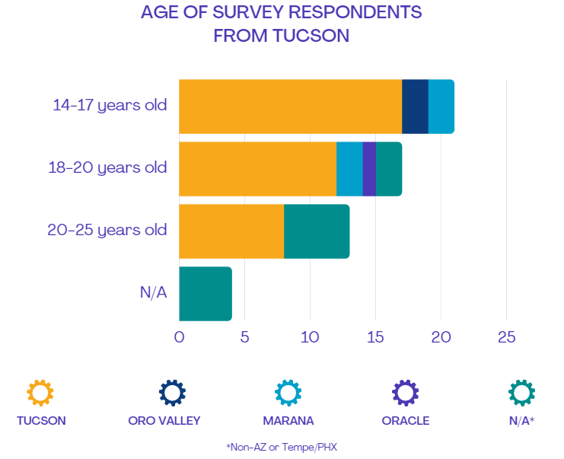

5 | Percentage of Participants who Responded to Vocation Interest Survey
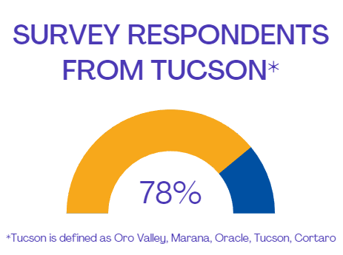
6 | Interest of Vocational Careers/Trades from Survey Respondents of Ages 16 – 24 in Tucson
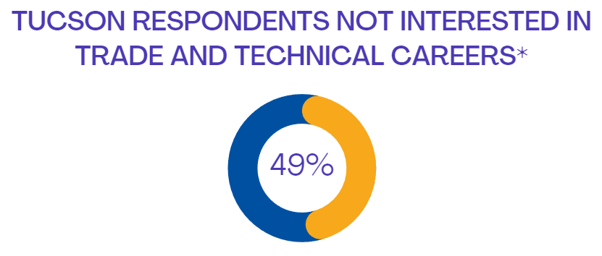
7 | Knowledge of Vocational Trades from Survey Respondents of Ages 16 – 24 in Tucson
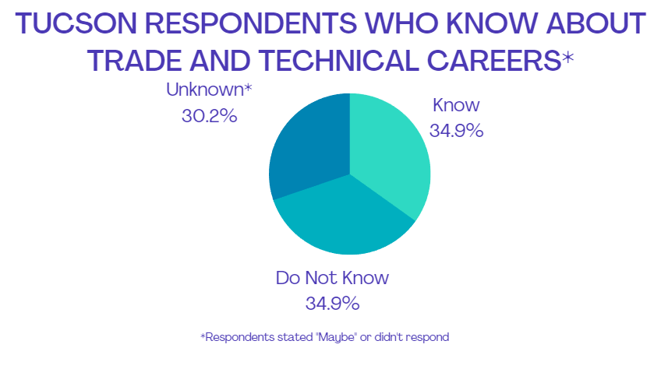

8| Rotary Vocational Fund of Arizona Financial Distribution 2021

