William Thomson Taylor 1952-2018

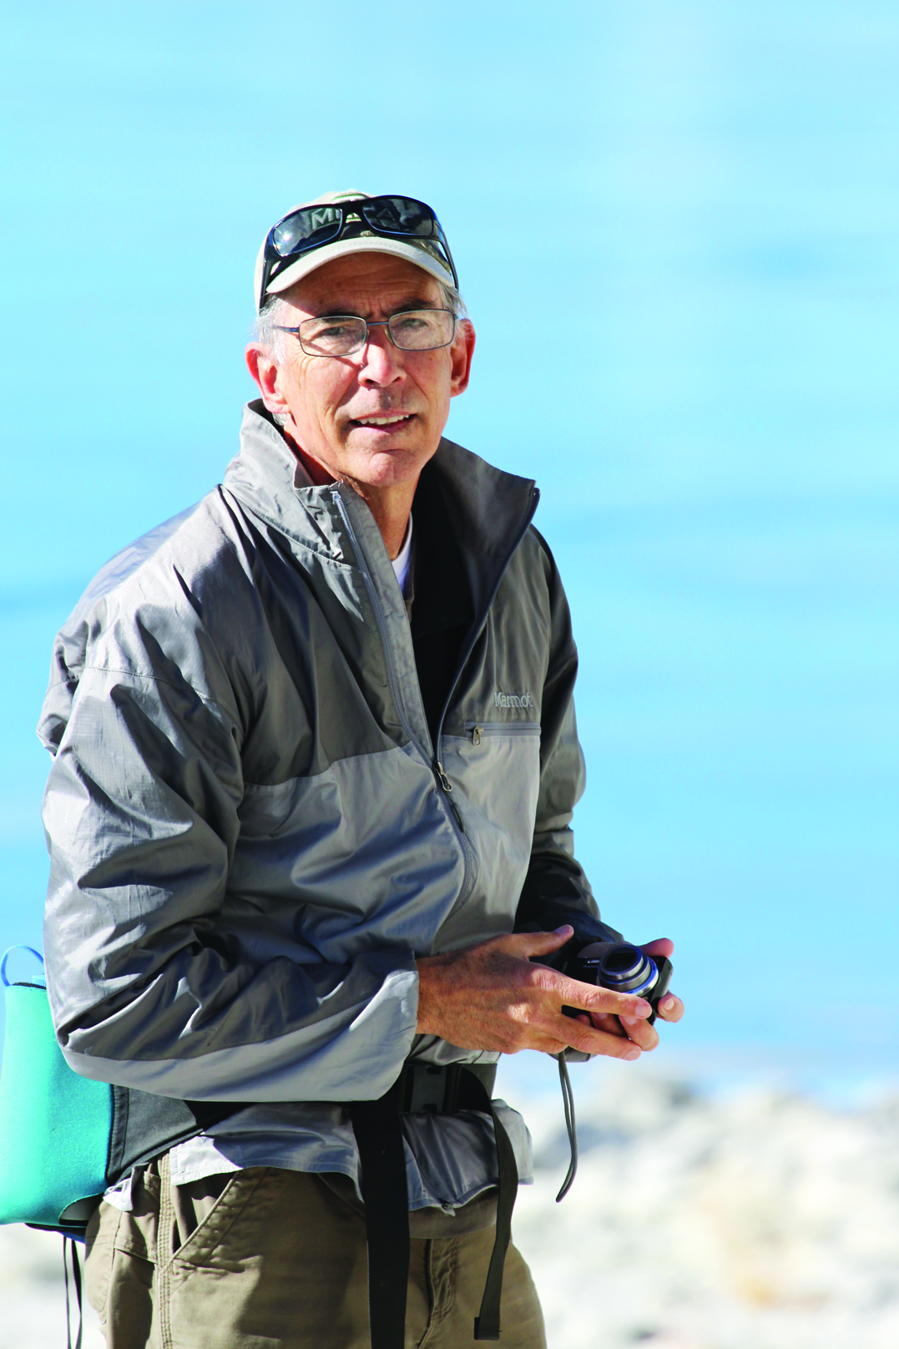

On Sunday, July 8, William Taylor died from complications related to leukemia. He was 65 years old. Born and raised in Philadelphia, Pennsylvania to parents Herb & Edie Taylor, Bill received a degree in anthropology from Amherst College in 1974 and traveled west toward a job in San Francisco after graduation. He stopped in Mammoth to visit a climbing friend, took a job as a ski-tuner at Kittredge Sports, and never left. An avid outdoorsman, Bill climbed in Tuolumne Meadows at the end of the golden era of Yosemite climbing. He hiked and backpacked countless trails and routes in the Sierra Nevada and Eastern Sierra and spent winters downhill and cross-country skiing. In the 1970s Bill worked as an archaeologist for the US Forest Service, a job he loved. He helped Mammoth incorporate and worked as one of its first town planners for 23 years, retiring in 2006. Bill was instrumental in the creation of the air quality ordinance, the Mammoth Creek easement along Old Mammoth Road, and the bike path. Retirement didn’t slow Bill down—he served on the board of Mammoth Lakes Trails & Public Access and Mammoth Lakes Housing, continued his active Rotary participation, and worked as a consultant on projects around town. He met Sherilyn Drake when she worked at Schat’s Bakery—they married and raised their sons Nathan and Davis, who are both graduates of Mammoth High School (2000 and 2004). Bill & Sherry instilled a deep love for the Eastern Sierra in their sons, taking them hiking, backpacking, skiing, and climbing throughout their childhoods. Once their kids were grown he and Sherry continued camping throughout the West and recently took up birding. Bill’s great intellect, love of the outdoors, and sense of civic responsibility were matched by a warm heart and a genuine interest in people. He brought collaboration and respect to every meeting he attended, letter he wrote, and community effort in which he participated. Even those who disagreed with Bill admired his integrity and courtesy. He will be very much missed by his countless Mammoth and Eastside friends, and family on the East and West Coasts. Bill is survived by his wife Sherry, son Nathan and wife Elin Ljung, son Davis and partner Mikkel Leslie, brother Richard Taylor and wife Phyllis, and brother Robert Taylor, as well as cousins, nephews, nieces, and in-laws. A memorial service is being planned for the fall.

