Jerry Kelly (1941-2019)

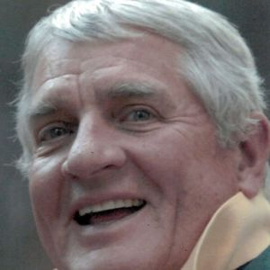

Jerry was born on December 27, 1941 in Philadelphia, Pennsylvania. Later his family moved outside the city to Horsham, PA., and then when he was 16 they relocated to the New York area. He graduated from Iona Prep and earned his Bachelors Degree from Fordham University. Throughout High School and College he competed on the track team. Specializing in Pole Vaulting. As an adult, he became an avid runner and played senior ice hockey with the Darien Winter Club. He lived most of his life, and raised his 2 children in Connecticut. He moved to Los Angeles for business in 1993 where he met his wife, Dawn. After retiring in 2001, they moved to Mammoth Lakes, CA to ski and enjoy the outdoor lifestyle of the Eastern Sierra mountains. Their next stop was in Central Orgeon to play golf and spend time with the wonderful friends they met in the Eagle Crest Resort community in Redmond, OR. After spending many winters in the Palm Springs area, he and his wife moved full time to Indio, CA last fall. Jerry had a long career in broadcast sales. Starting his career at NBC in New York in the early 60's eventually becoming president of RKO Network Radio Sales. In the mid-80's he and his partners at Manchester Productions owned the radio broadcast rights to the N.Y. Yankees. He entertained everyone with stories from the period of "hanging out" with the likes of Mickey Mantle, Billy Martin, Lou Pinella and the ever colorful Phil Rizzuto. His work life included a long stint with CNN Network Sales in NY and LA. Over his career he had the opportunity to work for ABC Network Radio, CBS Network Radio, Blair TV, CBS Network Television and ITN Syndication. Jerry was 77 when he was taken from us very suddenly on May 23, 2019. He will be sorely missed by his wife Dawn Imber Kelly, and his children Michael Kelly and Christine Stone, his son-in-law Richard Stone, and his three wonderful granddaughters - Savannah, Scarlett and Georgia. He is survived by his brother, Jeff Kelly and his sisters Rosemary Parnell and Veronica Serra. Remember to tell everyone right now how much you love them. He will be remembered with much love at a private celebration of his life at the home of great friends here in Palm Desert, and later this summer at his daughter's home in Connecticut.

A celebration of his life will be held at the home of friends Fred and Bobbie Anderson on June 12.

