Rodger Guffey (1943-2019)

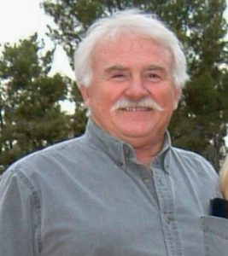

Rodger Guffey, born 5/18/1943, passed away unexpectedly on 5/17/2019. He was born in Kansas City, Kansas and played football and studied architecture at Kansas University.
Thanks to the Beach Boys, he moved west to Manhattan Beach where he worked as a toy designer for Ravel. His desire to ski brought him to relocate in Mammoth Lakes, Ca. in 1969. He skied every year since. In 1971 he started, owned and operated Perry’s Pizza, later renamed as Perry’s Italian Café. He owned and operated restaurants up until his passing including Pucchetti’s, Guiseppi’s, Tiger Bar, McDuffys, Grumpy’s, and Perry’s Italian Café. As if we wasn’t busy enough, he was intimately involved in running a variety of events. He was a charter member or Rotary and past president and became the “go-to” person for any and all barbeques or water stations to support athletic contests, Disabled Sports of the Eastern Sierra Events, and the Mono County Sheriff Search and Rescue Golf Tournament. He coached MHS softball and AYSO soccer. He was integral in running and managing the Gold Rush Days and the Mammoth Lakes Jazz Jubilee.
On most days, you would find him meeting with friends and other business owners early in the morning for breakfast or the Lunch Bunch on Tuesdays.
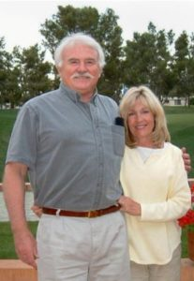
He is survived by his precious wife Carol Guffey, daughter Megan Guffey, son Ryan Naranjo, granddaughter Reyna Naranjo, and his brother Ron Guffey.
As I think back on my dad’s life and our life as a family, I couldn’t have been more blessed. He truly was an amazing man. He was selfless, put others first, always serving and supporting others, especially his wife. He was completely loyal and faithful to my mother and family. He always encouraged us and was kind. He never raised his voiced or put us down. He was diligent and worked hard so that he could play hard, and even never missed an athletic contest or music event I played in, including college and while I coached. He pursued the little things to bless, uplift, encourage, and set others up for success. He believed that one should work hard, do it well, and be proud of the work one did. When a situation seemed overwhelming, he was so even keel and tackled the looming task with one step at a time. He always sought ways to make things work. He was patient yet firm. He was humble yet confident, diligent yet fun loving. For as long as I can remember, we never left each other without a hug and an “I Love You,” even if we were only going to be gone a few minutes. He also loved and believed in Jesus as the author and finisher of our faith, our strength in times of weakness, our gentle and loving savior who gave his life so that others may live. He may not have vocalized it much, but his faith sure was visible in his serving of others and his character.

A public graveside service will be held Saturday June 8th at 12 pm at the East Line Cemetery in Bishop. In lieu of flowers and gifts, please make a donation in loving memory to Chamber Music Unbound, POB 1219 Mammoth Lakes, Ca. 93546 or Disabled Sports of the Eastern Sierra, POB 7275 Mammoth Lakes, Ca. 93546-7275.

