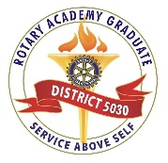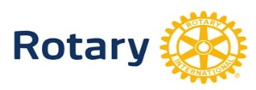
ROTARY DISTRICT 5030
2017-2018 ROTARY ACADEMY

The Rotary Academy is a comprehensive self-paced study program of Rotary information — great for both new and experienced Rotarians and anyone considering club or district leadership positions.

Register as a TEAM* --- Get a Discount!

*Two or more new student registrations from one club: $80
(save $15 each)

Name_____________________________________________________________________

Address___________________________________________________________________

City_____________________________________ Zip________________________

Phone # ( )______-___________ Email ____________________@________________

Rotary Club of _______________________________

Registration Fee for NEW Students (TEAM)....$80 List Team Members or Team Name Below:

___________________ ___________________ ____________________ __________________

Registration Fee for NEW Students.................$95

Registration Fee for FORMER** Students.......$70
**Previously, I completed lessons on the following topics: ________________________________,

_____________________________, _____________________________, ____________________

(Registration fee is non-refundable and includes all instructional materials and dinner for graduates.)

Mail completed registration form and check payable to Rotary District 5030 to:

Wayne Ottum, 218 Main St., #263, Kirkland, WA 98033

Note: To pay by credit card, please email or call Wayne Ottum (wayne@ottumenterprises.com – 206.351.4656) to receive a PayPal invoice.

Student Kickoff Meeting: Thursday, September 21st, 7-8 PM
Masonic Hall in West Seattle, 4736 40th Avenue SW

