NE Portland Rotary celebrates 50 years of service
Discover why this service club was founded “way out east” in Multnomah County‚ and why they’re still going strong‚
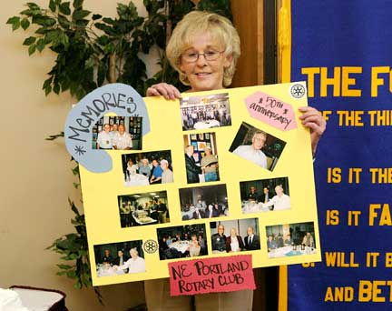
Holding a poster depicting activities of this 50-year-old Rotary club, is Northeast Portland Rotary’s treasurer, and a member since 1987, Shirley Wiltshire.
Story and photo by David F. Ashton
The Refectory’s banquet room was packed a few weeks ago, as the Northeast Portland Rotary club celebrated its 50th anniversary.
The club’s members were joined by well wishers from other area Rotary clubs, and past members.
First-hand history
One of the two founding members, Keith Manning, gave us a first-hand account of the club’s beginnings.
“When we started,” Manning began, “there wasn’t much out here in Multnomah County. Most of the ‘city’ stopped at 82nd Avenue. Back then, Parkrose was ‘the city’; Portland was way out west. One of the difficulties of forming a club here was that our membership was so spread out.”
Asked why he joined Rotary, Manning explained, “To begin with, it was a means of acquaintance. After you get involved a little, you realize that you’re part of something bigger than yourself, or even your local club. Together, we work to help many people in many ways.”
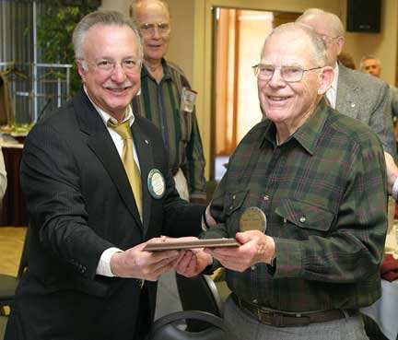
Stephen H. Wiley presents Keith Manning, one of two living founding members of the club, with a plaque commemorating the 50th anniversary of the Northeast Portland Rotary Club. The other founding member, Aldo Rossi, was unable to attend the meeting.
The club first met at St. Clair’s, now the Pig N’ Pancake. They moved to The Flame at SE 122nd Ave. and Halsey St. When that was torn down, the club met at Chinese Garden. Today it meets each Tuesday at noon at The Refectory, on NE 122nd Ave. north of Halsey St.
Manning, who told us he operated a dry cleaning business at NE 119th Ave. and Halsey St. “for 40 some-odd years”, said Rotary gives individuals the opportunity to come in contact with the people they would not otherwise meet. “I’ve attended somewhere in the neighborhood of 2,500 meetings. You can’t be around this group for any length of time and not gain an education.”
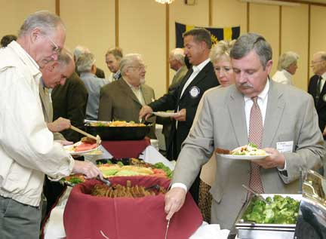
Club members line up for a delicious buffet luncheon served at their regular meeting place, The Refectory.
The club’s current president, Nick Rossi, told us his family has a long history with Rotary. “In 1957, my dad Aldo was a charter member here. We’re still working to do good things for our community and the world. I got involved because of Dad. It’s nice to give back to the community.”
Through their international organization, Rossi said Rotary is the driving force for eradicating polio. “We’re bringing fresh water to impoverished areas. Locally, we provide scholarships for high school seniors, we’ve restored Camp Collins, and we have a number of youth activities.”
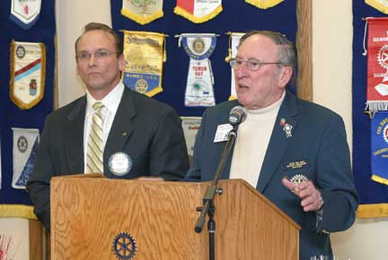
Rotary District 5100 Governor Thomas W. Jenkins presents the keynote address, congratulating the club for providing 50 years of service.
After introductions and other club traditions were observed, Rotary District 5100 Governor Thomas W. Jenkins addressed the group.
Jenkins recounted the history of Rotary, saying that Paul Harris, the founder, looked to create a group that valued fellowship, doing business with one another, and later, to be of service to their community.
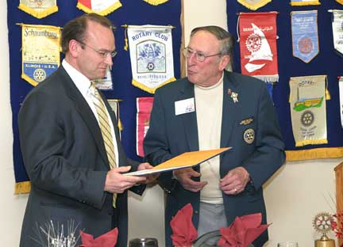
Northeast Portland Rotary Club president Nick Rossi accepts a certificate of commendation from Thomas Jenkins.
We at East Portland News Service extend our congratulations to the members who keep the spirit of Rotary alive in outer East Portland.

