This Photo by Unknown Author is licensed under CC BY-NC
Come celebrate with the

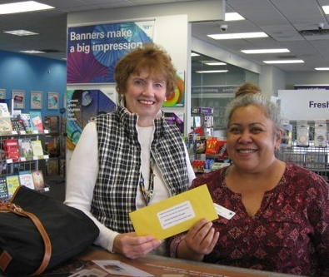
Committed to our Community:

Businesses: Donations to 30 local restaurants and businesses during pandemic.
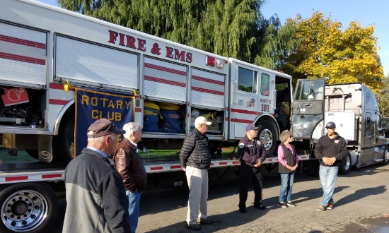
Firefighters: Rescue Truck with jaws of life and essential equipment sent to Mexico.
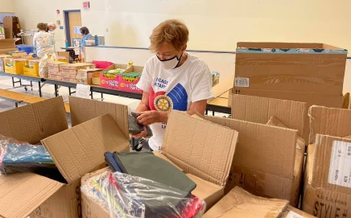
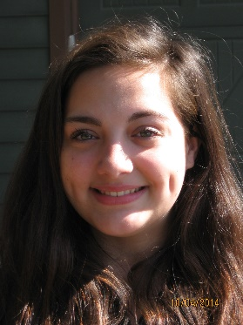
Veterans: Supporting the Vietnam War Memorial, The Tanner Project, Westcare.
Children: Supporting JGEMS Vex/Robotics Team, ALS-K Auxiliary Operation Backpack, Youth Exchange, Liberty House, Family Building Blocks.

Environment: Adopted Halls Ferry State Park.
Disasters: Aid to Ukraine Relief Fund and
to Local Fire Victims.

Camaraderie: Assemblies, Socials, Fellowships

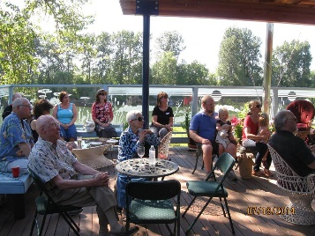 |  | 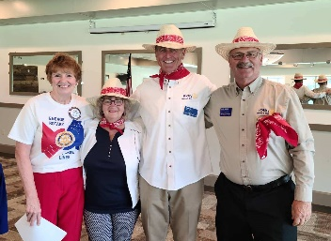 |  | 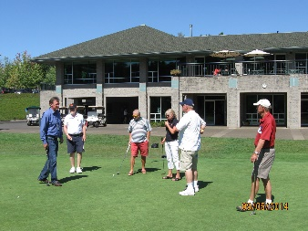 |  | 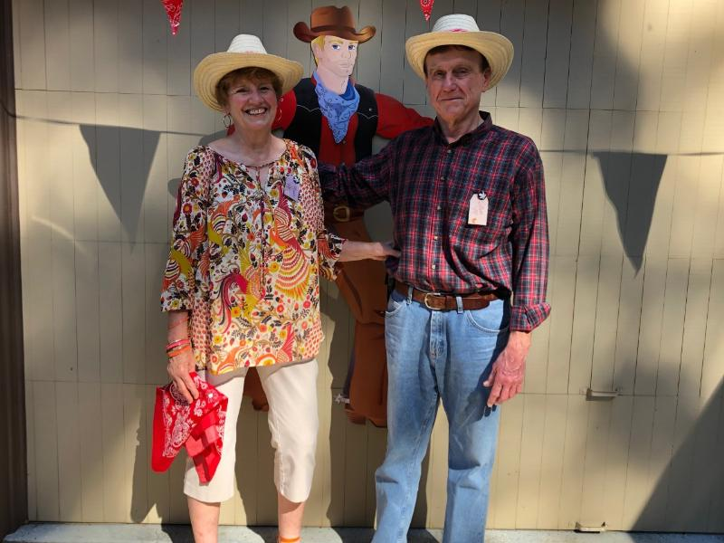

For more information and stories about our projects and activities, check our Club website: www.clubrunner.ca/salemcreekside, or call (503) 580-3755. Be our guest Thursdays at noon, Danny’s on the Green, Creekside Golf Club, 6250 Clubhouse Dr. SE.
Come help us plan our next service project. Easy to get involved or just have fun.

