
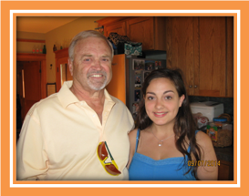
CONSIDER BEING A HOST FAMILY FOR ROTARY YOUTH EXCHANGE!

Rotary Club of Salem Creekside is looking for families to be hosts for our exchange students for 2015-2016. There are numerous reasons for hosting a student.
- Hosting is a lot of fun. These students are bright, fun, independent and interesting.
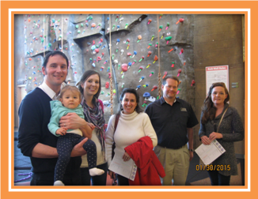
- Hosting gives you a glimpse of another culture without the cost of travel!
- Hosting for Rotary is great – you get lots of support. Rotary is always there to help provide rides, excursions and so much more.
- Hosting gives you someone to visit in another country when it is your turn to travel.
- Hosting allows you to explore your own environment through the eyes of someone else – giving you a great excuse for that extra trip to the coast, the mountains or your local museums.
- Hosting teaches you to communicate in many ways – not just English – and to learn how to teach English pronunciation and English idiosyncrasies to others.
- Hosting creates an opportunity for your children to learn about another culture and learn how to share with someone other than their siblings.
- Hosting gives you the opportunity to share our culture with students from around the world.
- Hosting brings the joy of adding another member to your family!
- Hosting fills that empty bedroom that has been haunting your house and adds another person to do dishes and chores!
- Hosting adds to your Holiday mailing list – with correspondence all over the world that lasts a lifetime!


There are numerous incentives to hosting. Consider making a commitment for 3-4 months (although it can be hard to give up the student). Students will be attending high schools in our area, so would prefer families in the South area. Open up the possibilities for our students and your family.
Please contact Elizabeth Griffin or Maria Mokrai at Salem Creekside Rotary if you are interested in hosting, or have a family you would recommend.

