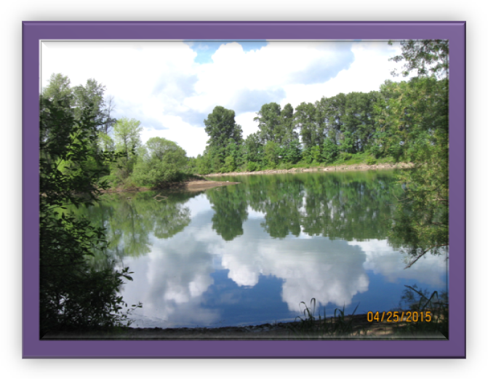
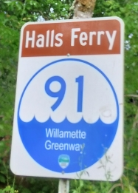
Halls Ferry State Park
On a beautiful spring day, there is nothing better than paddling your canoe down the Willamette River. About 6 miles south of Salem on River Road is Halls Ferry State Park, offering serene landscapes and tranquility disturbed only by the natural sounds of wildlife peering around every corner. Sunlight reflected by the clear water and a slight scent of pine, sage and lavender protrude through the brush.
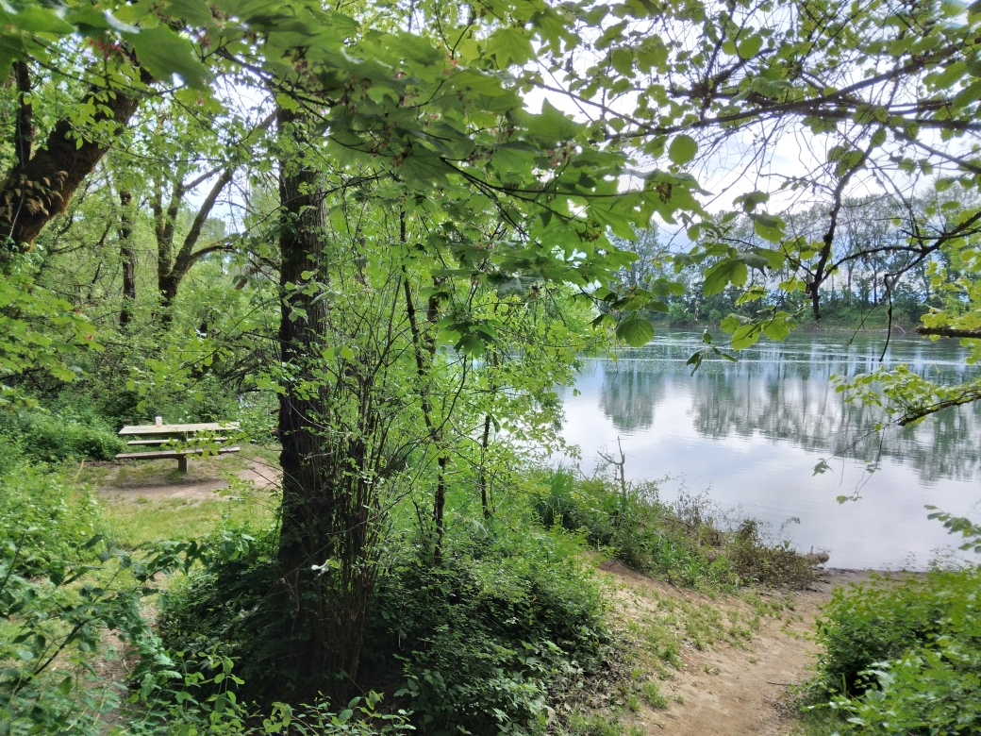
Halls Ferry operated in the Oregon Territory long before it became a state park. In 1868, the ferry allowed farmers to cross the Willamette River, transporting goods to nearby markets and providing prosperity to the local community. The original land has become Halls Ferry State Park, a quiet place to picnic, fish or start your adventure on the water. The Rotary Club of Salem Creekside adopted and maintain Halls Ferry State Park for all to enjoy.
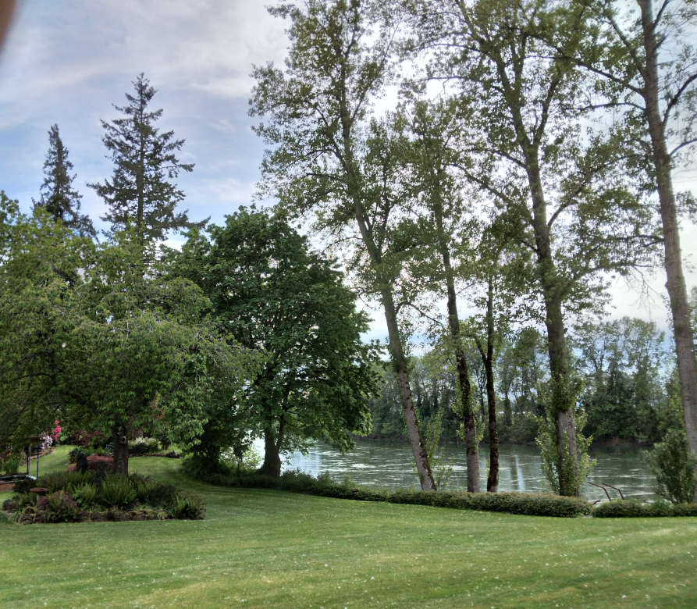

Come, join the Rotary Club of Salem Creekside Saturday, June 11th, 10 am, as we clean signs, clear pathways, trim bushes, and provide general maintenance. Then dine with us on the banks of the majestic Willamette River. For additional information on this or other Creekside Rotary service projects contact Doug at (503) 580-3755 or www. www.clubrunner.ca/salemcreekside.

Supporting the Environment

