Why I joined Creekside Rotary

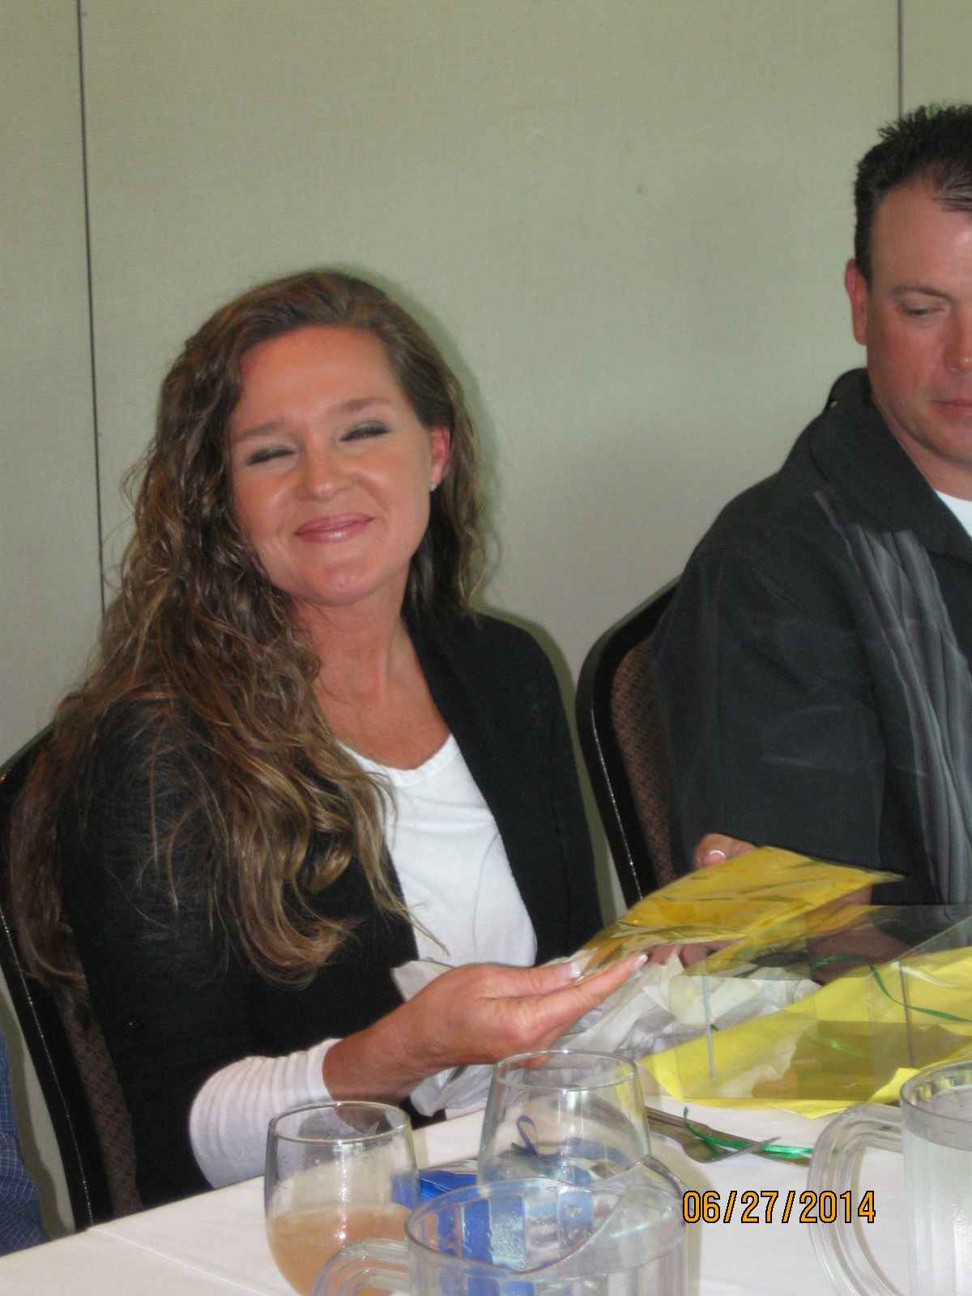
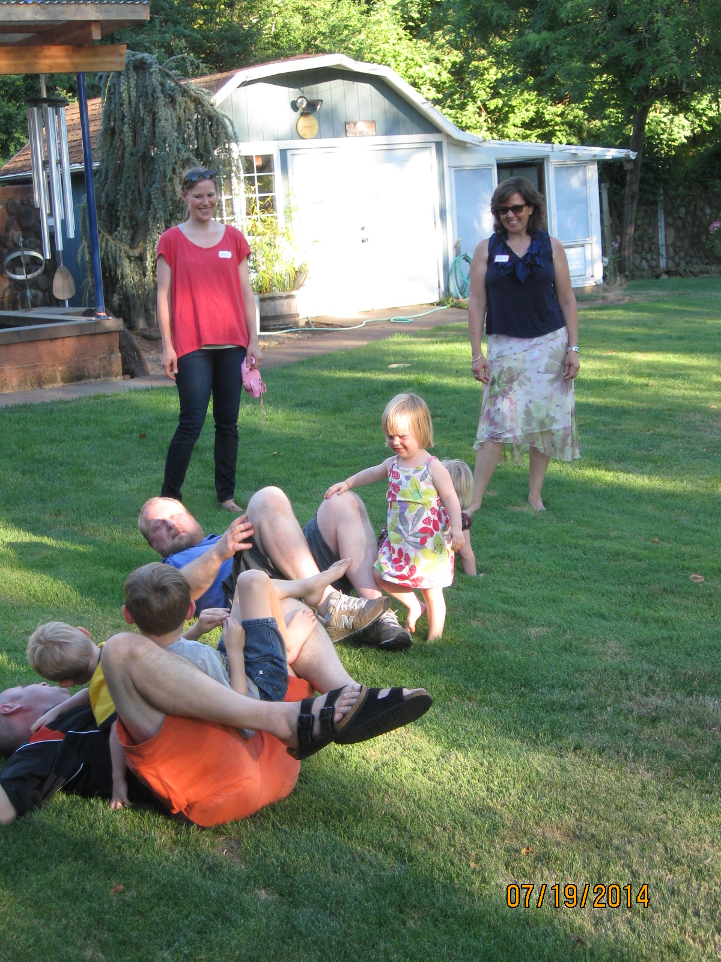
“If asked why I first joined Rotary, my initial response would have been, ‘because my friend asked me to and because my Grandpa was a Rotarian’. The truth of the matter is, Rotary has provided me with additional opportunities to serve my community. I volunteer frequently with local non-profits through my employment at Wells Fargo. Creekside Rotary has allowed me to explore more hands on service projects which I really enjoy and I’m thankful that I can share this experience with fellow Rotarians in this group that have the same aspect in life as I do, to give is better than to receive.” Jeremy Rand, Wells Fargo Bank
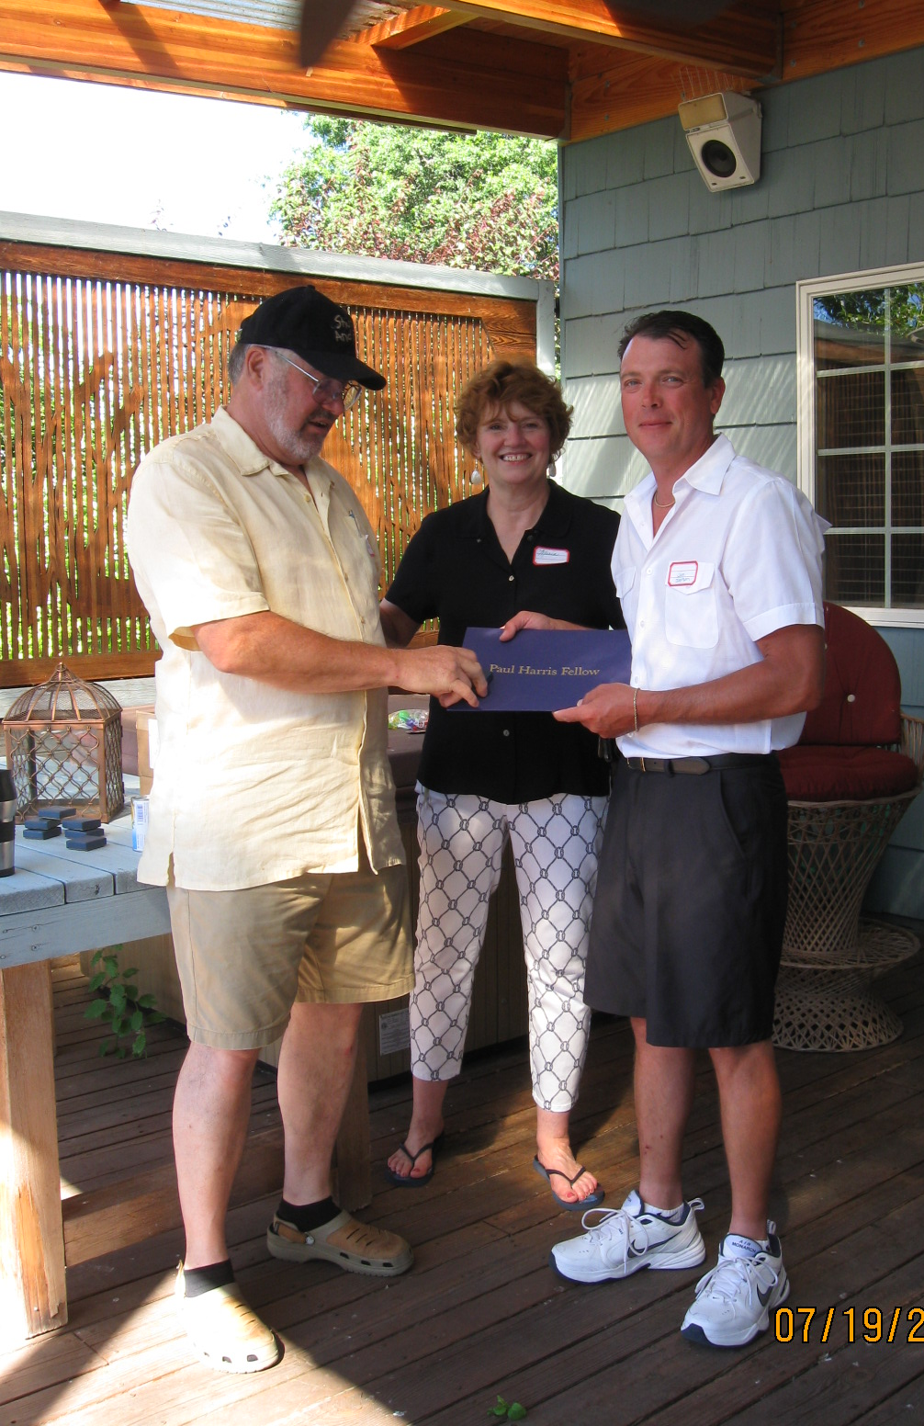
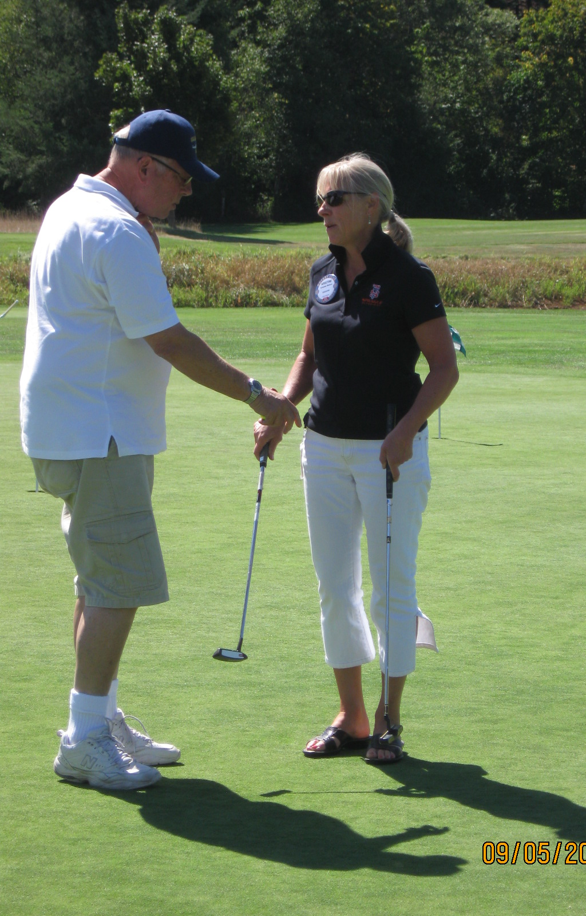
“My early memories of Rotary as a teenager were of attending with my father—a charter member of his Club. I admired how this group of local leaders worked to help our town and had fun doing it. Fast forward to 10 years ago—2004—when career changes allowed me more time for Rotary. The Creekside group became my Rotary family. Here we help the community with hands-on projects, join in worldwide humanitarian efforts, and have fun doing it. I like that members are friendly and enjoy each other’s company, and that the weekly programs keep us up to speed about what’s going on in Salem. My suggestion—give Rotary a chance!” Doug Carney
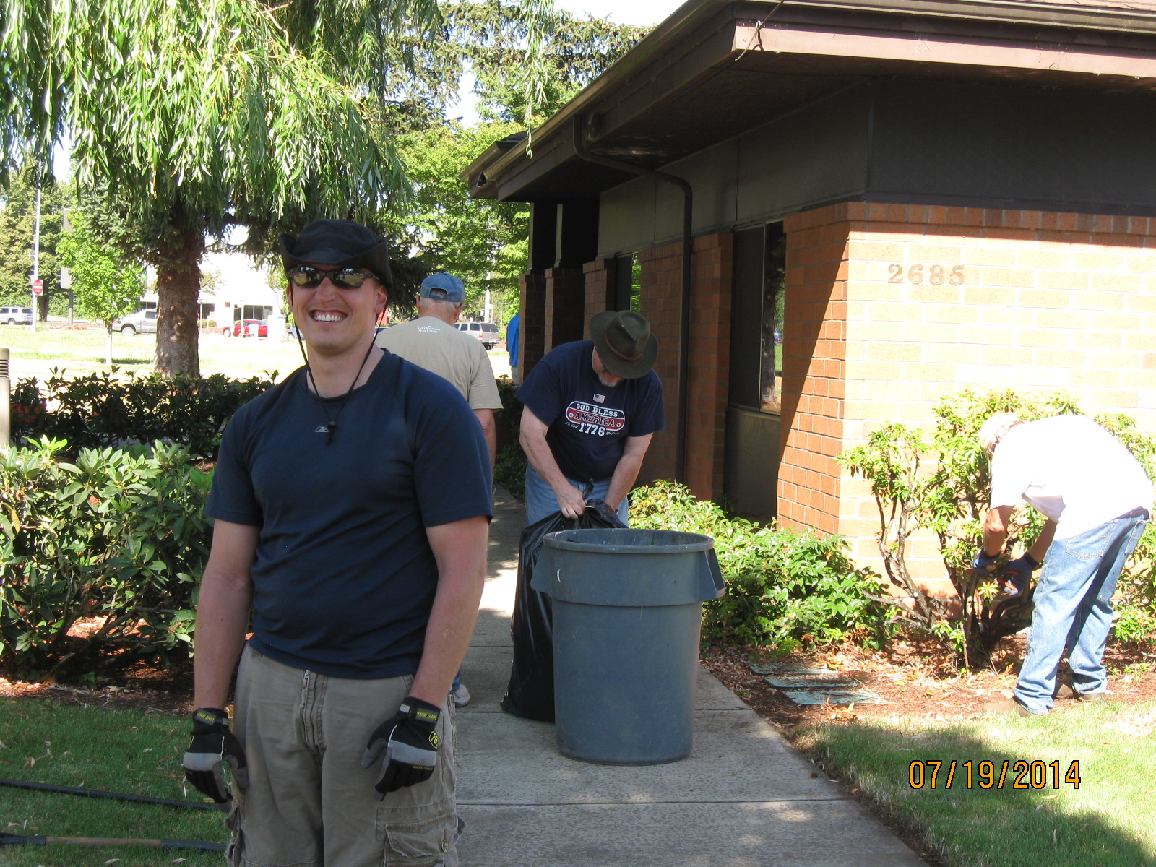
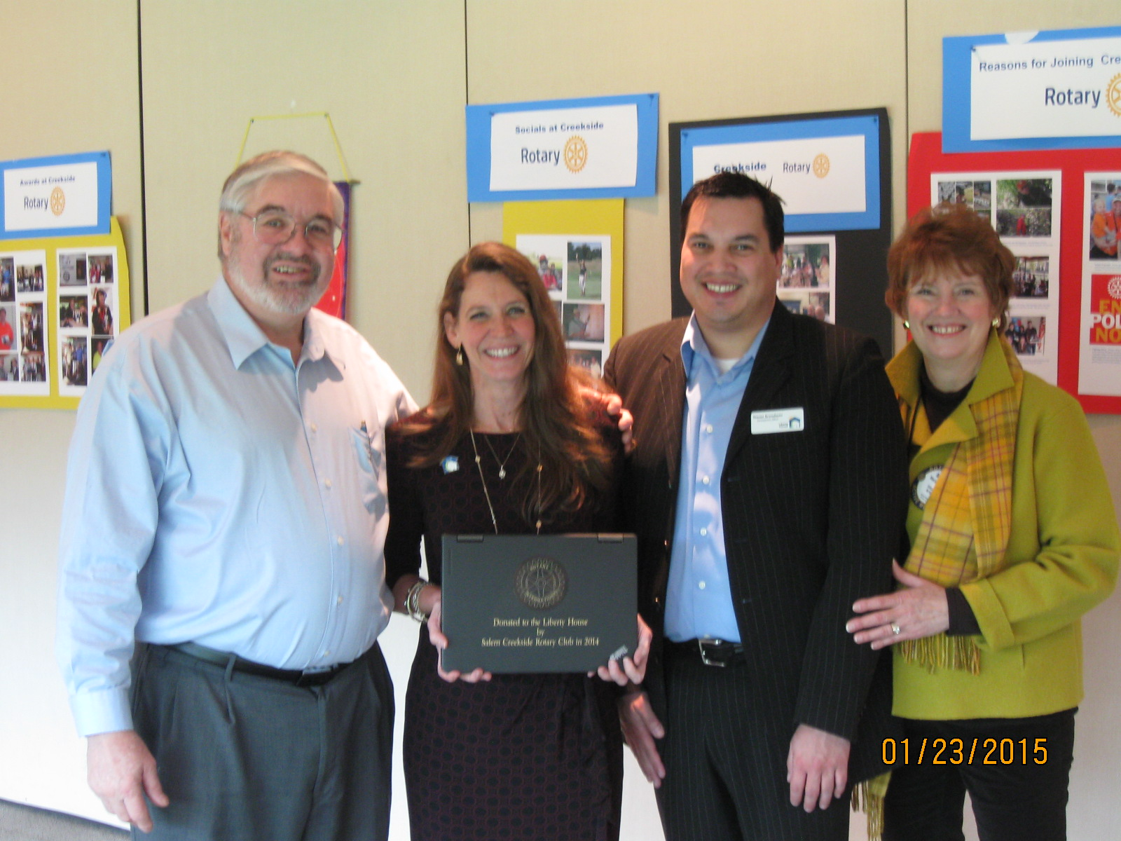
“I remember having a conversation with a co-worker and he asked me why I was joining Rotary. I looked at him and said I’m not real sure why. At the time I had no idea of all the good our Rotary club does for the community. I’m so happy to be part of a great club that strives unselfishly to help others. Now I can say with pride that I’m part of Rotary to help others and to work with a great team dedicated to the community. I’m relatively new to Rotary but I’m looking forward to being part of this club for years to come. Thank you for allowing me to be part of the Creekside Rotary.” Jeff Lewis, Store Manager, Roth’s Sunnyslope.
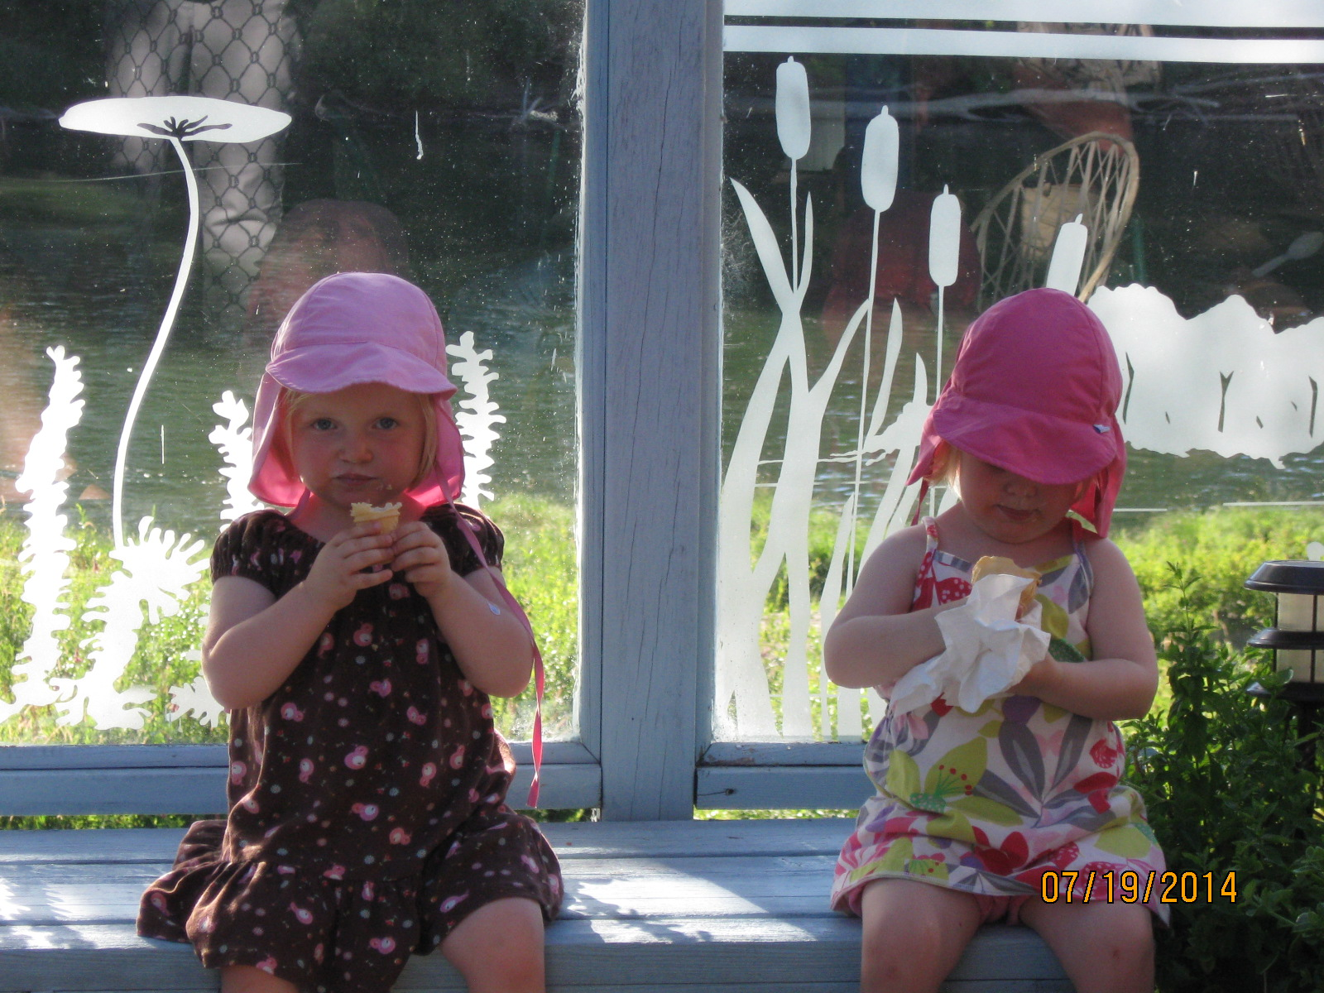
”I am a charter member of Creekside Rotary and have been with Creekside since day one. I am a member of Rotary for one simple reason - because there is where a person can team up with some of the best in their respective fields. True leaders who live to help others and the world they live in. What a great group of people who truly understand the Rotary motto of "Service Above Self." Creekside Rotary is a small club but this has great advantages. With a small cub every member must be a part of the team to do great things.” Richard D. Beck

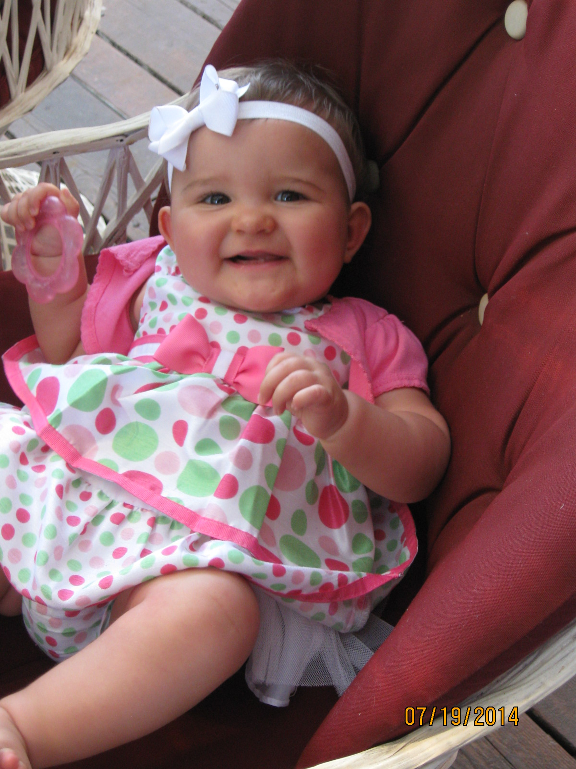
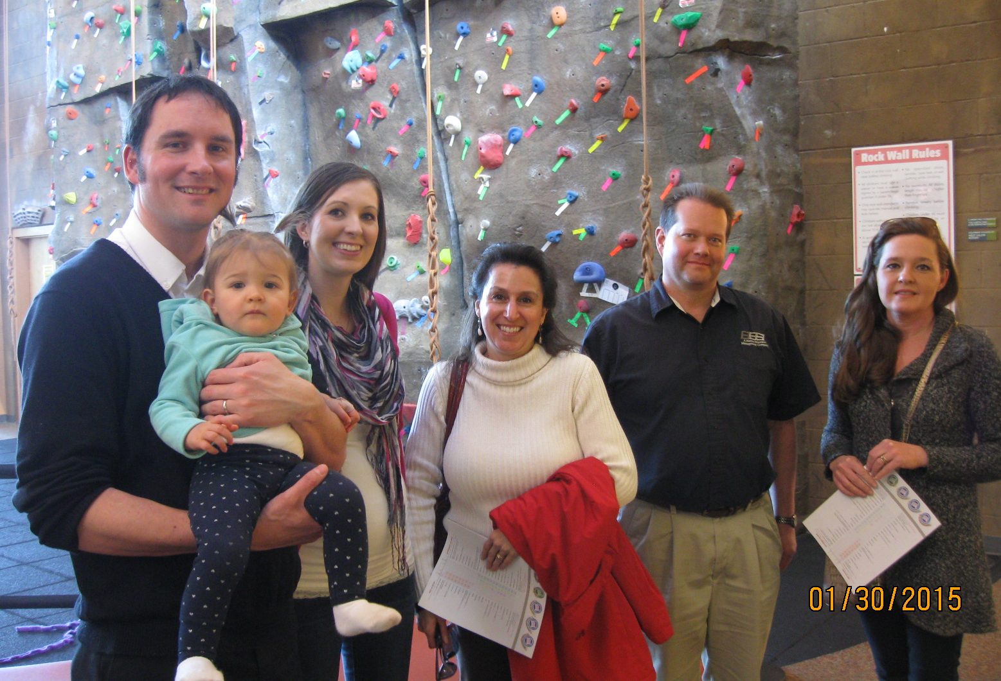
“As a new Rotarian I enjoy getting to know my community better through fellowship with fellow Rotarians and listening to guest speakers. I am also able to be an ambassador for the great things our students are achieving in the Salem-Keizer public schools. I look forward to continued learning and participating in service projects.” Kristine Walton, Principal, Crossler Middle School
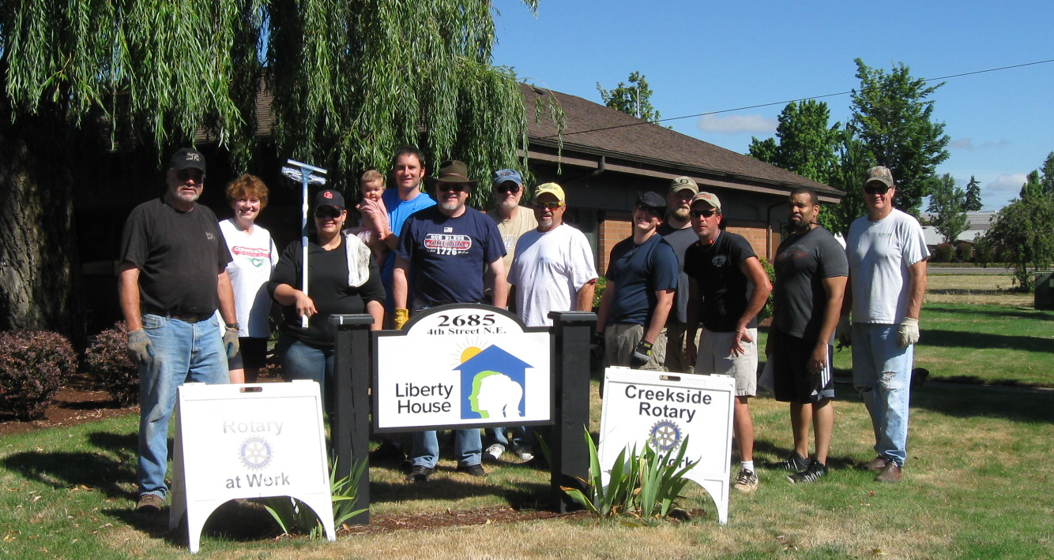
“I joined Rotary in 1980 in Fullerton, CA. I am a charter member of Creekside Rotary and past president 2001-2002. I belong to Rotary because of its strong international service. It is a way to interact with leaders of my communit y who give generously of their time and money to help others. It is a weekly commitment to make new and lasting friends. The weekly programs keep me informed of what is going on in my community and the world.

What I like most about Creekside Rotary is the close relationship of its membership. Although a small club, we work well together on small community and international projects. We have great social interactions. No one is left out. (Not even Beaver fans – ha, ha!)” Richard Peffley

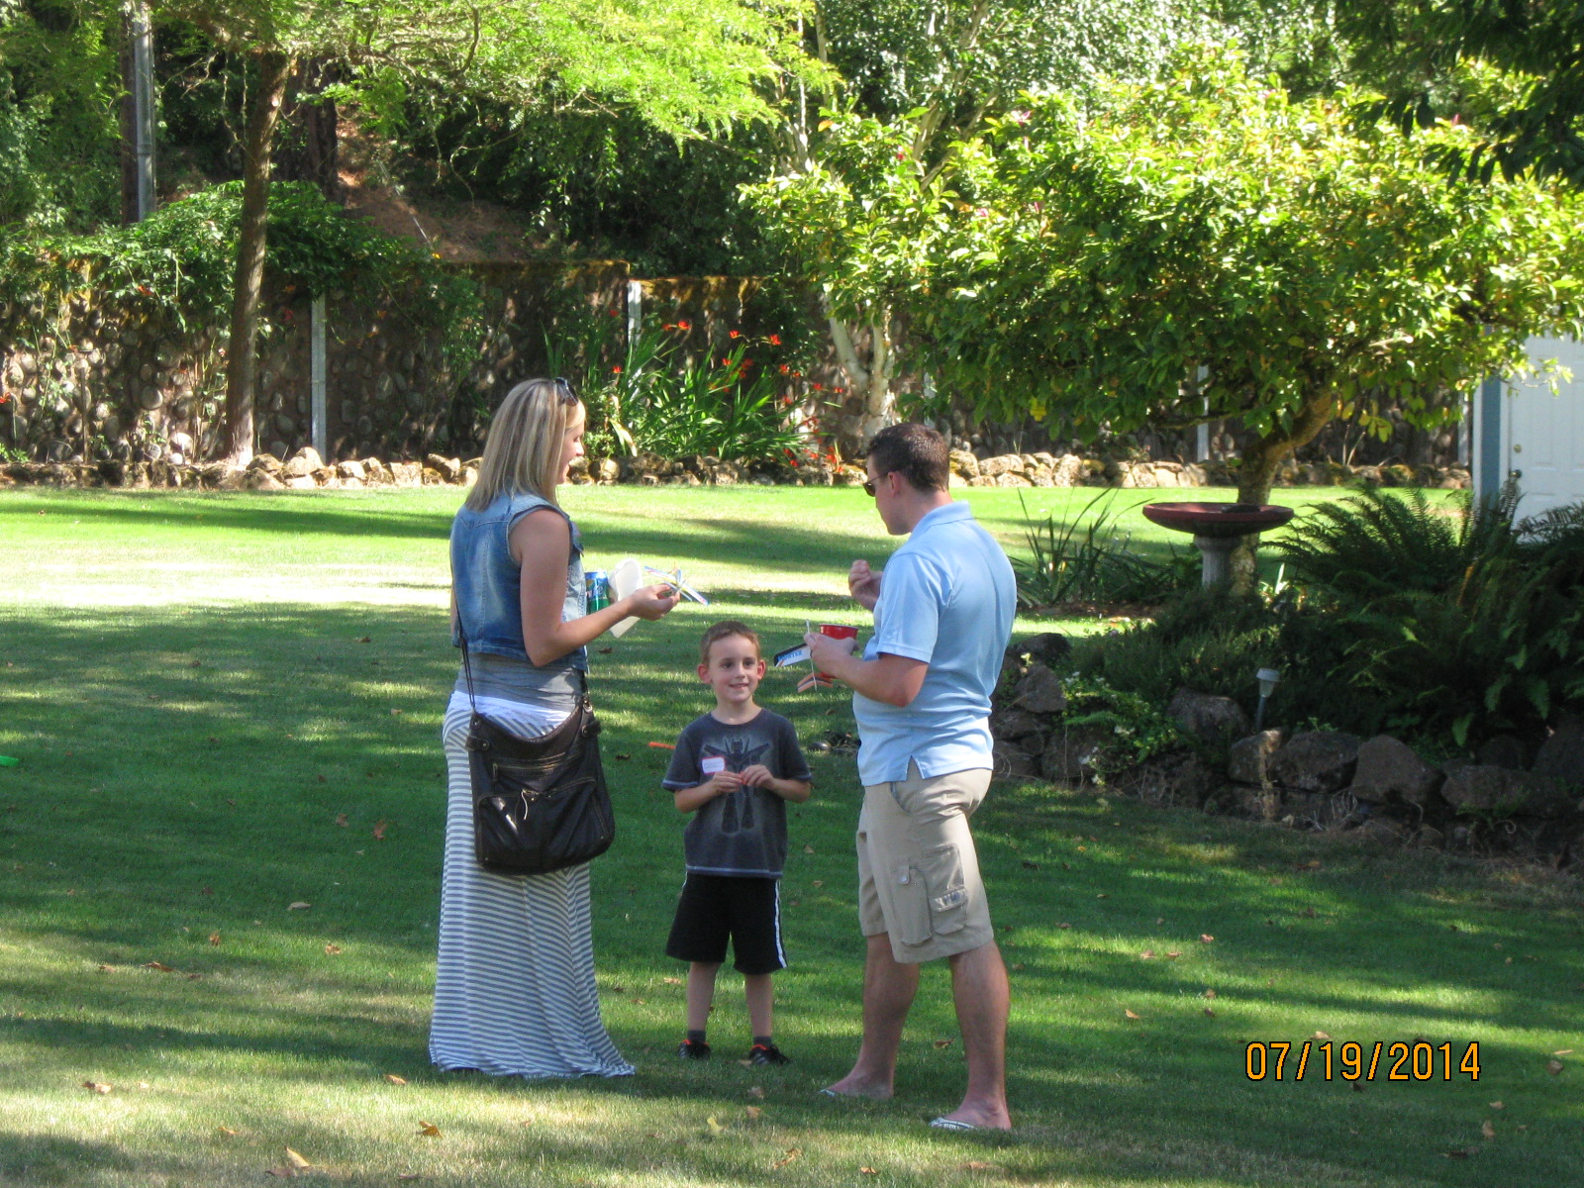
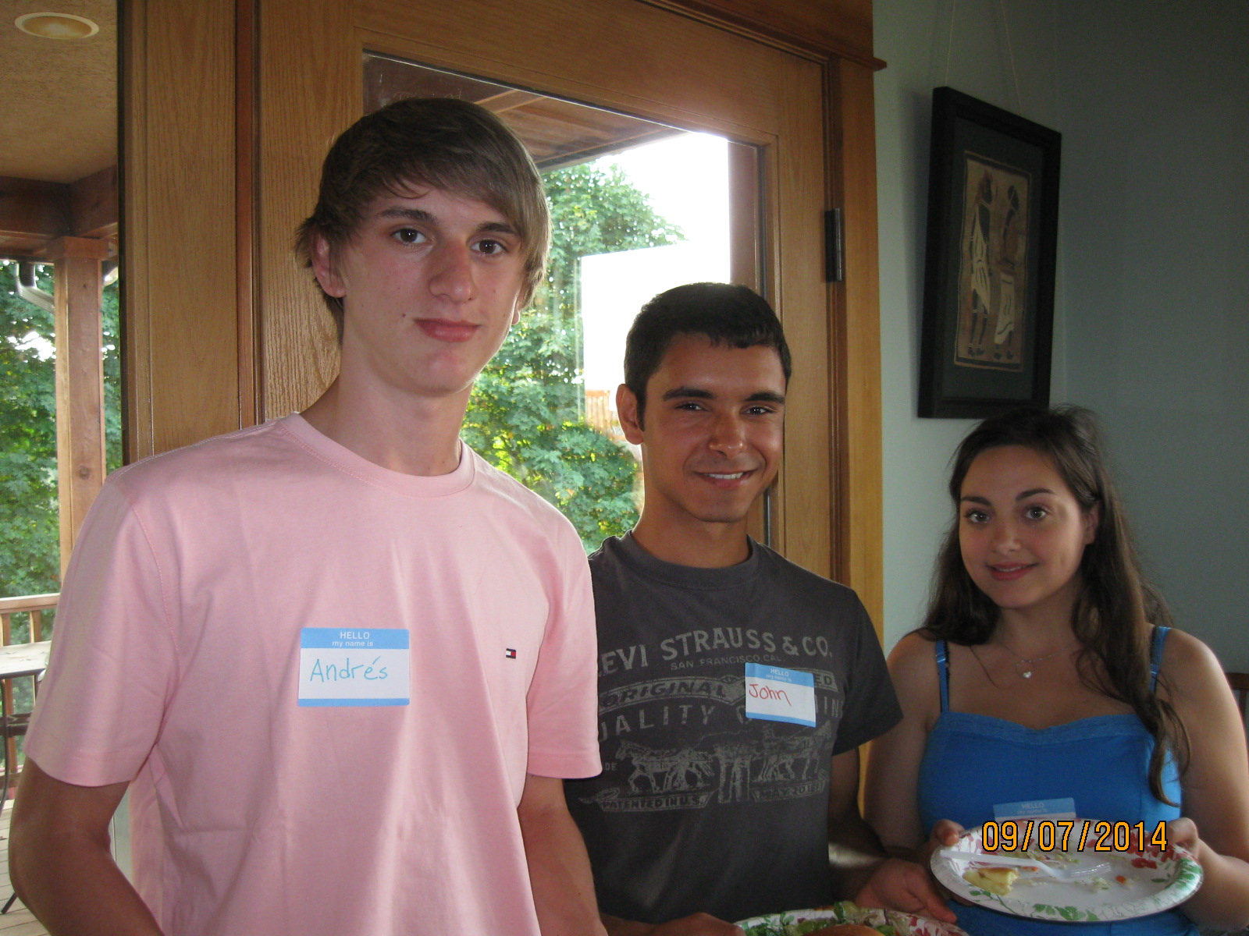
“I first joined Rotary with the Salem Downtown club primarily for business reasons. But, once I became active I “got hooked” on all the great activities that Rotary does. I decided to transfer to our Creekside club because it is smaller with closer personal ties with members than what I found with the larger club. My Creekside membership has been very rewarding. The camaraderie and involvement of our members is an inspiration to me and furthers my commitment to Rotary.” Pete Meuleveld

“I enjoy the camaraderie and relaxed character of this Club as well as its commitment to serving the community. My mission with this group is to support its good works locally and internationally and to be a valued and respected Rotary member.” Rich Ford, Broker, Windermere Pacific West Properties

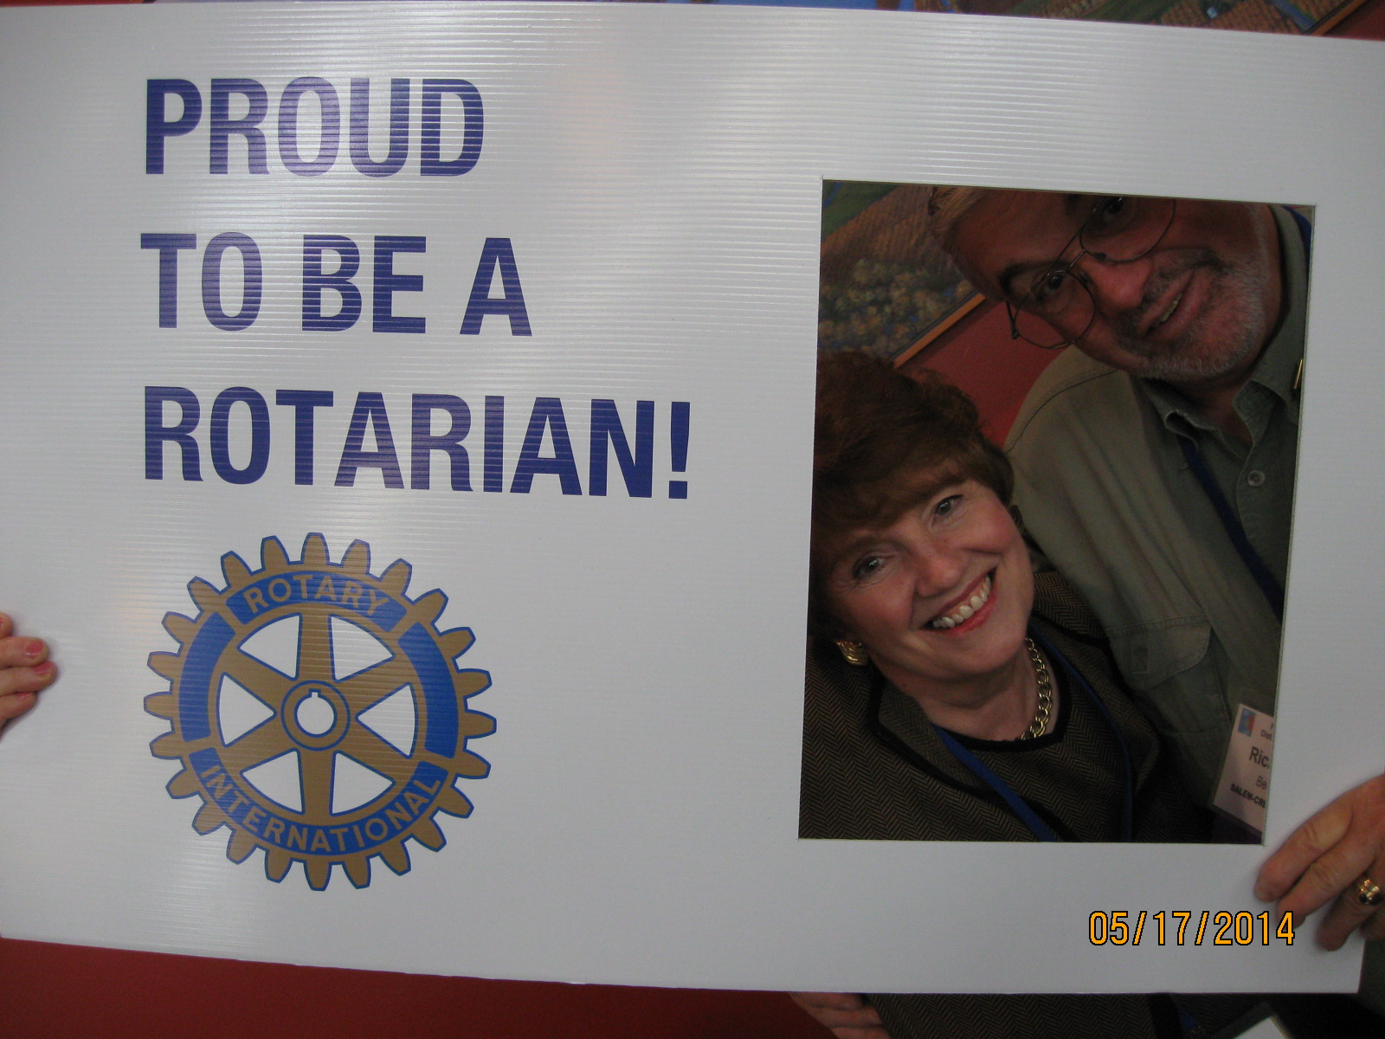
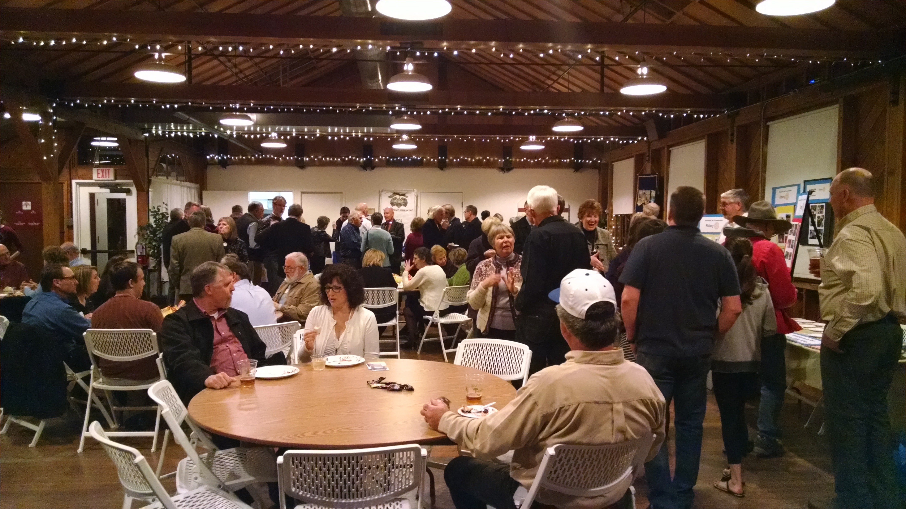
My ”appreciation and commitment to our group : small, intimate group; large member participation at firesides and social functions; quarterly local hand-on projects; international.” David Halter, Maps Credit Union

For more information and stories about our projects and activities, check our Club website: www.clubrunner.ca/salemcreekside. Be our guest and join in the fun and fellowship, Thursdays at noon, Danny’s on the Green Restaurant, Creekside Golf Club, 6250 Clubhouse Dr. SE. Join the fun, visit Salem Creekside Rotary!

