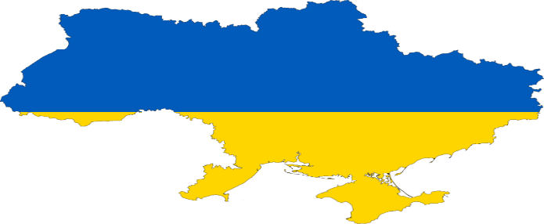
YOU CAN HELP!

We have seen, the devastation and destruction in Ukraine, and wondered how can we help? What can we do to make the biggest impact? Join the Rotary Club of Salem Creekside as we step forward to help those in NEED.

A donation of | $10 | $25 | $50 | $100 | $200 | $500 | $1,000 | $2,000
Becomes | $28 | $70 | $140 | $280 | $560 | $1,400 | $2,800 | $5,600
Your donation is tax deductible. Donations are matched 100% by Rotary District 5100, and 80% by Rotary International. Your entire donation will go the help those in NEED. Join the Rotary Club of Salem Creekside as we help our neighbors who so desperately need our assistance. Send donations to: Rotary Club of Salem Creekside, 6130 Lone Oak Rd. SE, Salem, OR 97306 or call (503) 580-3755.

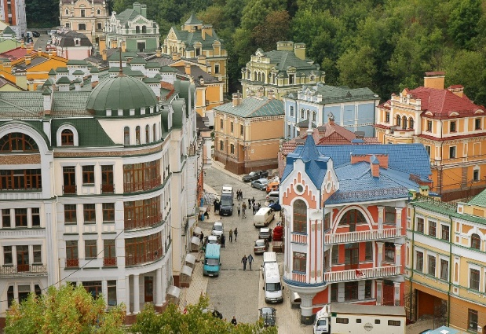 | Ukraine before the WAR. | This Photo by Unknown Author is licensed under CC BY

To learn more about our service projects, listen to informative guest speakers, join us Thursdays at noon, at Danny’s on the Green, Creekside Golf Course or www.clubrunner.ca/salemcreekside.
May 5 |  | Superintendent Christy Perry, Salem Keizer School District
May 12 |  | Professor Alan Mix, OSU, Climate Researcher
May 26 |  | John Paskel, Salem Airport Manager
June 2 |  | Roth’s Fresh Food Market

