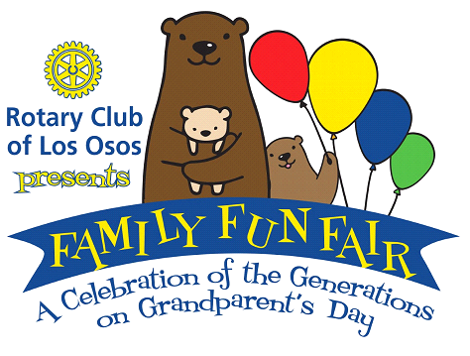
GRAND PRIZE
Central Coast Staycation Package
Lodging: Ragged Point Inn- Nite’s Stay + $100 cert. for amenities
Baywood Inn B&B - Nite’s Stay + Bkfst

Entertainment: Bay Theater Tix- Family pack/5 tickets
Great American Melodrama- Tickets for Two

Dining: Dorn's Breakers Café Morro Bay $75
Windows on the Water Morro Bay $150
Brightside Pizza $20
Bon Temps Creole Café $100
Bayside Café $50
Tognazzini’s Dockside Dinner for 2 + bottle of wine
Activities: Central Coast Gondola-Gondola Tour of Morro Bay for 6
A Kayak Shack-Two Double Kayaks for 2 hours
Sycamore Resort & Spa- Sweetheart Soak for 2
The Ravine Water Park- 2 one-day admission Tickets
Private Tour for 4 w/John Lindsey Port San Luis Lighthouse & Aquarium
Hearst Castle $100 GC for Tour of Choice for 2
Deovlet Wines Two Bottles Wine & Tasting for 2 for 1
Lost Isle Adventures- Tiki Cruise or Whale Watching for 2
Margarita Ranch Zipline Adventure for 2 adults
Morro Bay Paddle Sports-A Day of Kayaking for 2
And more to come!

