PROSPECTIVE MEMBER INFORMATION AND APPLICATION FORM

This information sheet and application form has been prepared for the business professional who is interested in membership in the Rotary Club of Montecito.

WHAT IS ROTARY?

Rotary is a worldwide fellowship of business and professional individuals who provide humanitarian service, encourage high ethical standards in all vocations, and help to build goodwill and peace in the world.

Rotary is the world’s first service club. Rotary was founded by Paul Harris, an attorney, and three friends who met in a small office in Chicago, Illinois, USA on February 23, 1905. These men wanted to rekindle the spirit of friendliness they had known in their own home towns. The members chose the name Rotary because they rotated weekly club meetings between each other’s places of business. Within a year, the Chicago club became so large it became necessary to adopt the now-common practice of a single, regular meeting place.

Rotary today comprises more than 1.2 million service-minded men and women. The club is the most important component of Rotary’s organizational structure. There are more than 35,000 Rotary clubs in 166 countries worldwide. These clubs are grouped into 530 districts and 34 regional zones. Our Rotary District 5240 was chosen in 1993 as one of the 12 Model Districts in the world.

Rotarians meet regularly for fellowship and interesting, informative programs presenting topics of local, regional and global interest. Membership is by invitation and reflects a wide cross-section of the community. Rotary is not a secret organization and does not conflict with any religious or political organization.

Rotary International is the global association of Rotary Clubs throughout the world and is led by the Rotary International President and Rotary International Board of Directors. Rotary International’s headquarters are located at One Rotary Center, 1560 Sherman Avenue, Evanston, Illinois 60201.

Rotary International established The Rotary Foundation in 1917 to help clubs and districts work together to bring sustainable change to communities in need. Out top-rated, award-winning Foundation has spent more than $3.7 billion on life-changing, sustainable projects such as clean water initiatives, mobile medical clinics, teacher training, and child immunizations to eradicate polio. Each year The Rotary Foundation provides some US $60 million for international scholarships, cultural exchanges, and humanitarian projects in local communities and throughout the world.

ROTARY MOTTOS AND THE FOUR WAY TEST

The Rotary mottos are:

- Service Above Self
- He/She Profits Most Who Serves Best

The Four-Way Test has long served as an ethical guide for Rotarians to live by in their personal and professional lives, and is regularly recited at Club meetings. Of the things we think, say, or do:
- Is it the Truth?
- Is it Fair to all Concerned?
- Will it Build Goodwill and Better Friendships?
- Will it be Beneficial to all Concerned?

THE ROTARY CLUB OF MONTECITO

The Rotary Club of Montecito represents a membership of business and professional men and women that meets the first and third Tuesdays of the month from 12:00 P.M. until 1:30 P.M. Due to the COVID-19 pandemic meetings are currently conducted virtually (over Zoom).

The Rotary Club of Montecito is led by a Board of Directors that includes four Club officers who serve for the current year (President, President-Elect, Secretary, and Treasurer), and elected Board members who serve two-year terms.

INDUCTION FEES AND MEMBERSHIP DUES

The membership application fee is $100, which is to be tendered when the prospective member submits their application to the Club. At time of application, the potential member should provide the Club with a digital picture for the Club’s website.

Quarterly dues for membership in the Rotary Club of Montecito are $75.00, plus $25.00 for each meeting meal. Currently there is no cost for meeting meals as the Club is meeting virtually. Dues must be paid within thirty (30) days of billing. Dues, meal cost (when reinstated), and participation in the Club’s community and international activities will cost approximately $1,300.00 yearly. Membership fees are billed quarterly in advance in January, April, July, and October.

ROTARY DISTRICT 5240

The Montecito Rotary Club is part of Rotary District 5240. District 5240 is bordered by the Pacific Ocean on the southwest and runs East across the Tehachapi and Sierra-Nevada Mountain ranges to our eastern-most border, Death Valley National Park. It encompasses Kern, San Luis Obispo, Santa Barbara, and Ventura Counties and a small portion of Los Angeles County.

There are currently 72 Rotary Clubs and approximately 3,000 Rotarians in District 5240. The local clubs (known as District Group 8) include Carpinteria, Carpinteria Morning, Carpinteria Sunset, Goleta, Goleta Noontime, Montecito, Santa Barbara, Santa Barbara North, Santa Barbara Sunrise, Santa Barbara Rotaract and UCSB Rotaract.

ROTARY WEBSITES AND RESOURCES

- The Montecito Rotary Club website is: www.montecitorotary.org .
- The District 5240 website is: www.rotarydistrict5240.org
- The Rotary International website is www.rotary.org
- “The Rotarian” is the monthly publication of Rotary International.

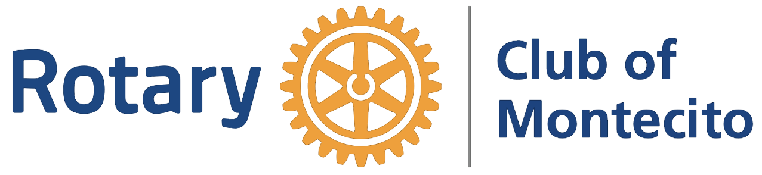

APPLICATION FOR INDIVIDUAL MEMBERSHIP

Full Name:

Nick Name:

Rotarian Sponsor’s Name:

BUSINESS INFORMATION

Business Classification (insurance, software, healthcare, etc.):

Business Name:

Business Address:
(Number, Street, State, Zip Code)

Position at Business:

Business Telephone Number: ( )

Mobile Telephone Number: ( )

Email Address:

PERSONAL INFORMATION

Date of Birth: Month Day Year

Spouse’s Name:

Anniversary Date: Month Day Year

Residence Address:
(Number, Street, State, Zip Code)

Residence Telephone Number: ( )

Indicate your preferred phone number and email address for Rotary correspondence:

Preferred Phone Number:

Preferred Email Address:

Children: (How Many?)

Names Ages

ROTARY EXPERIENCE

Former Rotarian? Number of Years in Rotary:
Yes/No (How Many)

Name of Former Rotary Clubs State(s) Years Active in Clubs

1.
2.
3.

Paul Harris Fellow? Multiple Paul Harris Fellow?
Yes/No (How Many)

RI Benefactor? PRLS Graduate?
Yes/No Yes/No

OTHER INFORMATION
Hobbies:

Academic History:

Employment History:

What else would you like Club members to know about you?

Signature Date

Notes:

- This application must be accompanied by a digital picture for the Club website and a $100 Application Fee.
- Checks should be made out to “The Rotary Club of Montecito”.

Revised 01-13-2021

