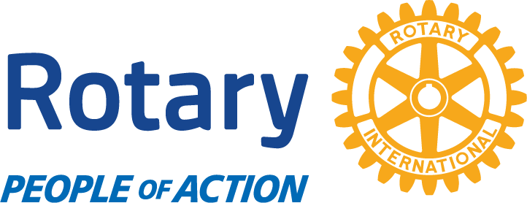
Morro Bay
Lighted Boat Parade 2022

Thank you for joining us for the Lighted Boat Parade and Santa House! Please fill out this form and return it via email! We will be in contact with you to secure your spot.
Please email your LOGO to Nancy Ford-Retchless at Rotaryfromtheheart@gmail.com JPEG or PNG version of your Logo is recommended.
Business Name: ____________________________________________________________________
Contact:__________________________________________________________________________
Address:__________________________________________________________________________
Business Phone:____________________________________________________________________
Email:____________________________________________________________________________
Website:_________________________________________________________________________
Business Hours:__________________________________________________________________
Level of Sponsorship: (check one)
Santa House- $350.00
Printed Sign on Santa House, social media Mentions, Logo on Poster, Link on the website, mention at a live performance and during the parade.
Business Sponsorship: $250.00
Logo and Link on the website, Social Media mentions, mention at a live performance and during parade and Sign with your name on the Santa House.
Individual Sponsorship- $100.00
Name on website, mention at a live performance and during the parade.
Morro Bay Rotary
PO Box 806
Morro Bay CA 93442
805-235-3733

