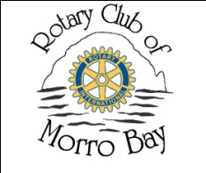
Rotary Club of Morro Bay
COMMUNITY SERVICE GRANTS
2010-11 GRANT APPLICATION

Date:_______________________________ Fed Tax ID:___________________

Organization:_____________________________________________________

Address:________________________________________________________

Contact Person / Title:_____________________________________________

Telephone:______________________ Email:___________________________

Application endorsed by Rotarian:___________________________________

Amount requested: $ _______

Documents required:
- Organization mission statement:
- Project synopsis: Please attach a proposal describing the project, the benefits to your organization and its impact on the community.
- Organization financial information: Attach a copy of your current operating budget, the project budget related to this request and a copy of your federal tax exempt status letter.

List all previous grants received from Morro Bay Rotary Club:

Amount | Year

Submit Application and requested Attachments as soon as possible and before June 30th, 2011 to: (Please do not include videos or other promotional materials.)

Jude Long, Chairperson
Community Services Grant Committee
Rotary Club of Morro Bay
P.O. Box 806
Morro Bay, CA 93442-0806

