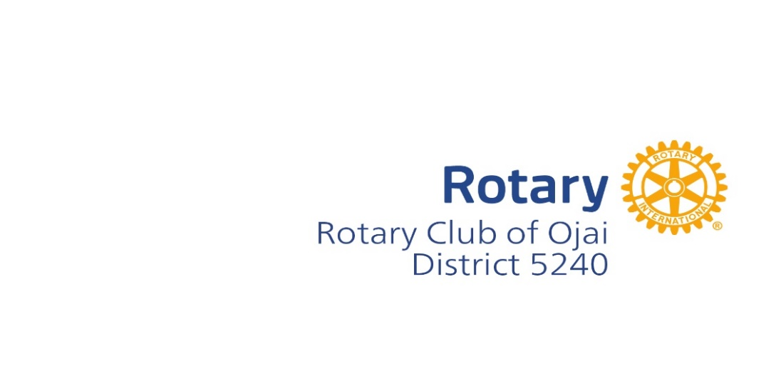
2024 Community Grant Application
Funding opportunity:
The Rotary Club of Ojai invites Ojai not-for-profit organizations to submit grant applications that support the youth of the Ojai Valley. Grants will be for youth services, arts, and music. The Rotary Club of Ojai is especially interested in funding grants from small nonprofits that fund new projects with minimal administration expenses.
Applicant information:
Applicant:___________________________________________
Organization: ________________________________________
Email Address/Telephone: ______________________________
Address: ____________________________________________
Contact Person: _________________________Amount requested: ___________________________
Need: ______________________________________________________________________________________________
Submission:
Please mail this application with attachments and the applicant’s most recent IRS Form 990 or 990EZ and the first page of RRF-1 (Registry of Charitable Trusts) along with this completed application no later than March 8, 2024, to: ojairotarygrants@gmail.com
Grant request details:
Please answer the following question to help us understand your project and grant request in a Word document attached to this form.
- What need is met by this project? How does this project assist the youth of Ojai Valley?
- Has this project previously been funded by the Rotary Club of Ojai? (Eligibility not affected by previous funding).
- Is this a new project?
- Success metrics: How will success be measured?
- How will the funds be used? Please provide the project budget (including revenue and expenses) with a timeline.
- What alternative or supplemental funding has this project received or applied for?

