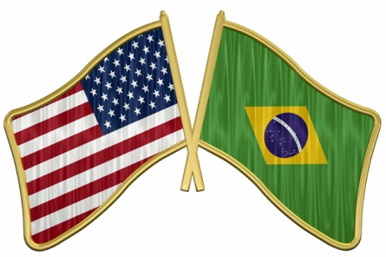

Task Force Team to Visit Brazil in May 2013

A Task Force Team will be visiting District 4590 at the end of May with the purpose of developing and cementing relationships between District 5970 and District 4590 to plan future projects to continue with Rotary’s good works.
The visit is a result of the connections made in the past couple of years with the Brazilian District.

The team has a very specific agenda while in Brazil, as they will work towards setting up a structure to facilitate future projects and exchanges between the two Districts. Some of the possible future projects are aimed at developing Global Grant Projects to create opportunities for Multi-District – Multi-Club involvement.
In addition, the Task Force Team expects to deliberately propose future exchanges for Vocational Training Teams, Friendship Exchanges, Youth Exchanges, and exchanges with Interact and Rotaract Clubs in both Districts.

The Task Force Team, composed by Michelle Bell, Jacob Wittrock, Jim Patton, Diane Patton, Ana Lucia Gil, and Orlando Gil, will travel to Brazil on May 22 in time to present a program at District 4590’s District Conference and share the vision of future work between the Districts. Future leadership opportunities for Rotarians in both Districts will be plentiful, as the effort will require the help of many to carry out future work and to build these relationships.

To learn more about future International Projects opportunities, please contact:
Orlando Gil
orlando.gil@tctglobal.net 712-240-0624
District Chair International Programs
District Chair Friendship Exchange
District 5970
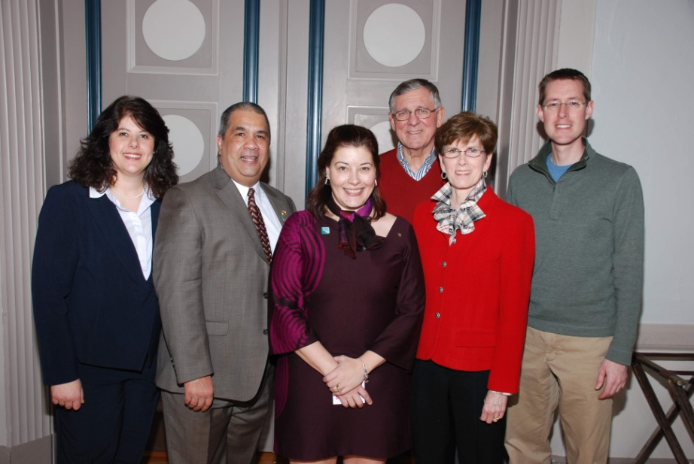

Task Force Team:
Ana Lucia Gil, Orlando Gil, Michelle Bell, Jim Patton, Diane Patton, and Jacob Wittrock

