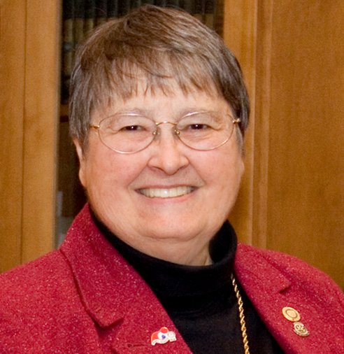
Janice H. McElroy Scholarship

Jan was born and raised in the wheat and cattle country of Kansas and later lived in Denver. She majored in Chemistry at Colorado College before going to the University of Cologne, Germany as a Fulbright Scholar in Biochemistry. Jan taught science in Baltimore and earned her masters at Johns Hopkins. She served as chair of the science department at the Bishop’s School in La Jolla, California, before she completed her Ph.D. in Human Behavior.
Jan, her husband Jim, and their two children moved to New Jersey and later Pennsylvania, where she became very involved in the American Association of University Women serving four years as State President of AAUW and four years on AAUW’s national Board of Directors. In 1988 she accepted a gubernatorial appointment as Executive Director of the Pennsylvania Commission for Women. Her proudest accomplishment in that role was the creation of the Leadership Development Institute for Women in State Government and achieved the transition of the Institute to the next administration. In 1998, she ran unsuccessfully for Congress in the PA 15th
In 1999, she moved to Henniker to be the Assistant to the President and Director of Planning at New England College. In 2005, she joined the development staff at Colby-Sawyer College as their Grants Manager until her retirement in 2009.
Jan McElroy’s Rotary Legacy
Jan joined the Henniker Rotary Club in 2000 and served as its President in 2004—05, receiving the Presidential Citation for the club. She received the Rotarian of the Year Award in 2008. Jan served 3 years as an Assistant Governor, as District Rotary Foundation Chair and as Secretary of the District 7870 Foundation. She is a multiple Paul Harris Fellow and was a member of the Rotary Leadership Institute Faculty. Her travels took her throughout Europe, Japan, China, Ghana and all fifty United States. During her year as District Governor 2011-2012, Hurricane Irene devastated southern Vermont. Representing District 7870, Jan partnered with Marilyn Bedell, her counterpart in Vermont’s District 7850, to submit a matching grant to The Rotary Foundation to help with Vermont’s long-term recovery. They secured pledges from individuals and 114 Rotary Clubs around the world and ultimately received an RI grant of $412,000 –the largest RI grant ever awarded for a US project. Jan was invited to present at the International Rotary Conference, but had been recently diagnosed with cancer and was unable to attend. Still, she narrated a multi-media presentation which was shown at the conference.
After a valiant struggle, Jan died in the winter of 2014. Prior to her death, she decided what she would like her legacy in Rotary to be. She asked that a fund be set up to award scholarship assistance to non-traditional students that was open to eligible youth 21 and over from throughout the district to attend post-secondary education in a 2 or 4 year program.
District 7870 is proud to honor Janice’s service to Rotary, the district and the world with the announcement of the Janice H. McElroy Scholarship for Non-Traditional Students.
Eligibility
This scholarship fund is to be used to support the college education of non-traditional students from Rotary District 7870. Applicants must be 21 years of age or older and must have completed high school or have earned a G.E.D. There must be at least a three-year gap between graduating from high school and full time college attendance or a record of part-time college for three years after graduating from high school.
Scholarship recipients earning a B average or better may apply for a subsequent year of support, allowing the possibility for support to continue until the supported course of study is completed. The scholarship can be used for expenses at a four- year or a two- year college, or for another type of accredited institution.
A committee consisting of representatives from District 7870 will determine the Scholarship recipient each year. The scholarship award will be at least $1,000 and will be presented at the annual District Conference.

Rotary District 7870
Janice McElroy Scholarship Application
Rotary Club of Brattleboro

ELIGIBILITY: Applicants must be 21 years of age or older, have completed high school or earned a G.E.D. There must be at least a three-year gap between graduating from high school and full time college attendance or a record of part-time college for three years after graduating from high school. Scholarship recipients earning a B average or better may apply for a subsequent year of support, allowing the possibility for support to continue until the supported course of study is completed. The scholarship can be used for expenses at a four- year or a two- year college, or for another type of accredited institution.

Name________________________________ Date of Birth (MM/DD/YYYY) ________________________
Address_______________________________________________________________________________________________________________________ Telephone________________ Email____________________

School or College to attend next year: __________________________________________________________
Major Field of study __________________________________________________________________
Length of Program: _______ 1 year, _______ 2 years, _________ 3 years, ____________ 4 years

Year you completed high school or received your high school equivalency (GED) _______________________

List any post-secondary courses you have attended since high school: _______________________________

You may use additional paper to complete any of the following sections:

Employment or Military History (Please include dates):__________________________________________
_______________________________________________________________________________________

Tell us about your community or volunteer experiences and how they have impacted your life thus far. _______________________________________________________________________________________ _______________________________________________________________________________________

Give examples of activities that demonstrate your accomplishments (awards, honors, military service). _________________________________________________________________________________________ ___________________________________________________________________________________________________________________________________________________________________________________
Please complete a minimum one page (no longer than two page) essay to include information about yourself, why you are applying for this scholarship and why you are the ideal candidate for the scholarship. Additional information including video/multi-media presentations are welcomed.

Submit completed application by April 15, 2019 to: Sandra McGonagle
165 Potter Hill Rd
Gilford, NH 03249
mcgonagle@metrocast.net

